Unit 6 Lesson 11: How Long Are Our Shoes?

WU Notice and Wonder: Length of a Shoe (Warm up)

Student Task Statement
What do you notice?
What do you wonder?
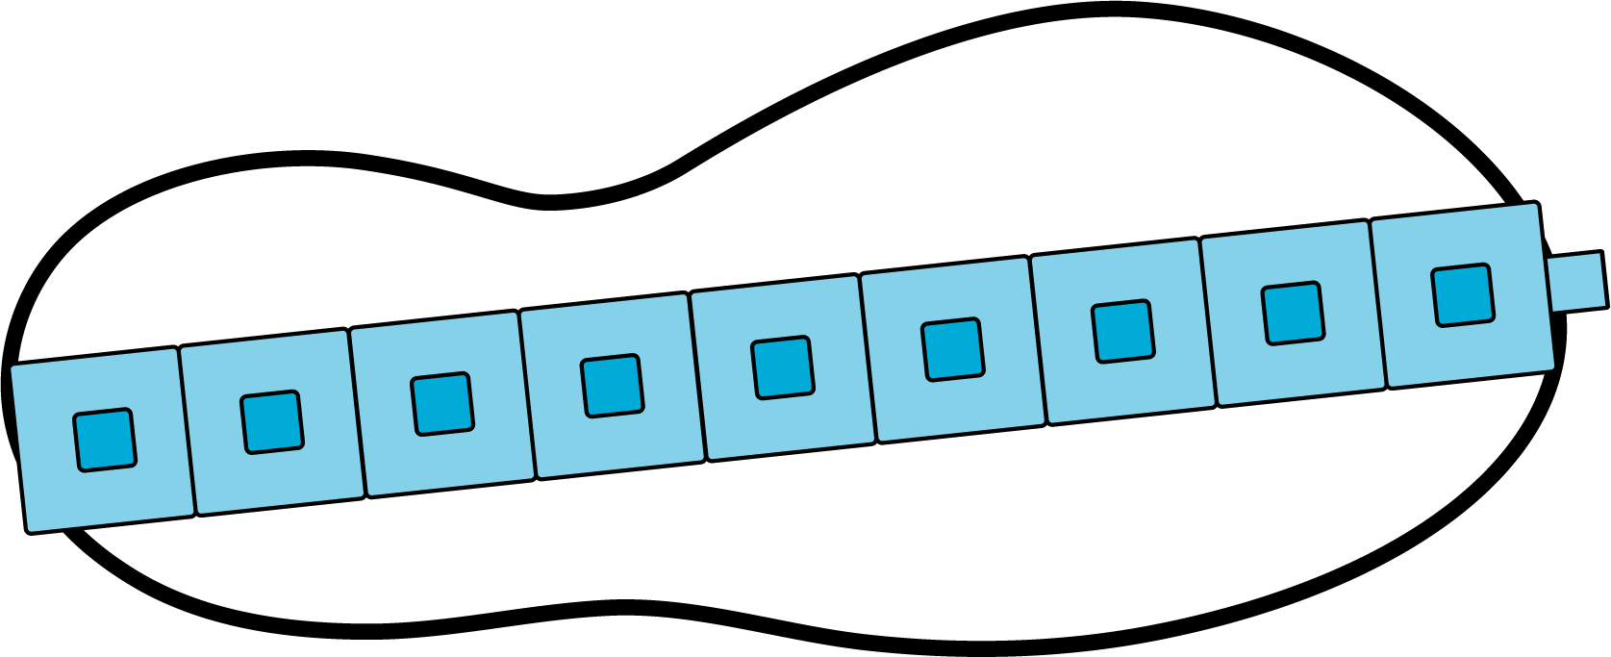

1 The Length of Our Shoes

Student Task Statement
My teacher's shoe is ____________ connecting cubes long.
My shoe is ____________ connecting cubes long.
My partner’s shoe is ____________ connecting cubes long.
Solve these problems about the length of your group’s shoes.
Show your thinking using drawings, numbers, words, or equations.
- What is the length of your shoe and your partner’s shoe together?
- Whose shoe is longer, yours or your partner’s?
- How much longer?
- Whose shoe is shorter, your teacher’s shoe or your shoe?
- How much shorter?

2 Shoe Stories

Student Task Statement
Show your thinking using drawings, numbers, words, or equations.
- Clare’s shoe is 9 cubes long.
Han’s shoe is 7 cubes long.
How many cubes long are Clare’s and Han’s shoes together?
- Kiran’s shoe is 7 cubes long.
His older brother's shoe is 9 cubes long.
His younger brother's shoe is 4 cubes long.
What is the total length of their shoes?
- Diego's shoe is 8 cubes long.
His father's shoe is 13 cubes long.
How many cubes longer is his father's shoe than his shoe?
- Jada's shoe is 8 cubes long.
She put her shoe together with Elena’s shoe.
Together the shoes are 17 cubes long.
How long is Elena's shoe?
© CC BY 2021 Illustrative Mathematics®

