Unit 5 Lesson 17: Annually, Quarterly, or Monthly?

1 Finding Equal Expressions (Warm up)

Student Task Statement
- Find pairs of expressions that are equal. Be prepared to explain how you know.
- $(3^{5})^{2}$
- $(3⋅3⋅3⋅3⋅3)⋅(3⋅3)$
- $3⋅3⋅9⋅9⋅9$
- $3^{6}$
- $(3^{2})^{4}$
- $3^{7}$
- $3^{10}$
- $3⋅9⋅27$
- Write an expression that is equal to $(2^{30})^{7}$ using a single exponent.
- Without evaluating the expressions, explain why $2^{15}$ is equal to $8^{5}$.

2 How Many Times Per Year?

Student Task Statement
- Complete the table.
- If something happens... | - It happens this many times a year... | - It happens every $\underset{_}{​}$ months...
- annually
- semi-annually
- quarterly
- monthly
- A gym membership has an annual fee, billed monthly. How much is each bill, if the annual fee in dollars is . . .?
  - 360
  - 540
  - $g$
- An educational foundation gives an annual scholarship, distributed semi-annually. How much is each distribution, if the annual scholarship amount in dollars is . . .?
  - 1,800
  - 5,000
  - $s$
- A magazine subscription has an annual price, billed quarterly. How much is each bill, if the annual price in dollars is . . .?
  - 48
  - 80
  - $m$

3 Your Problems Are Compounded

Student Task Statement
Match each item in the first column to a representation in the second column.
1. A worker sets aside $6,000 per year for their retirement fund by saving the same amount monthly.
A. $6,​000⋅{1.21}^{3}$
2. A business’s revenue increases by 20% per quarter. This happens for 2 years. Initially, their quarterly profit was $6,000.
B.
$x$ | 0 | 1 | 2 | 3 | 4 | 5
$y$ | 6,000 | 7,200 | 8,640 | 10,368 | 12,442 | 14,930
3. $6,​000⋅((1.05)^{4})^{x}$
C. $6⋅(3^{4})^{2}$
4. A man borrows $6,000 from his sister. He will reduce the amount he owes in 1 year by paying her back quarterly.
D.
$x$ | 0 | 1 | 2 | 3 | 4 | 5
$y$ | 6,000 | 4,800 | 3,840 | 3,072 | 2,457.6 | 1,966.1
5. A business’s revenue decreases by 20% semi-annually. This happens for 3 years. Initially, their quarterly revenue was $6,000.
E. $6,​000⋅{1.2155}^{x}$
6. The number of subscribers to a website triples quarterly for 2 years. Initially there were 6 subscribers.
F. $6⋅4,​{096}^{2}$
7. $6,​000⋅((1.1)^{2})^{3}$
G.
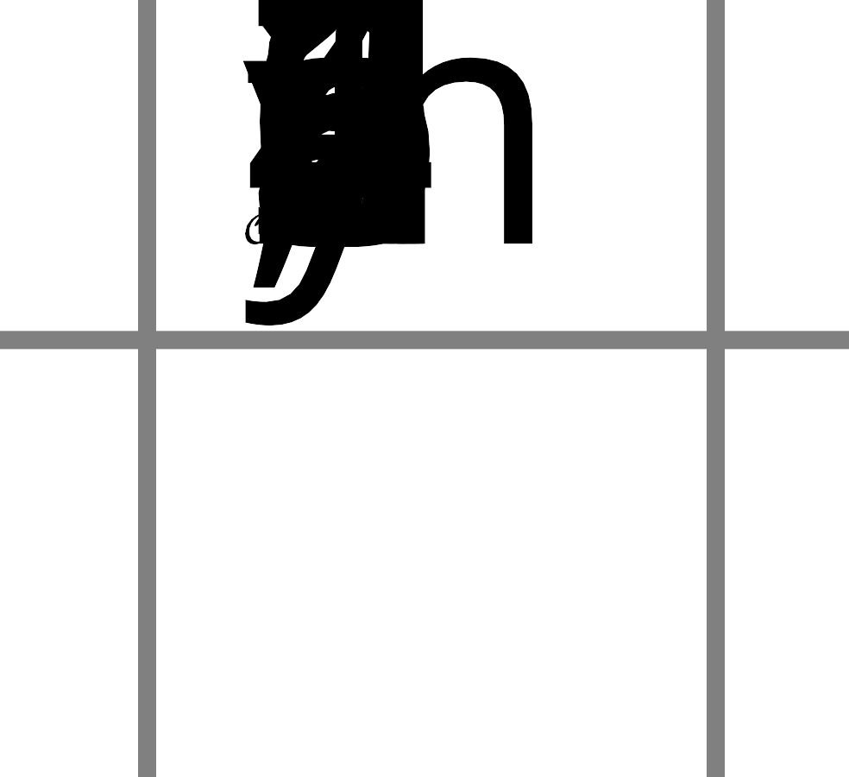
8. The number of likes on a post was 6, and then for the next 2 years, the number of likes doubled, monthly.
H.
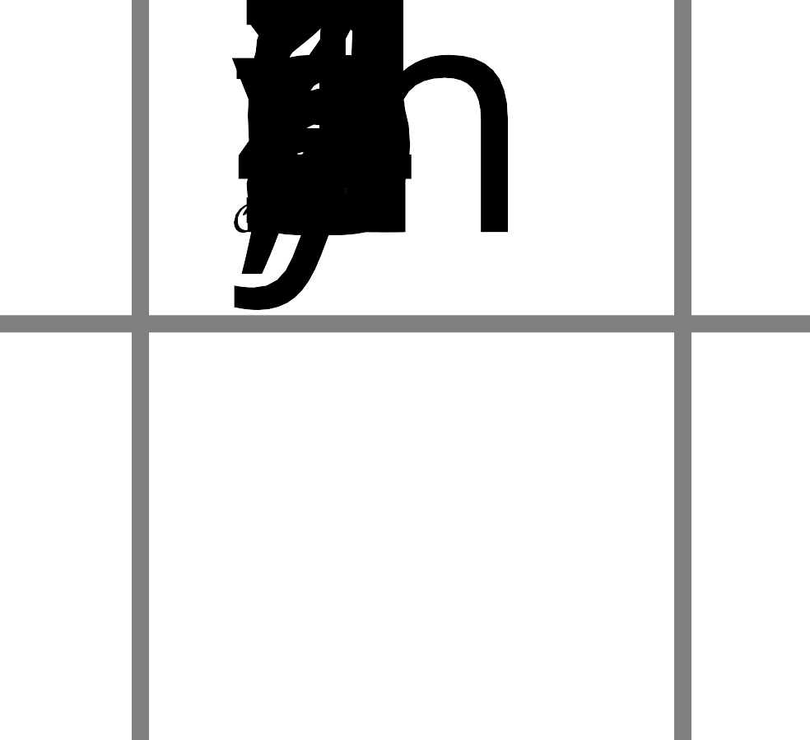
© CC BY 2019 by Illustrative Mathematics®

