Unit 3 Lesson 4: Converting Units

1 Number Talk: Fractions of a Number (Warm up)

Student Task Statement
Find the values mentally.
$\frac{1}{4}$ of 32
$\frac{3}{4}$ of 32
$\frac{3}{8}$ of 32
$\frac{3}{8}$ of 64

2 Road Trip

Student Task Statement
Elena and her mom are on a road trip outside the United States. Elena sees this road sign.
Elena’s mom is driving 75 miles per hour when she gets pulled over for speeding.
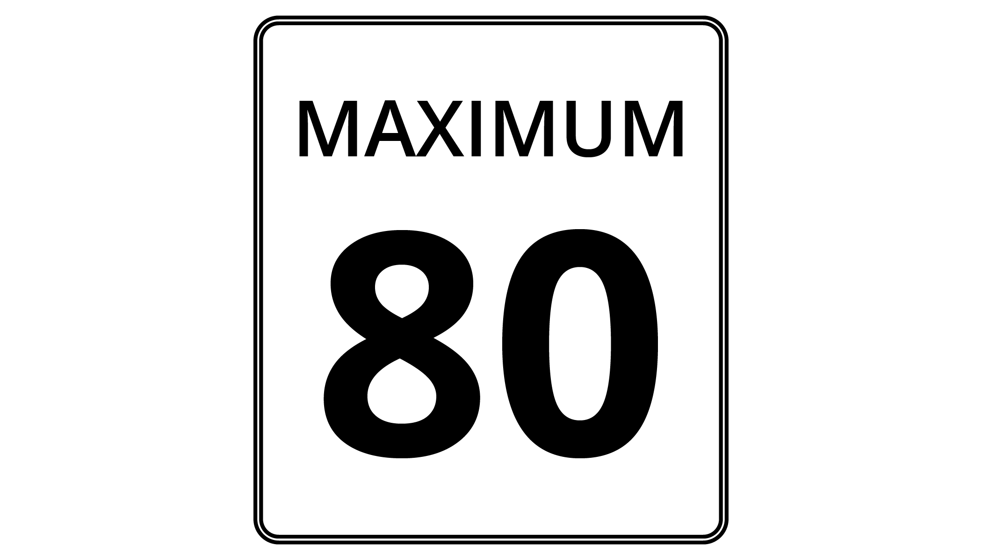
- The police officer explains that 8 kilometers is approximately 5 miles.
  - How many kilometers are in 1 mile?
  - How many miles are in 1 kilometer?
- If the speed limit is 80 kilometers per hour, and Elena’s mom was driving 75 miles per hour, was she speeding? By how much?

3 Veterinary Weights

Student Task Statement
A veterinarian uses weights in kilograms to figure out what dosages of medicines to prescribe for animals. For every 10 kilograms, there are 22 pounds.
- Calculate each animal’s weight in kilograms. Explain or show your reasoning. If you get stuck, consider drawing a double number line or table.
  - Fido the Labrador weighs 88 pounds.
  - Spot the Beagle weighs 33 pounds.
  - Bella the Chihuahua weighs $5\frac{1}{2}$ pounds.
- A certain medication says it can only be given to animals over 25 kilograms. How much is this in pounds?

4 Cooking with a Tablespoon (Optional)

Student Task Statement
Diego is trying to follow a recipe, but he cannot find any measuring cups! He only has a tablespoon. In the cookbook, it says that 1 cup equals 16 tablespoons.
- How could Diego use the tablespoon to measure out these ingredients?
- $\frac{1}{2}$ cup almonds
- $1\frac{1}{4}$ cup of oatmeal
- $2\frac{3}{4}$ cup of flour
- Diego also adds the following ingredients. How many cups of each did he use?
- 28 tablespoons of sugar
- 6 tablespoons of cocoa powder
© CC BY Open Up Resources. Adaptations CC BY IM.

