Lesson 2: Count and Arrange
- Let’s figure out how many objects we have.

2.1: Count, Rearrange, Count

2.3: Centers: Choice Time
Choose a center.
Shake and Spill
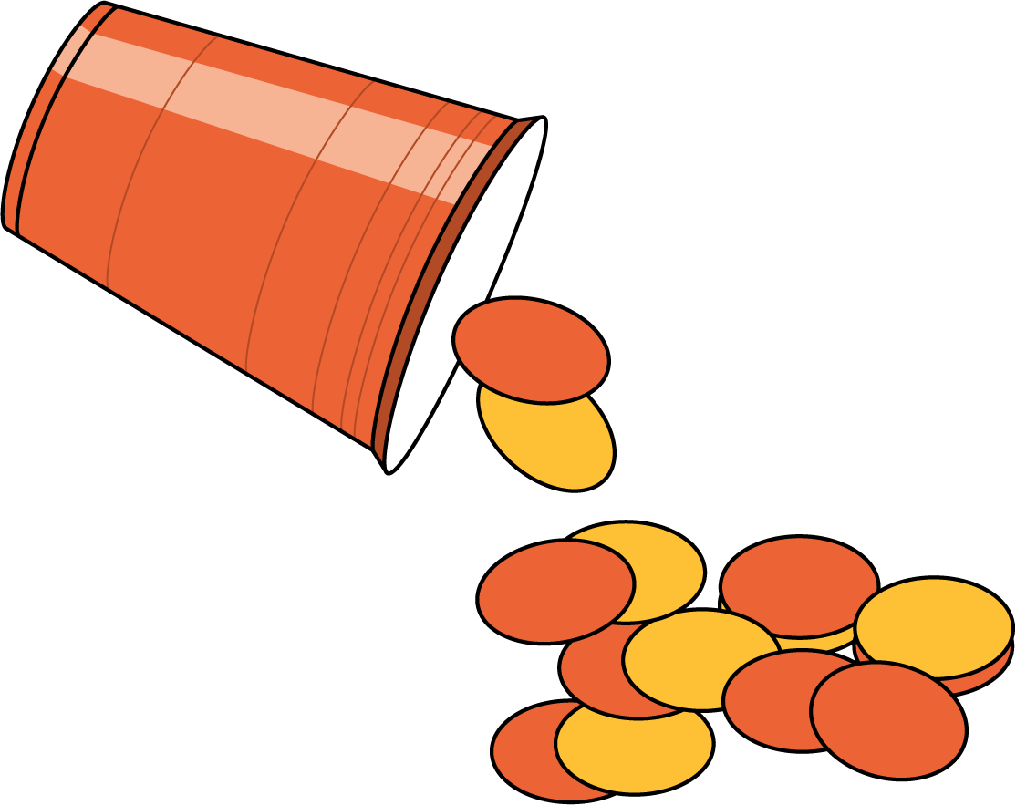
Math Fingers
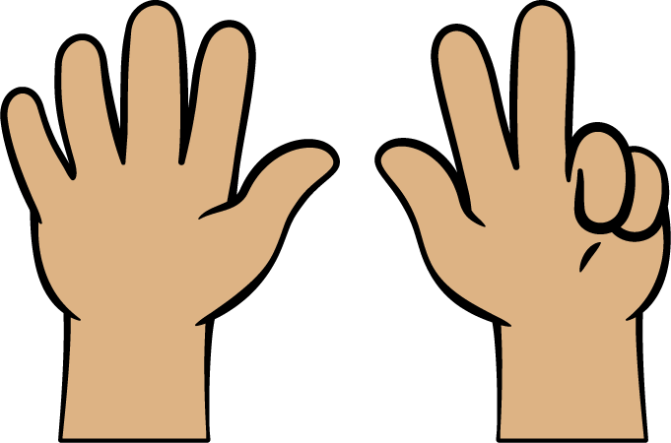
Pattern Blocks
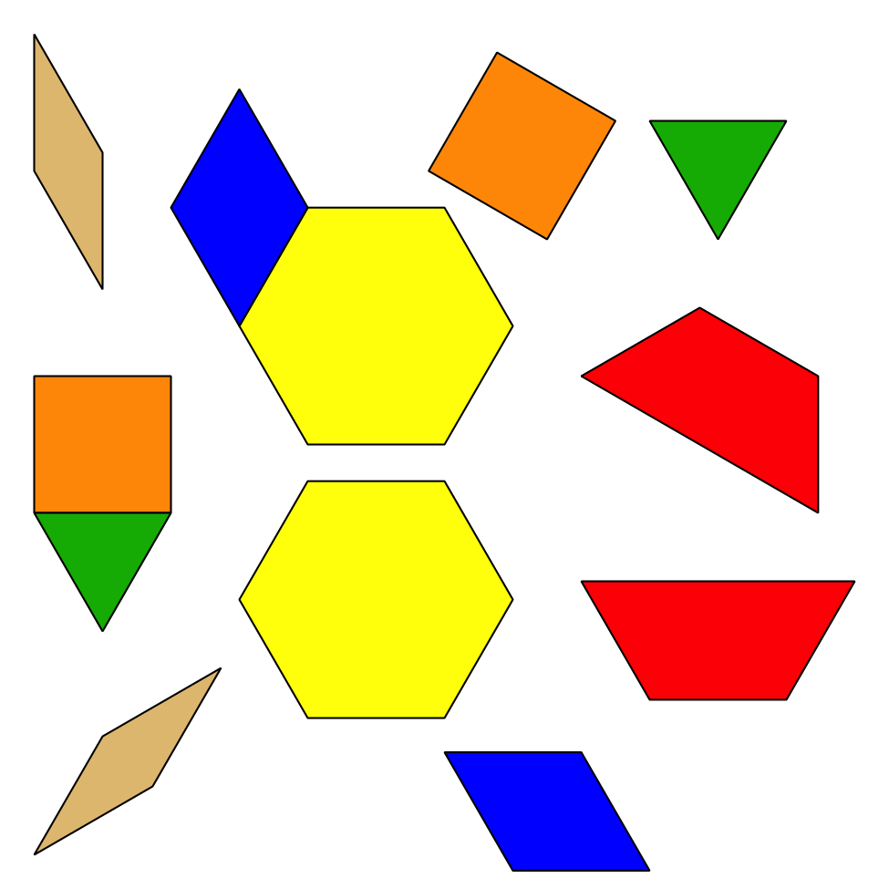
Picture Books
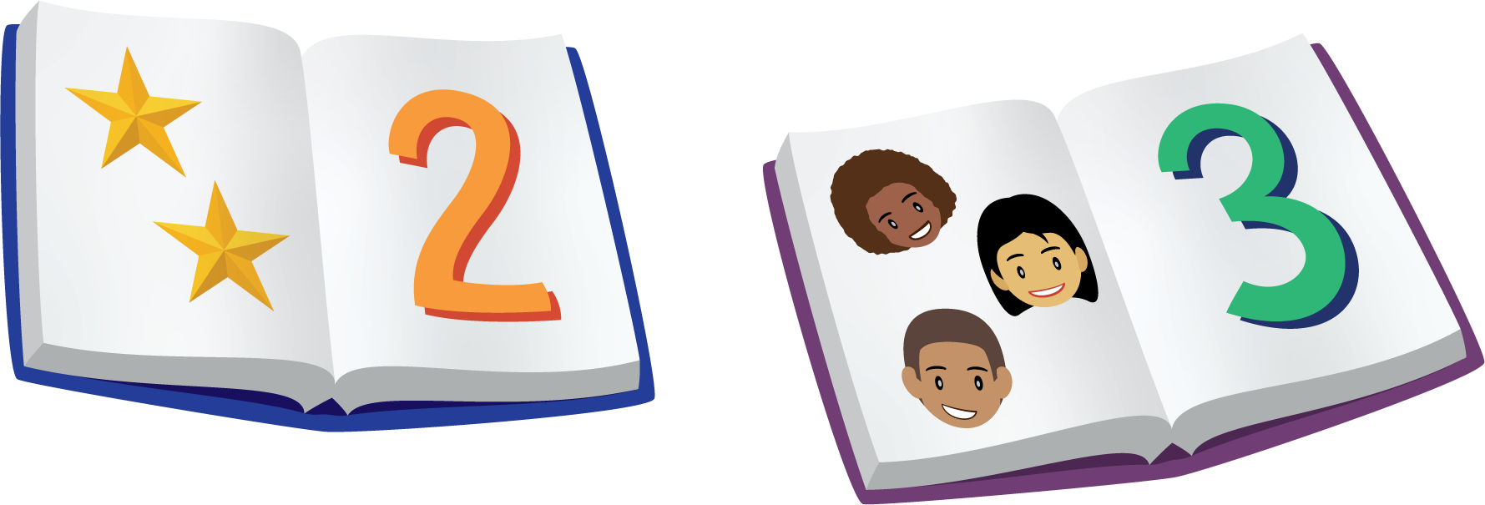
© CC BY 2021 Illustrative Mathematics®

