Unit 3 Lesson 10: Put Together Pattern Blocks

WU Notice and Wonder: Quilts (Warm up)

Student Task Statement
What do you notice?
What do you wonder?
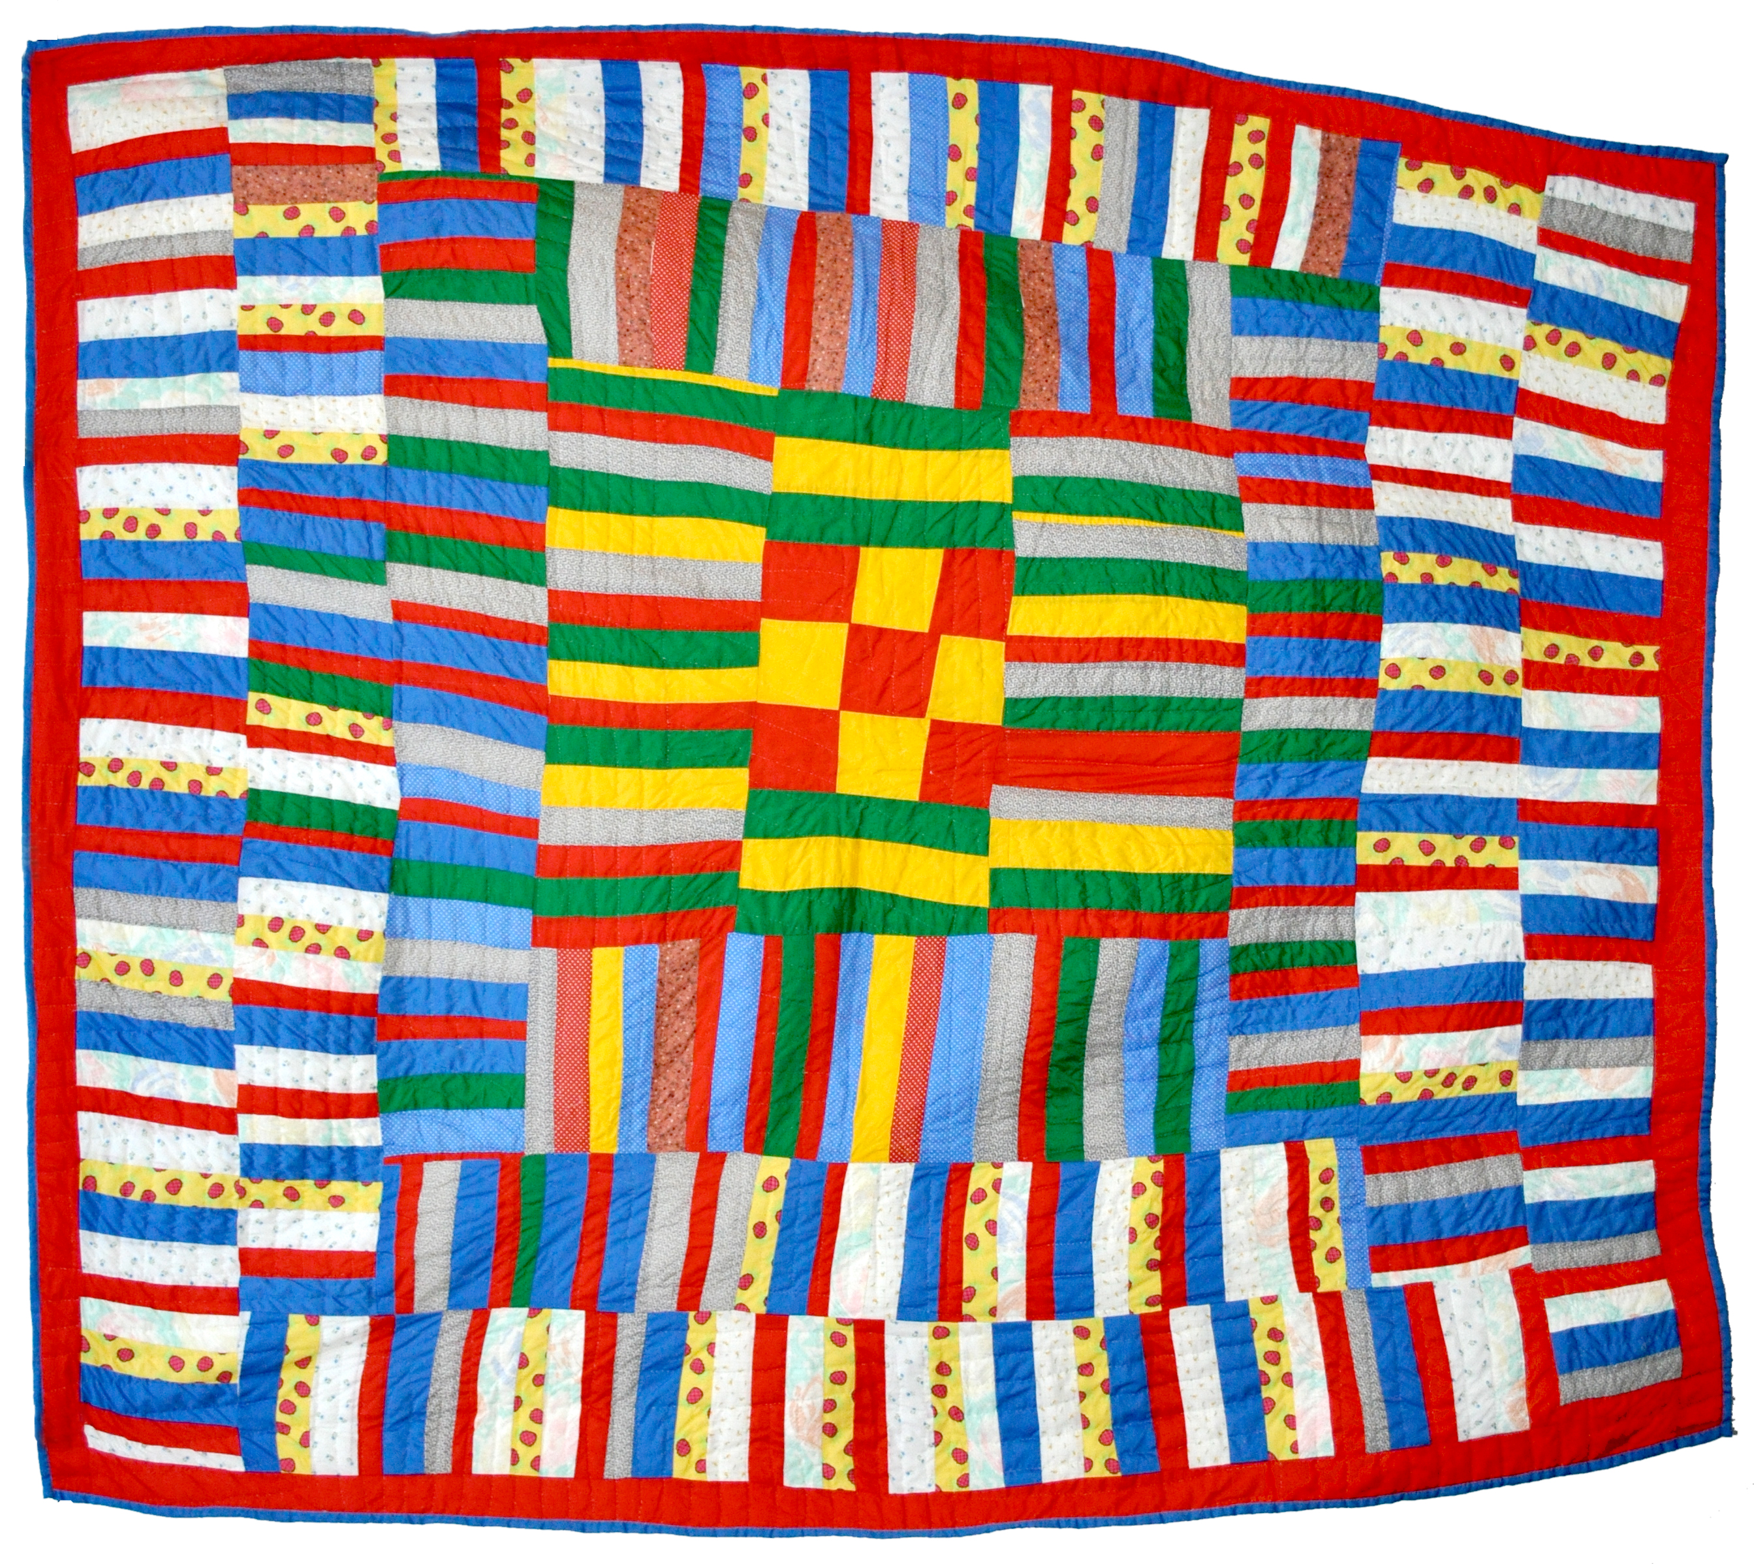
Synthesis:
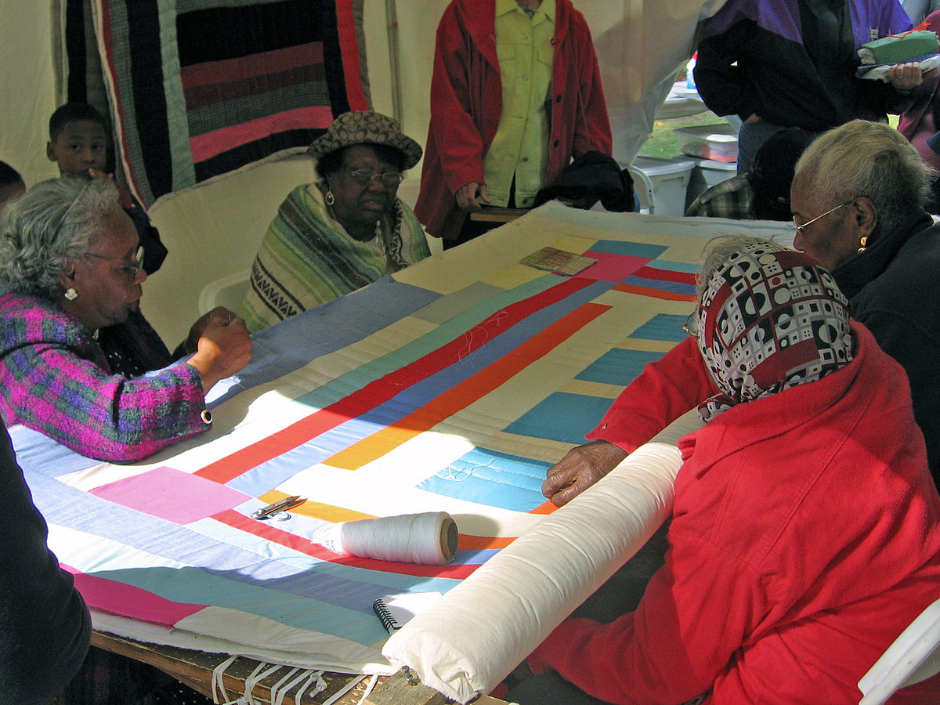

Activity Synthesis

1 Introduce Pattern Blocks, Count Out and Build

Student Task Statement
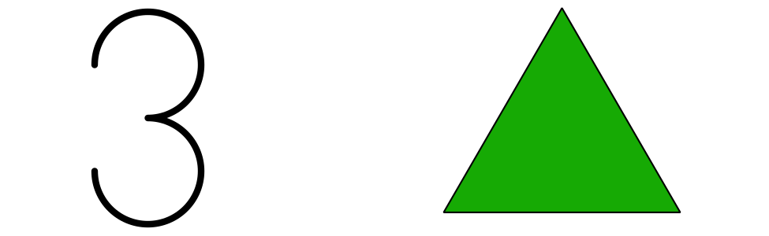
green triangles
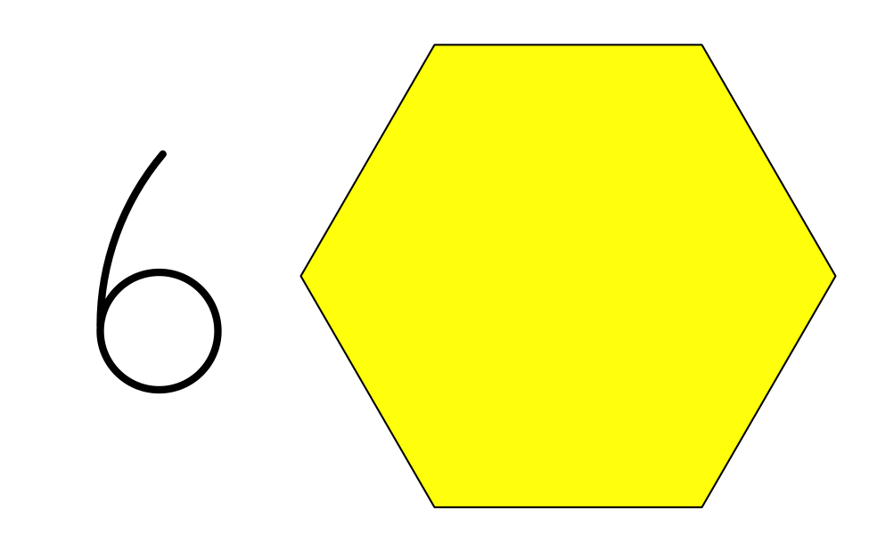
yellow hexagons
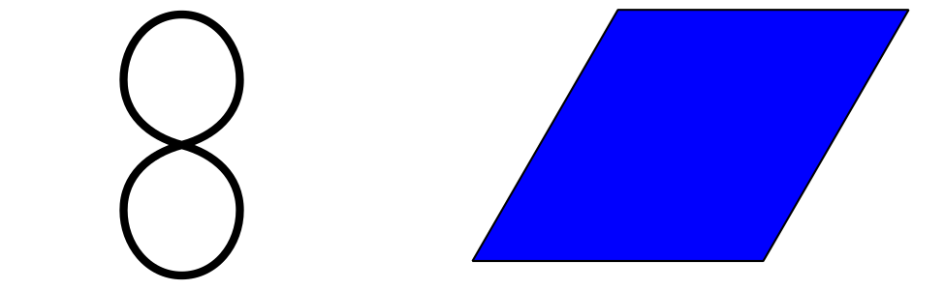
blue rhombuses
orange squares
I used more ____________________ than ____________________.
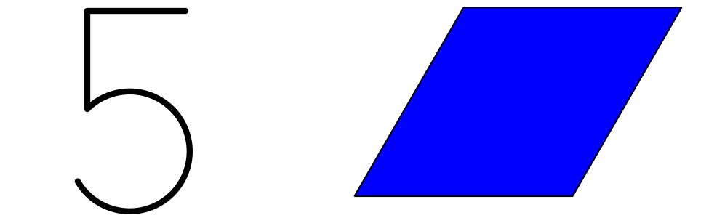
blue rhombuses
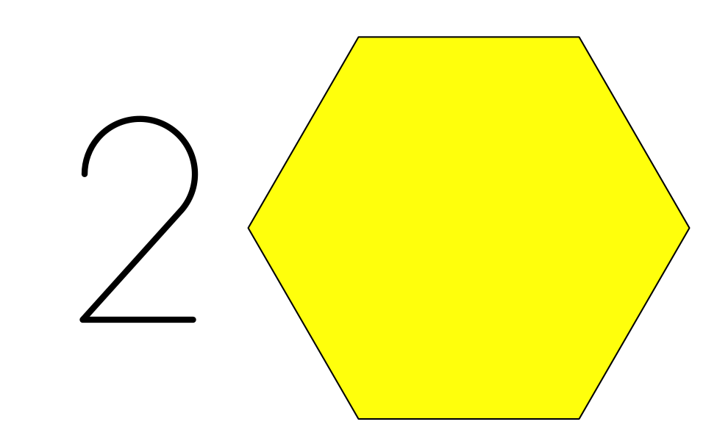
yellow hexagons
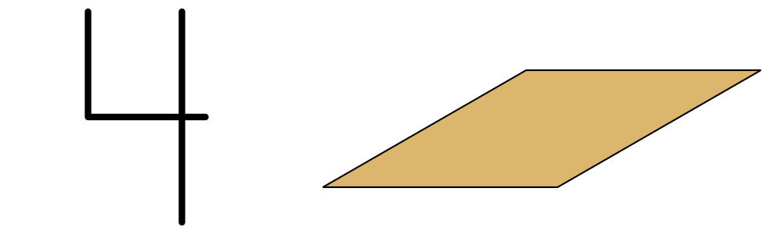
tan rhombuses
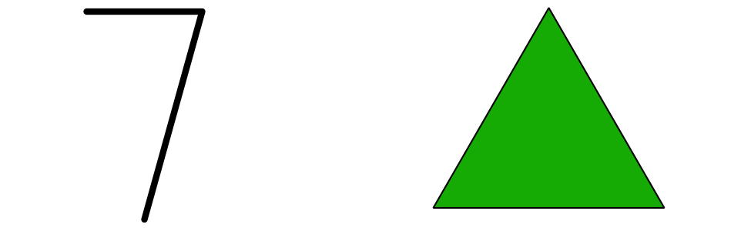
green triangles
I used more ____________________ than ____________________.

2 Pattern Block Puzzles

Student Task Statement
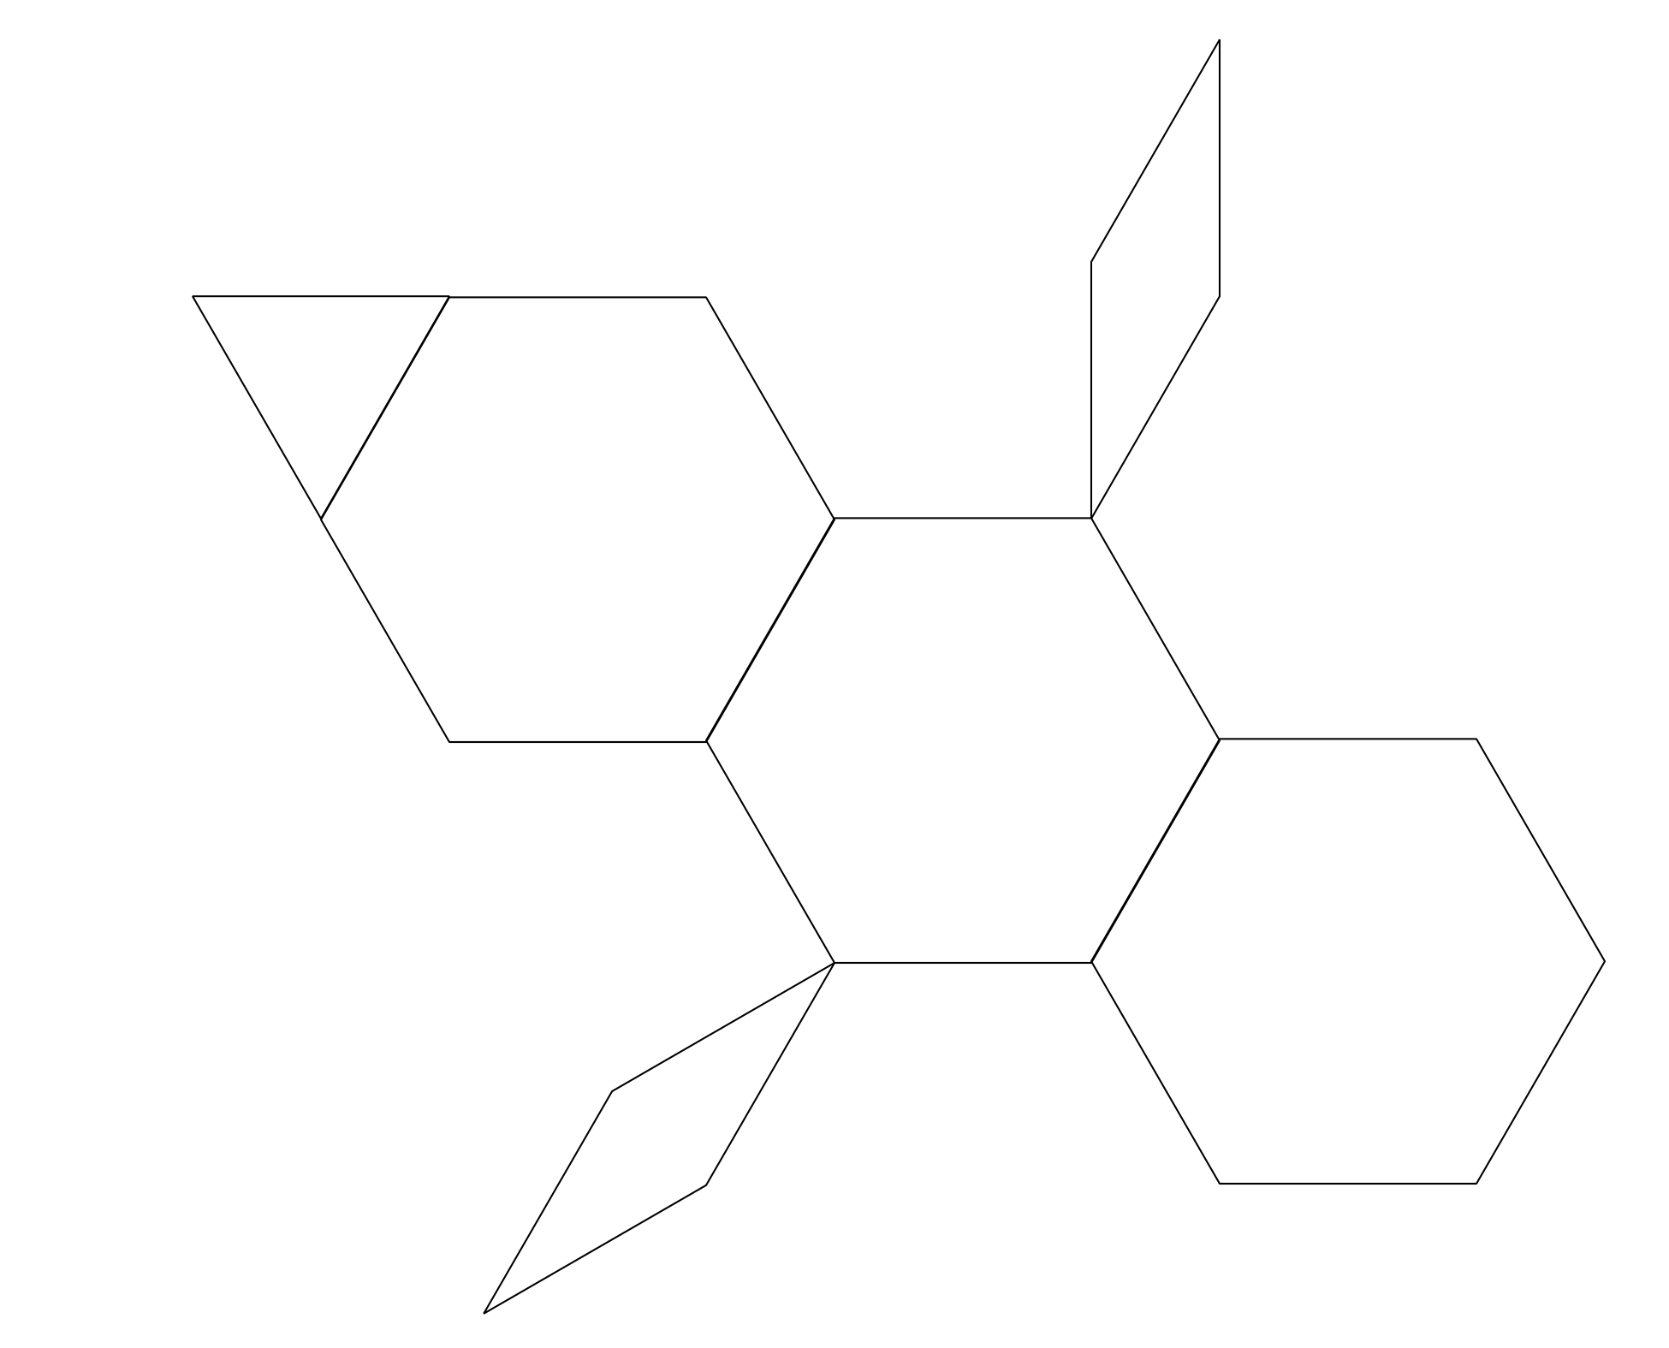
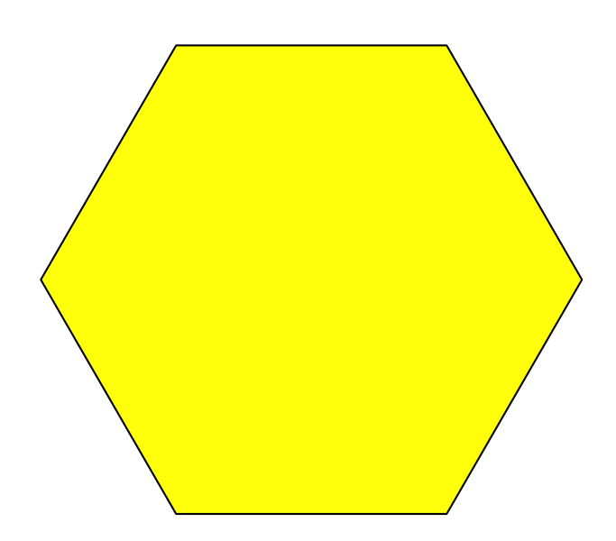
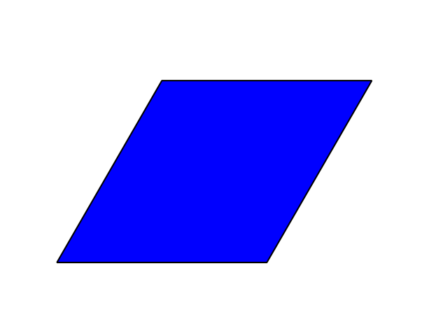
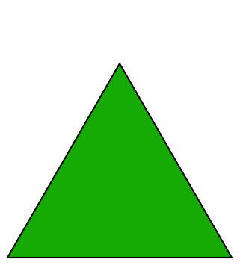
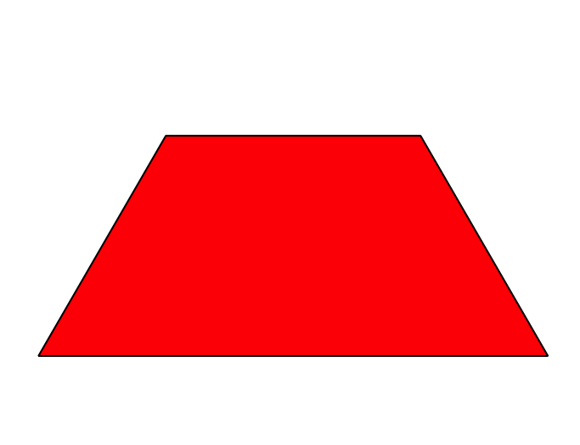
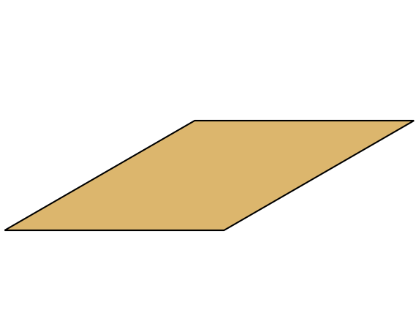

Activity Synthesis

3 Centers: Choice Time

Student Task Statement
Choose a center.
Geoblocks
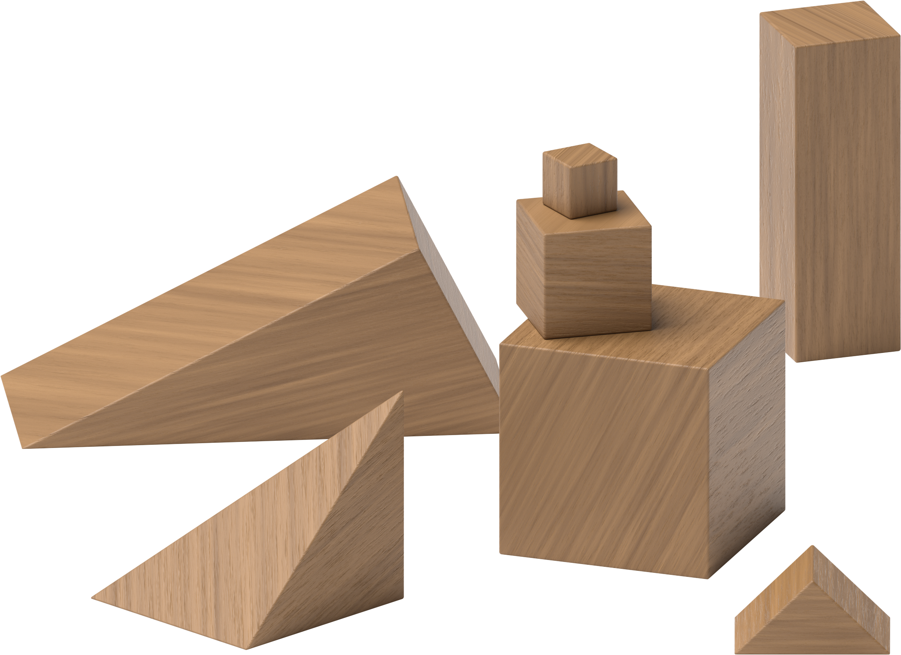
Build Shapes
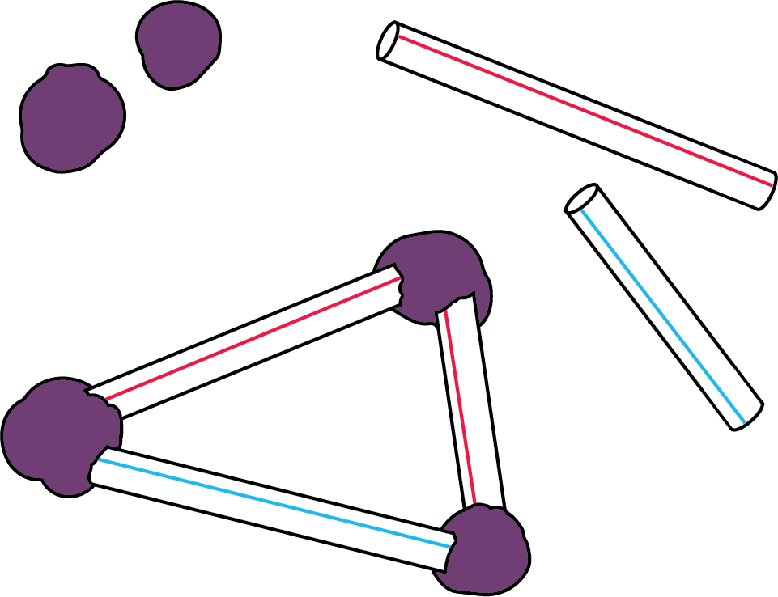
Pattern Blocks
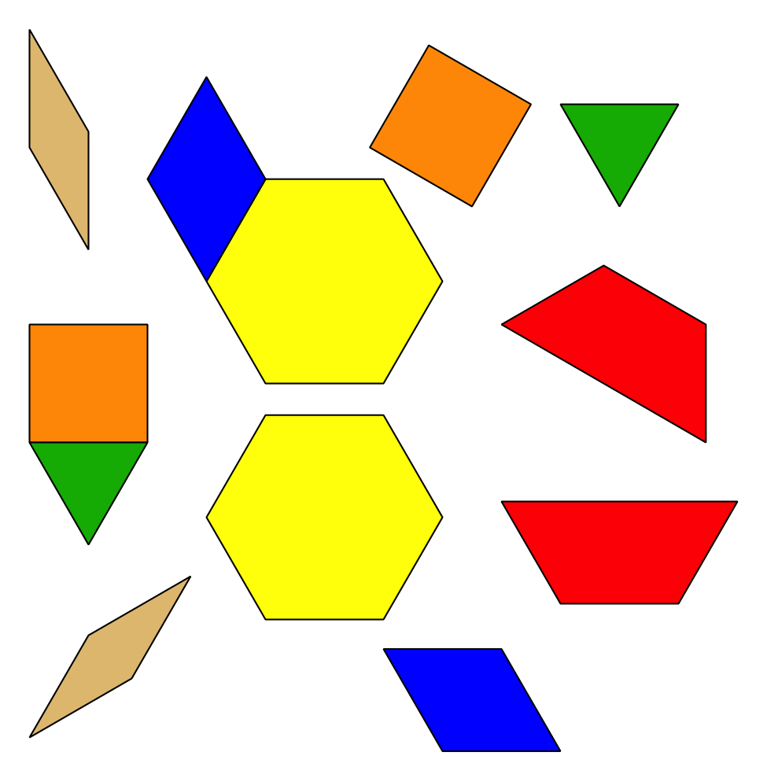
Less, Same, More
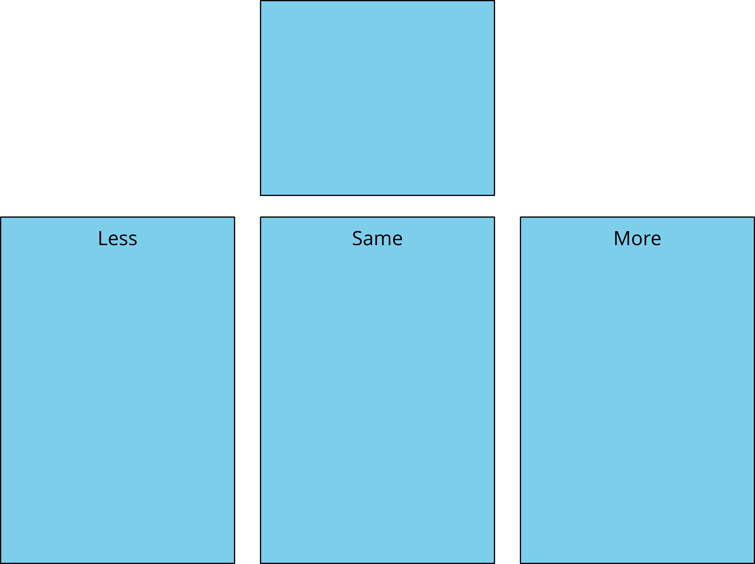

Images for Activity Synthesis
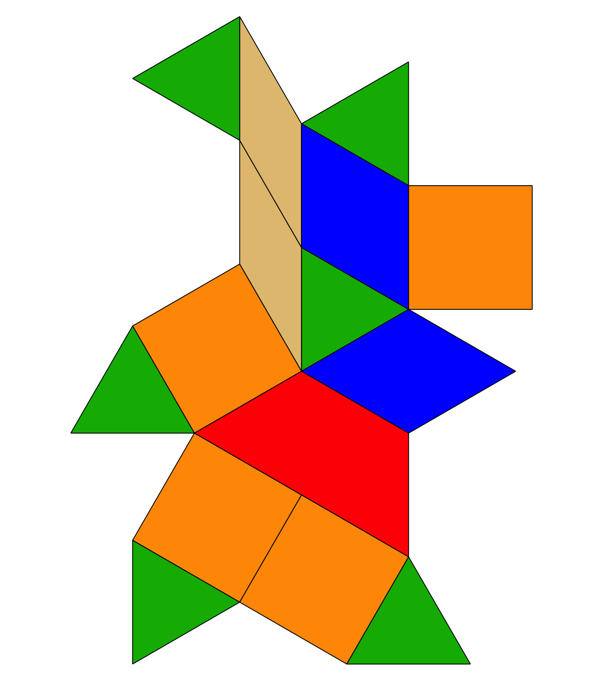
© CC BY 2021 Illustrative Mathematics®

