Lesson 15: Where Are We Eating?
- Let’s use graphical representations to compare real-world scenarios.

15.1: Estimation: Marathon Runner 2
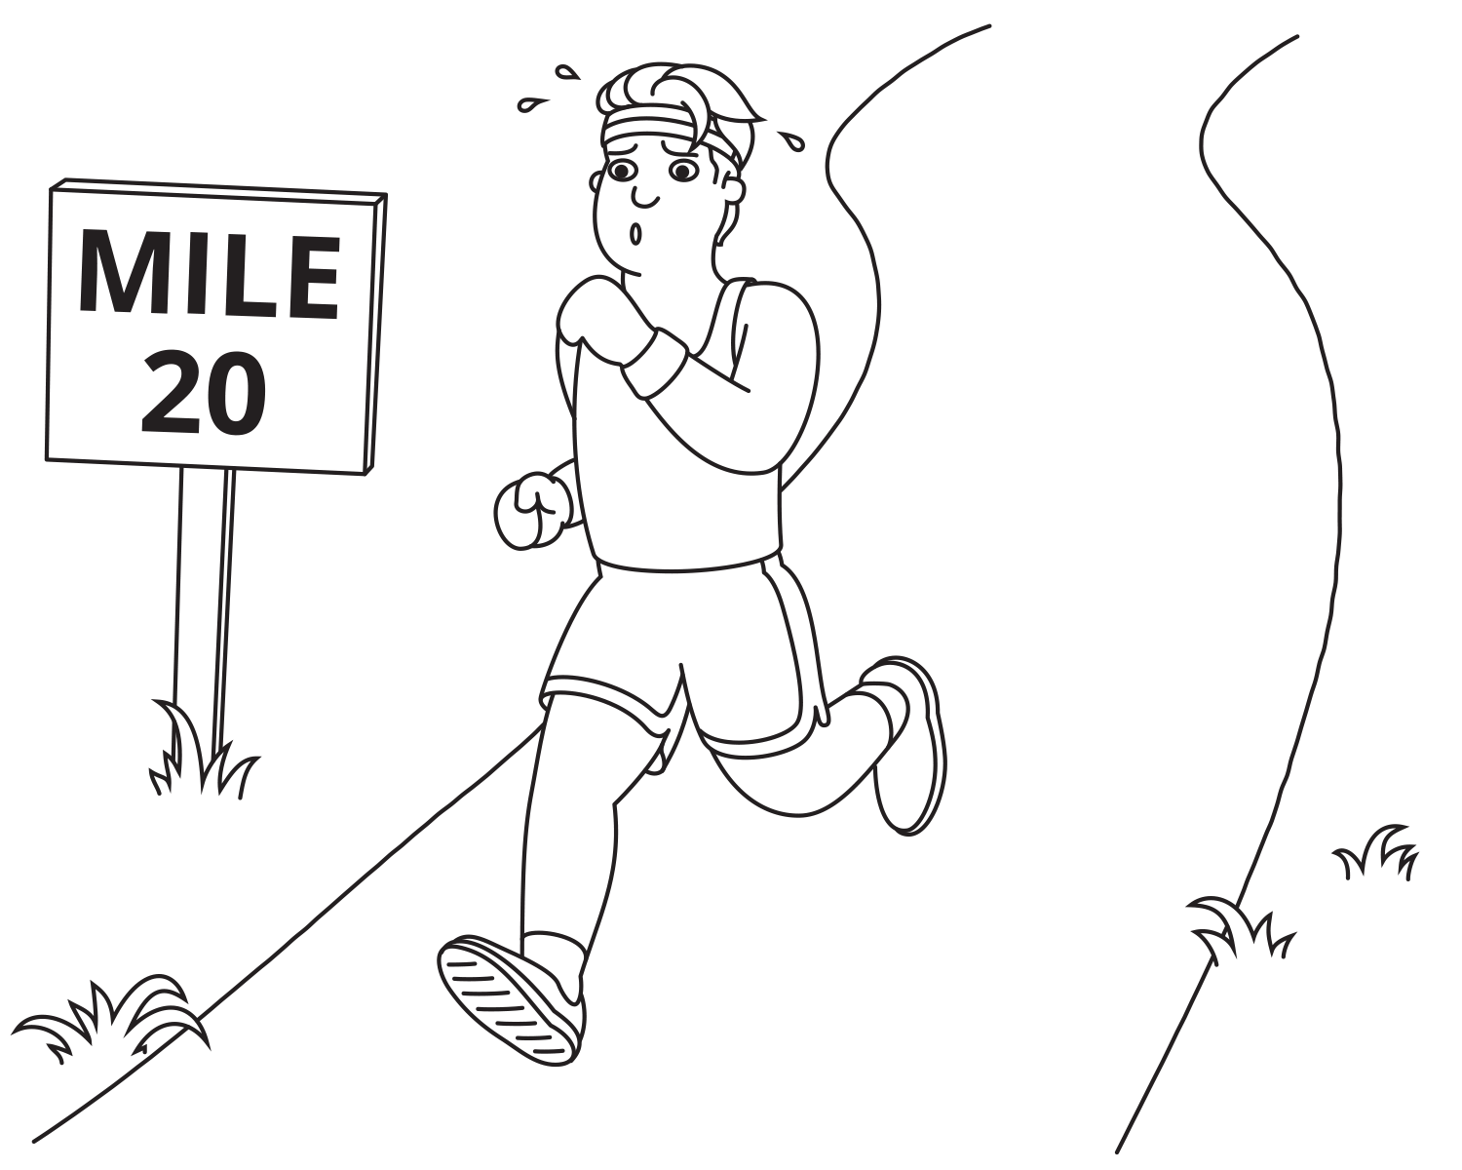
How long will it take the marathon runner to finish the marathon?
- Record an estimate that is:
- too low | - about right | - too high
- Explain your reasoning.

15.2: Groups of Runners
These distributions represent marathon times for different groups.

A
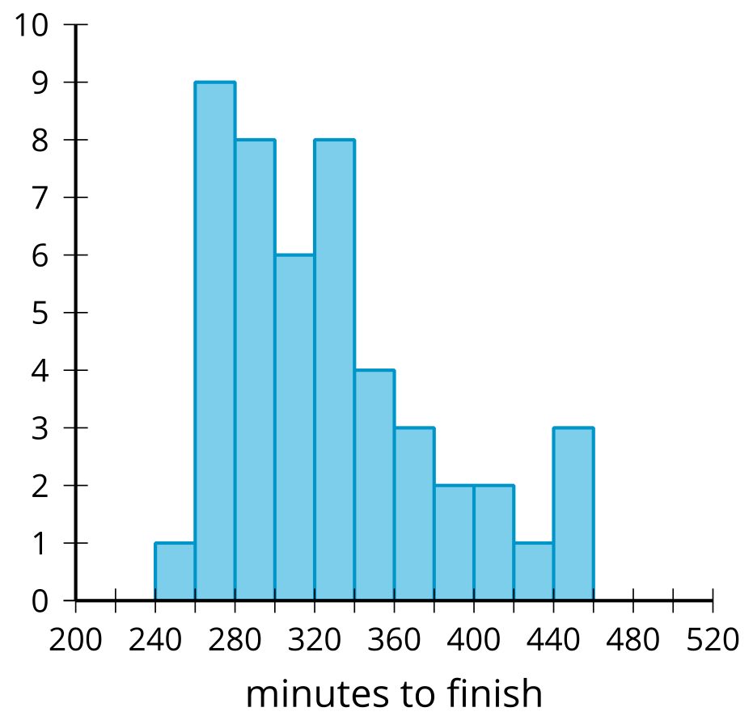

B
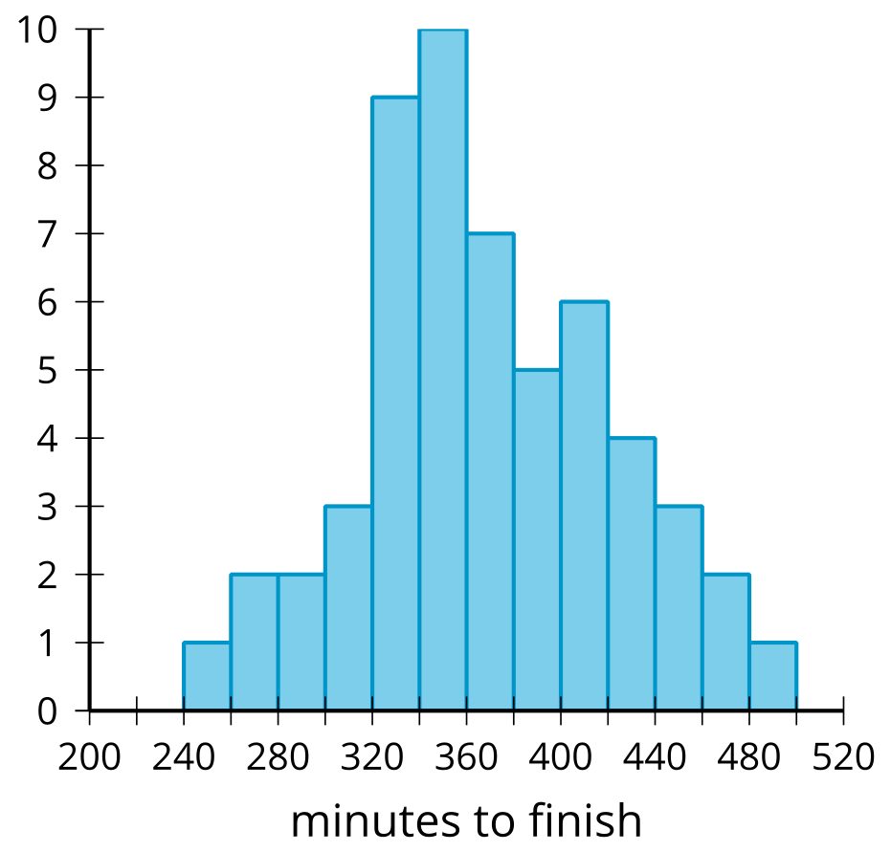

C
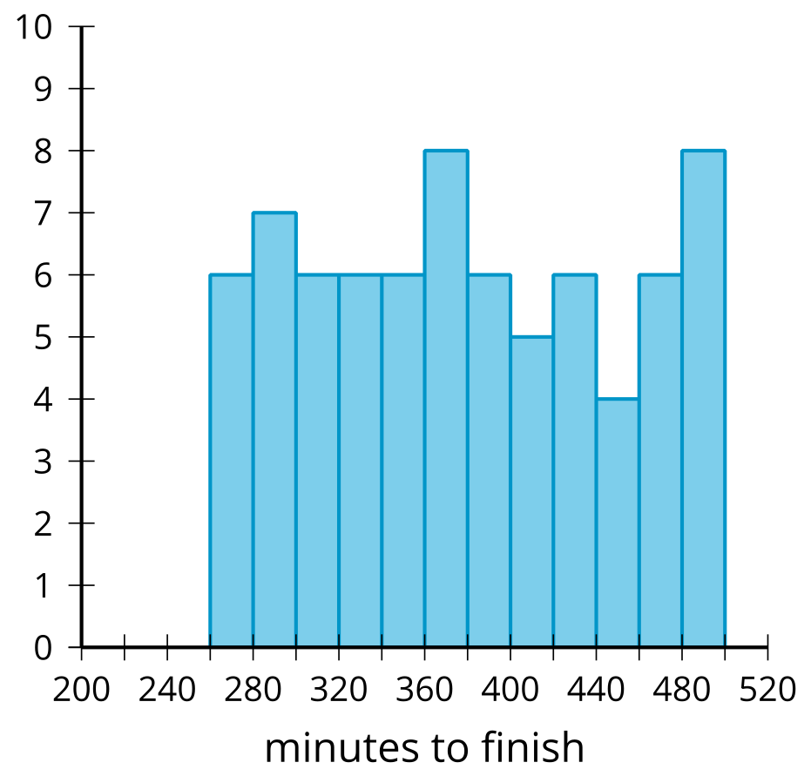
- Which display is most likely to represent the marathon times for people aged 20–30? Explain your reasoning.
- Which display is most likely to represent the marathon times for every tenth person to cross the finish line? Explain your reasoning.
- Which display is most likely to represent the marathon times for people aged 40–50? Explain your reasoning.

15.3: Where Are We Eating?
Restaurant A
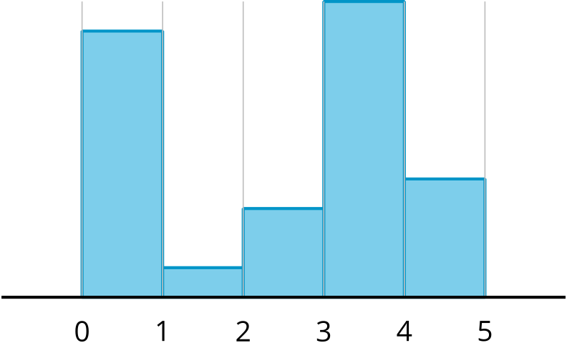
Restaurant B
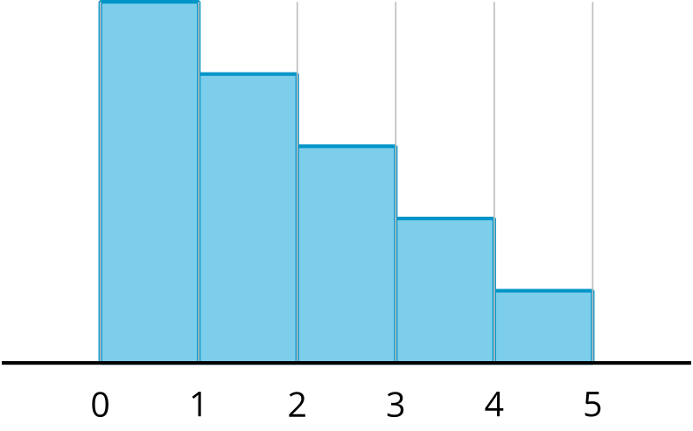
Restaurant C
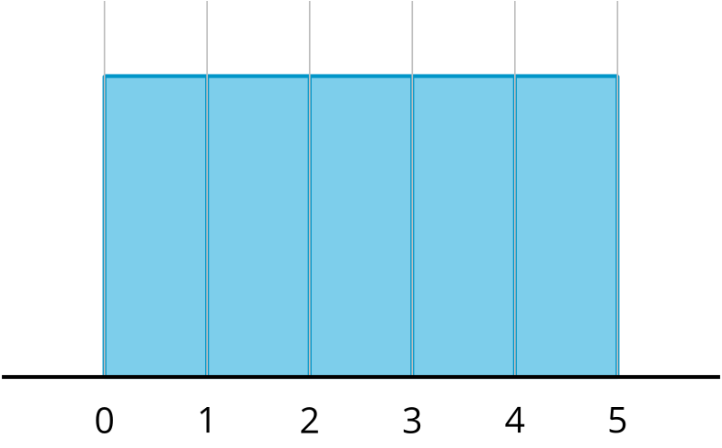
Restaurant D
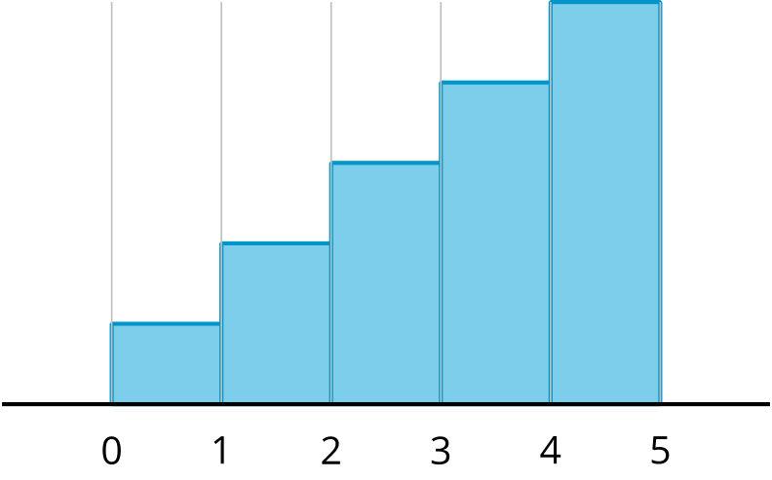
Each histogram represents the number of star ratings for a different restaurant. The ratings range from 0–4, with 0 representing a very poor experience and 4 representing an excellent experience. For each question, explain your reasoning.
- Which restaurant do reviewers like the most?
- Which restaurant do reviewers like the least?
- Which restaurant received mostly mixed reviews?
- Which restaurant would you choose to try?
© CC BY 2019 by Illustrative Mathematics®

