Lesson 11 Practice Problems
- For which of these angles is the sine negative? Select all that apply.
  - $\text{-}\frac{π}{4}$
  - $\text{-}\frac{π}{3}$
  - $\text{-}\frac{2π}{3}$
  - $\text{-}\frac{4π}{3}$
  - $\text{-}\frac{11π}{6}$
- The clock reads 3:00 p.m.
- Which of the following are true? Select all that apply.
- 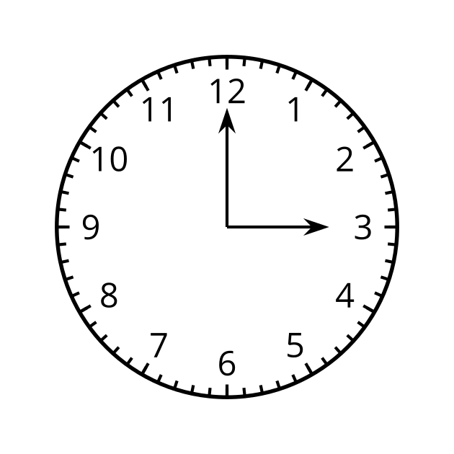
  - In the next hour, the minute hand moves through an angle of $2π$ radians.
  - In the next 5 minutes, the minute hand will move through an angle of $\text{-}\frac{π}{6}$ radians.
  - After the minute hand moves through an angle of $\text{-}π$ radians, it is 3:30 p.m.
  - When the hour hand moves through an angle of $\text{-}\frac{π}{6}$ radians, it is 4:00 p.m.
  - The angle the minute hand moves through is 12 times the angle the hour hand moves through.
- Plot each point on the unit circle.
  - $A=\left(cos\left(\text{-}\frac{π}{4}\right),sin\left(\text{-}\frac{π}{4}\right)\right)$
  - $B=\left(cos\left(2π\right),sin\left(2π\right)\right)$
  - $C=\left(cos\left(\frac{16π}{3}\right),sin\left(\frac{16π}{3}\right)\right)$
  - $D=\left(cos\left(\text{-}\frac{16π}{3}\right),sin\left(\text{-}\frac{16π}{3}\right)\right)$
- 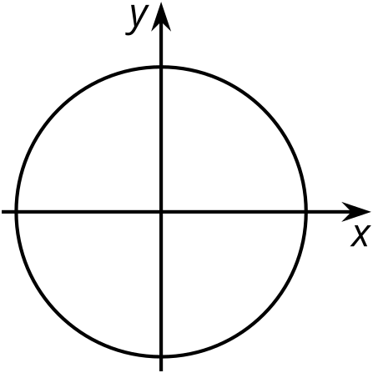
- Which of these statements are true about the function $f$ given by $f\left(θ\right)=sin\left(θ\right)$? Select all that apply.
  - The graph of $f$ meets the $θ$-axis at $0,±π,±2π,±3π,…$
  - The value of $f$ always stays the same when $π$ radians is added to the input.
  - The value of $f$ always stays the same when $2π$ radians is added to the input.
  - The value of $f$ always stays the same when $\text{-}2π$ radians is added to the input.
  - The graph of $f$ has a maximum when $θ=\frac{5π}{2}$ radians.
- Here is a unit circle with a point $P$ at $\left(1,0\right)$.
- For each positive angle of rotation of the unit circle around its center listed, indicate on the unit circle where $P$ is taken, and give a negative angle of rotation which takes $P$ to the same location.
- 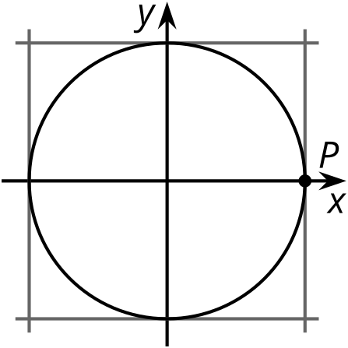
  - $A$, $\frac{π}{4}$ radians
  - $B$, $\frac{π}{2}$ radians
  - $C$, $π$ radians
  - $D$, $\frac{3π}{2}$ radians
- In which quadrant are both the sine and the tangent negative?
  - first
  - second
  - third
  - fourth
- (From Unit 6, Lesson 6.)
- Technology required. Each equation defines a function. Graph each of them to identify which are periodic. Select all that are.
  - $y=sin\left(θ\right)$
  - $y=e^{x}$
  - $y=x^{2}−2x+5$
  - $y=cos\left(θ\right)$
  - $y=3$
- (From Unit 6, Lesson 8.)
- 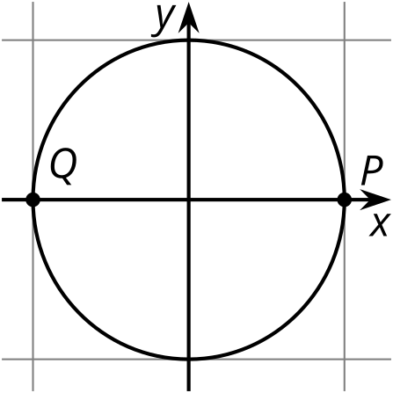
  - List three different counterclockwise angles of rotation around the center of the circle that take $P$ to $Q$.
  - Which quadrant(s) are the angles $\frac{13π}{4}$ and $\frac{10π}{3}$ radians in? Is the sine of these angles positive or negative?
- (From Unit 6, Lesson 10.)
© CC BY 2019 by Illustrative Mathematics®

