Lesson 2: Function Notation
- Let’s learn about a handy way to refer to and talk about a function.

2.1: Back to the Post!
Here are the graphs of some situations you saw before. Each graph represents the distance of a dog from a post as a function of time since the dog owner left to purchase something from a store. Distance is measured in feet and time is measured in seconds.
Day 1
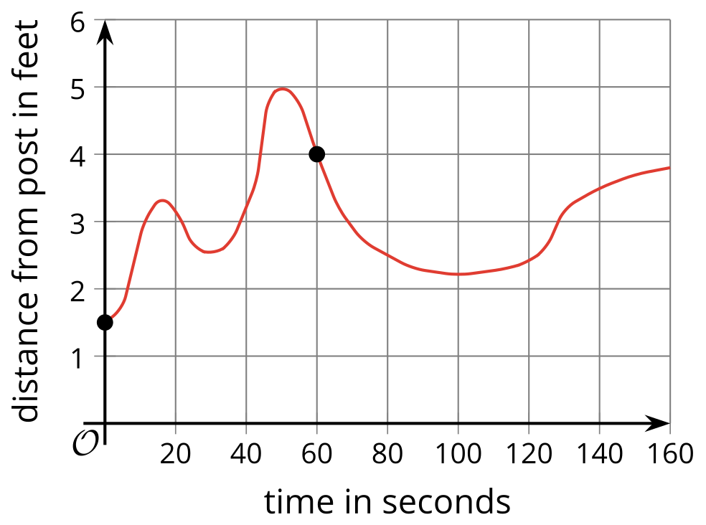
Day 2
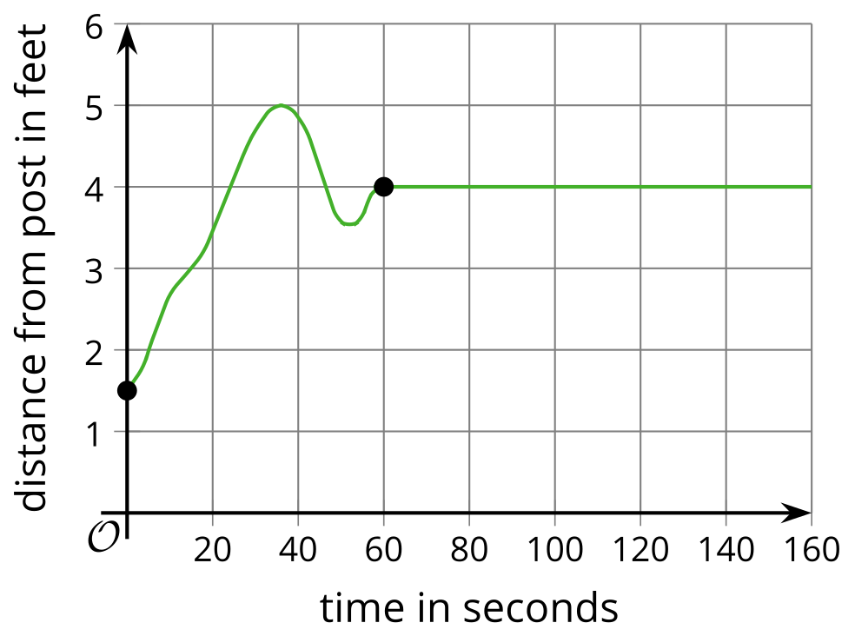
Day 3
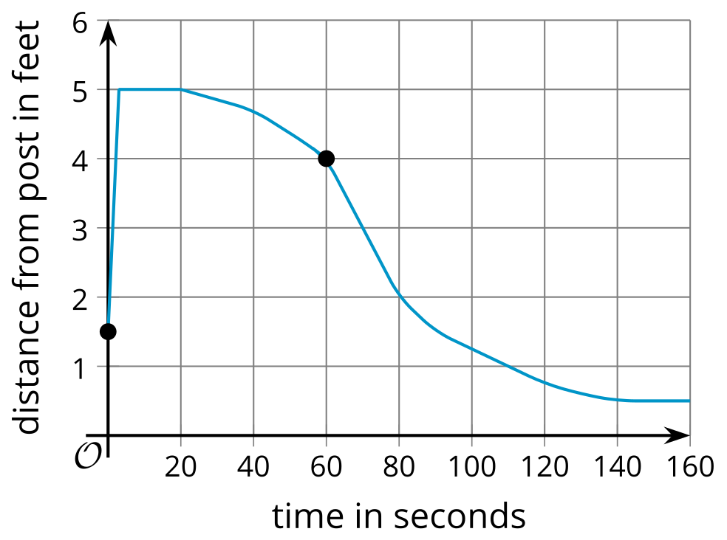
- Use the given graphs to answer these questions about each of the three days:
  - How far away was the dog from the post 60 seconds after the owner left?
  - Day 1:
  - Day 2:
  - Day 3:
  - How far away was the dog from the post when the owner left?
  - Day 1:
  - Day 2:
  - Day 3:
  - The owner returned 160 seconds after he left. How far away was the dog from the post at that time?
  - Day 1:
  - Day 2:
  - Day 3:
  - How many seconds passed before the dog reached the farthest point it could reach from the post?
  - Day 1:
  - Day 2:
  - Day 3:
- Consider the statement, “The dog was 2 feet away from the post after 80 seconds.” Do you agree with the statement?
- What was the distance of the dog from the post 100 seconds after the owner left?

2.2: A Handy Notation
Let’s name the functions that relate the dog’s distance from the post and the time since its owner left: function $f$ for Day 1, function $g$ for Day 2, function $h$ for Day 3. The input of each function is time in seconds, $t$.
- Use function notation to complete the table.
 | - day 1 | - day 2 | - day 3
- a. distance from post 60 seconds after the owner left
- b. distance from post when the owner left
- c. distance from post 150 seconds after the owner left
- Describe what each expression represents in this context:
  - $f\left(15\right)$
  - $g\left(48\right)$
  - $h\left(t\right)$
- The equation $g\left(120\right)=4$ can be interpreted to mean: “On Day 2, 120 seconds after the dog owner left, the dog was 4 feet from the post.”
- What does each equation mean in this situation?
  - $h\left(40\right)=4.6$
  - $f\left(t\right)=5$
  - $g\left(t\right)=d$

2.3: Birthdays
Rule $B$ takes a person’s name as its input, and gives their birthday as the output.
input | output
Abraham Lincoln | February 12
Rule $P$ takes a date as its input and gives a person with that birthday as the output.
input | output
August 26 | Katherine Johnson
- Complete each table with three more examples of input-output pairs.
- If you use your name as the input to $B$, how many outputs are possible? Explain how you know.
- If you use your birthday as the input to $P$, how many outputs are possible? Explain how you know.
- Only one of the two relationships is a function. The other is not a function. Which one is which? Explain how you know.
- For the relationship that is a function, write two input-output pairs from the table using function notation.

Are you ready for more?
- Write a rule that describes these input-output pairs:
- $F\left(\text{ONE}\right)=3$
- $F\left(\text{TWO}\right)=3$
- $F\left(\text{THREE}\right)=5$
- $F\left(\text{FOUR}\right)=4$
- Here are some input-output pairs with the same inputs but different outputs:
- $v\left(\text{ONE}\right)=2$
- $v\left(\text{TWO}\right)=1$
- $v\left(\text{THREE}\right)=2$
- $v\left(\text{FOUR}\right)=2$
- What rule could define function $v$?

Lesson 2 Summary
Here are graphs of two functions, each representing the cost of riding in a taxi from two companies—Friendly Rides and Great Cabs.
For each taxi, the cost of a ride is a function of the distance traveled. The input is distance in miles, and the output is cost in dollars.
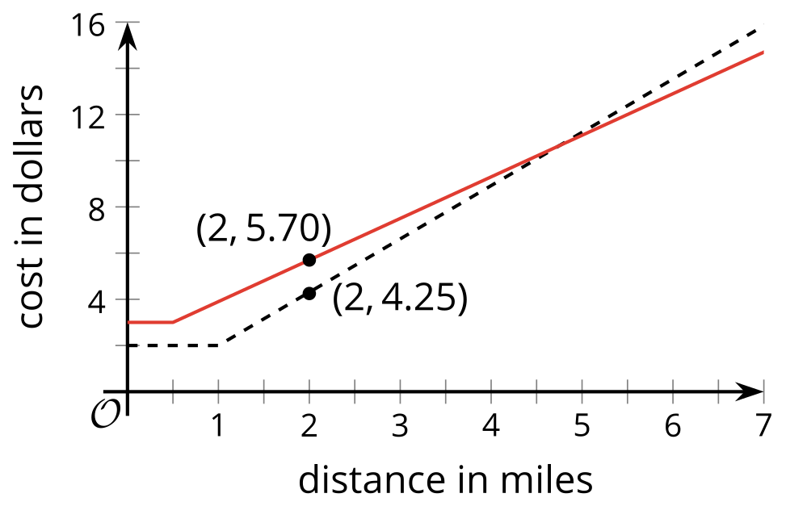
- The point $\left(2,5.70\right)$ on one graph tells us the cost of riding a Friendly Rides taxi for 2 miles.
- The point $\left(2,4.25\right)$ on the other graph tells us the cost of riding a Great Cabs taxi for 2 miles.
We can convey the same information much more efficiently by naming each function and using function notation to specify the input and the output.
- Let’s name the function for Friendly Rides function $f$.
- Let's name the function for Great Cabs function $g$.
- To refer to the cost of riding each taxi for 2 miles, we can write: $f\left(2\right)$ and $g\left(2\right)$.
- To say that a 2-mile trip with Friendly Rides will cost $5.70, we can write $f\left(2\right)=5.70$.
- To say that a 2-mile trip with Great Cabs will cost $4.25, we can write $g\left(2\right)=4.25$.
In general, function notation has this form:
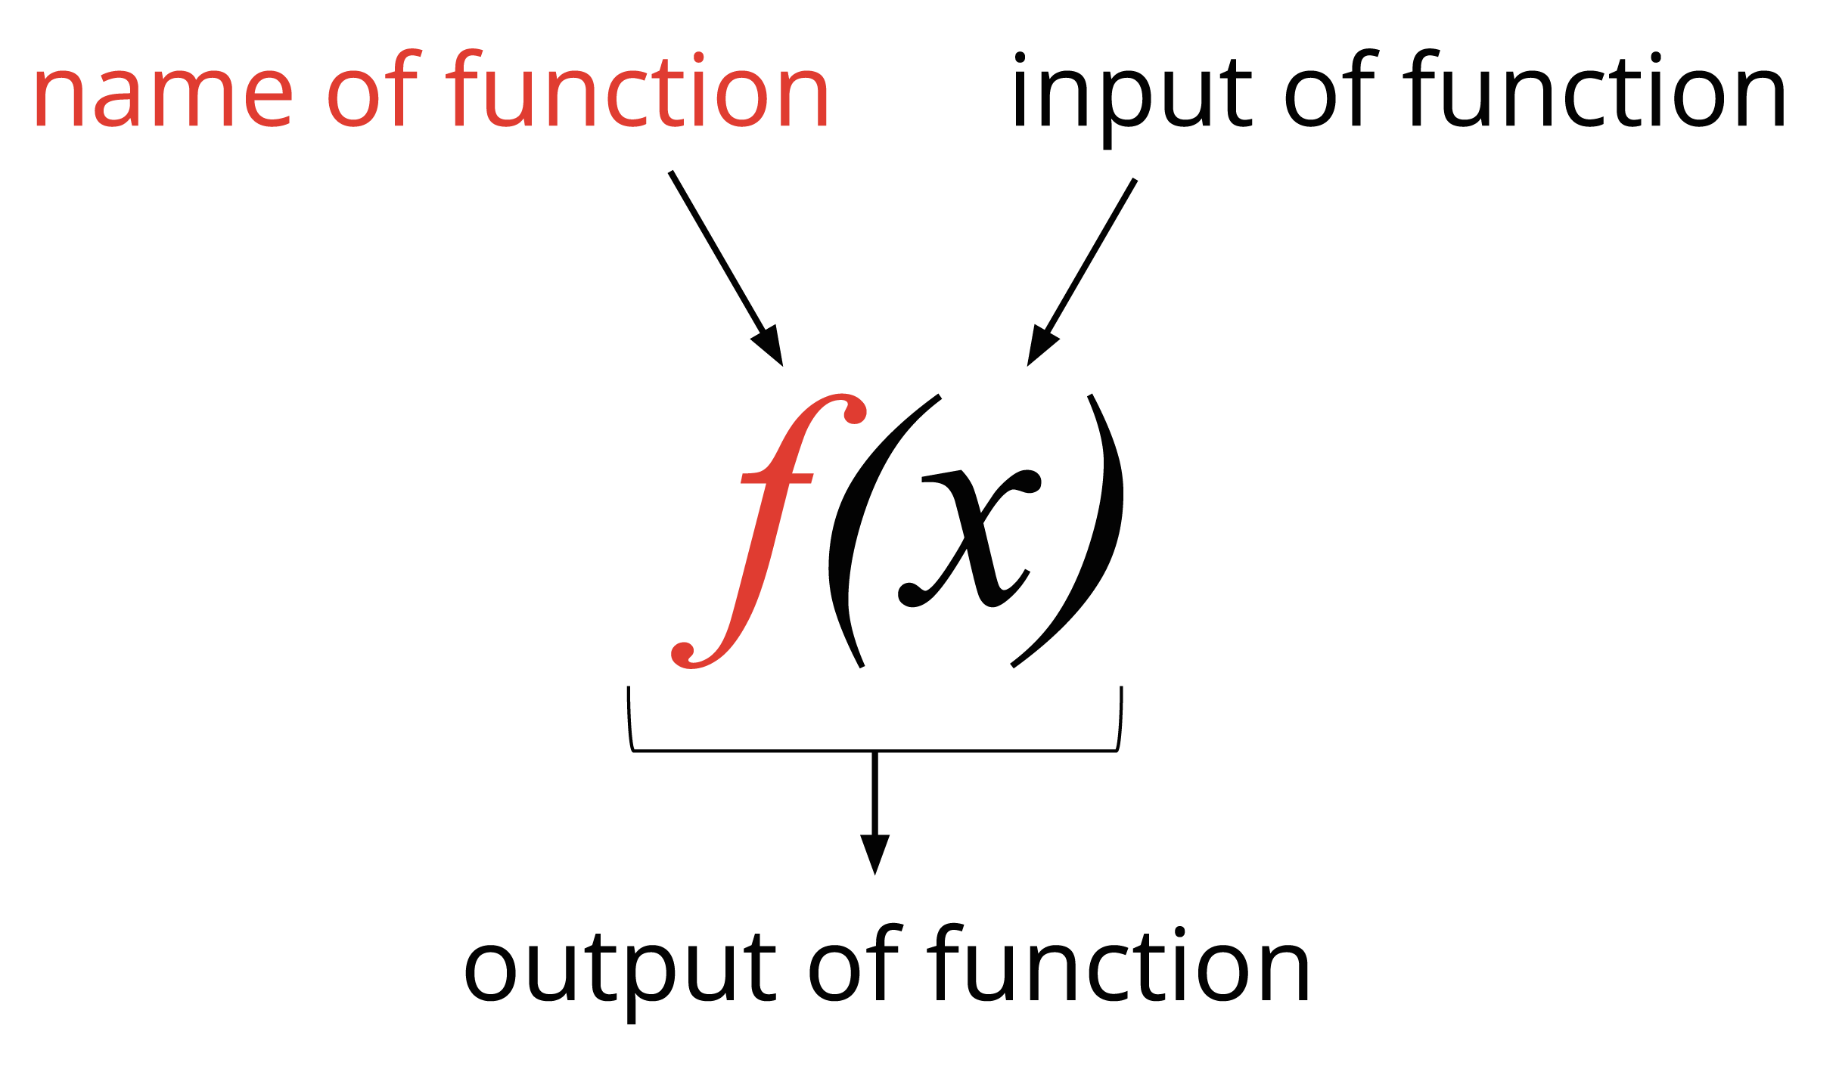
It is read “$f$ of $x$” and can be interpreted to mean: $f\left(x\right)$ is the output of a function $f$ when $x$ is the input.
The function notation is a concise way to refer to a function and describe its input and output, which can be very useful. Throughout this unit and the course, we will use function notation to talk about functions.
© CC BY 2019 by Illustrative Mathematics®

