Unit 1 Lesson 12: Lots and Lots of Garbage

WU Notice and Wonder: Garbage Truck (Warm up)

Student Task Statement
What do you notice? What do you wonder?
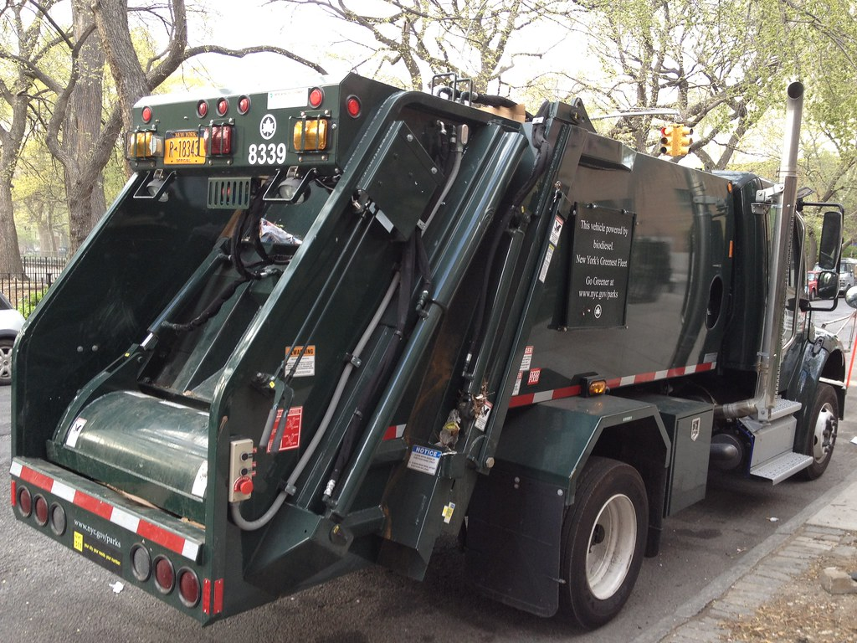

1 60 Containers

Images for Launch
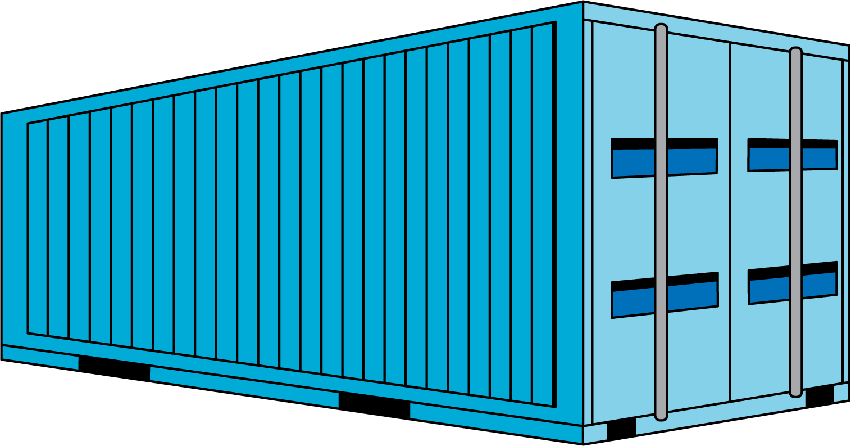

Student Task Statement
- Find at least 5 different ways to arrange 60 containers. Represent each arrangement with an expression.
- Create a visual display to show which is the best arrangement for shipping the 3,300 tons of garbage.

2 How Many Containers on the Ship?

Student Task Statement
- How many containers are on the cargo ship?
- Record an estimate that is:
- too low | - about right | - too high
- How many containers are on the cargo ship?
- Record an estimate that is:
- too low | - about right | - too high
- What assumptions were you making when you came up with your estimates?
© CC BY 2021 Illustrative Mathematics®

