Unit 5 Lesson 10: Place Value Comparisons (Part 1)

WU Number Talk: Add Tens (Warm up)

Student Task Statement
Find the value of each expression mentally.
- $36+40$
- $46+30$
- $59+40$
- $69+30$

1 Compare by Place

Student Task Statement
Who has more? How do you know?
Mai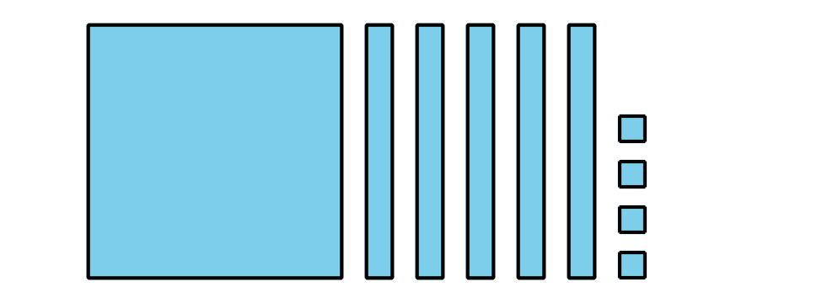
Tyler
Compare the base-ten diagrams.
Write each value as a three-digit number. Use the symbols $<$, $>$, or $=$ to compare the numbers.
- 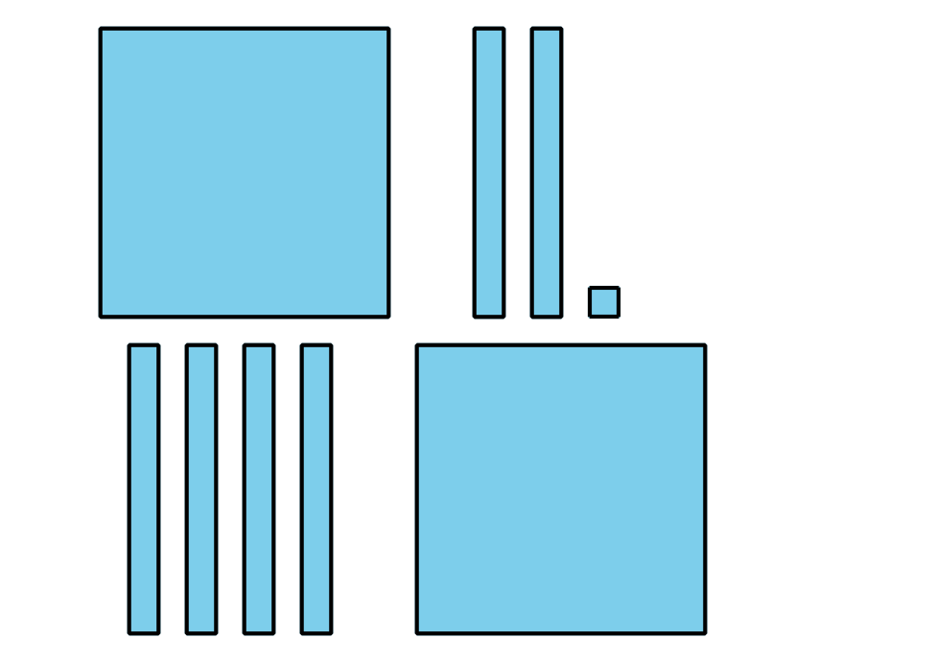
- 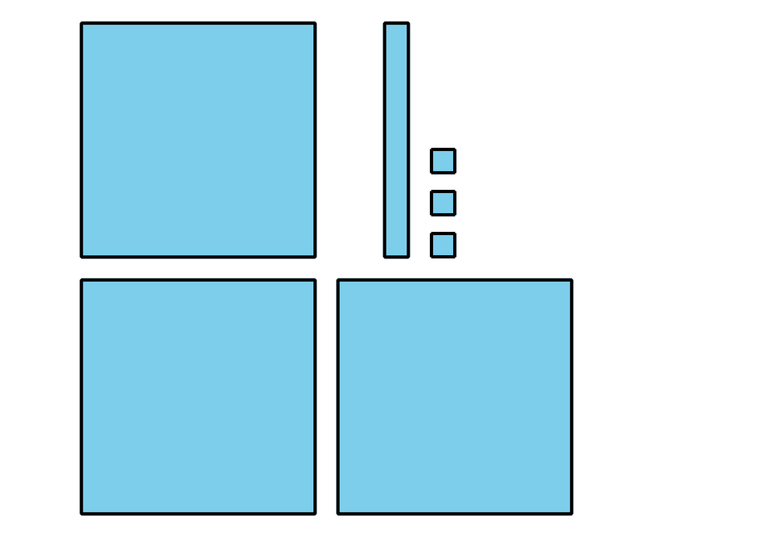
- _3333 _
- 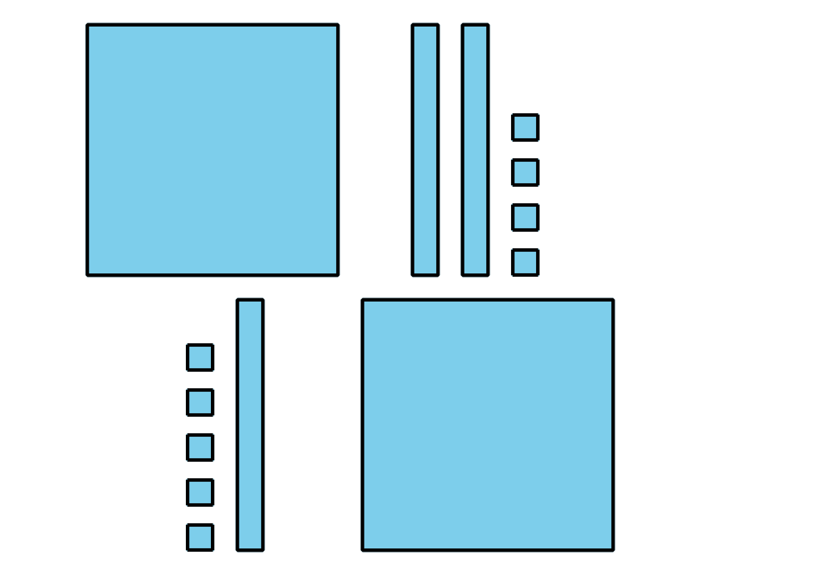
- _3333 _
- 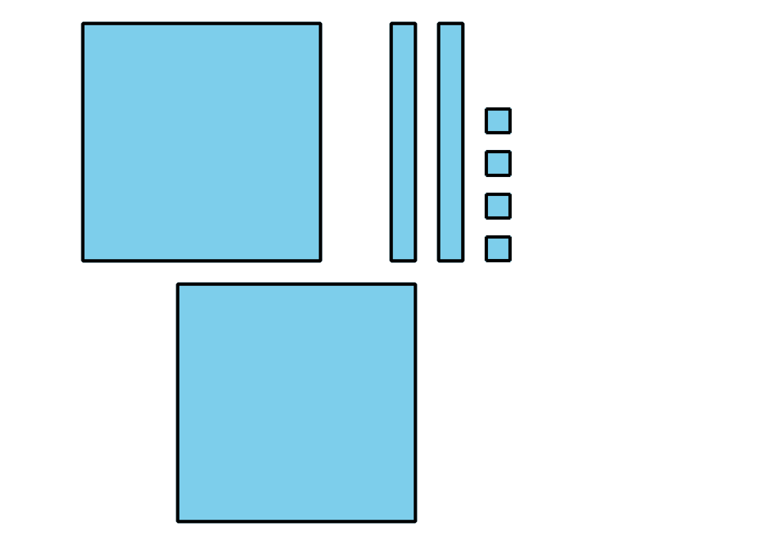
- 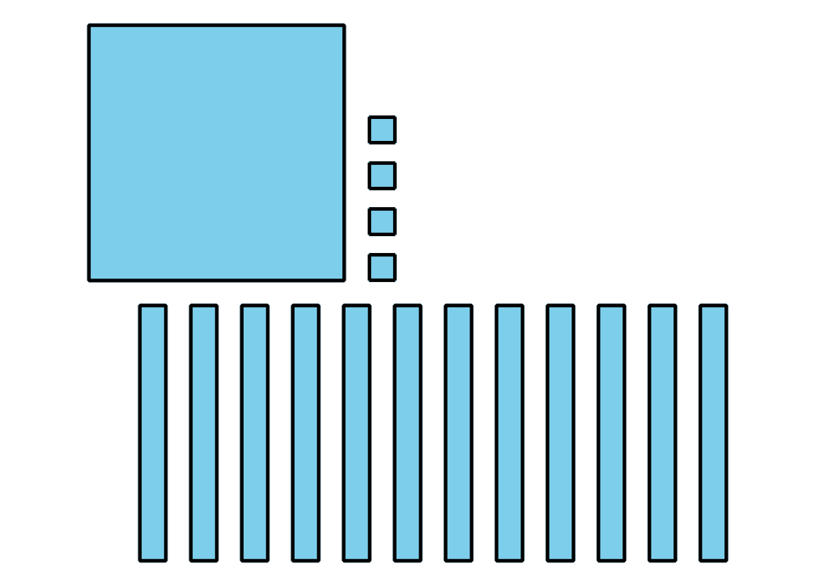
- _3333 _
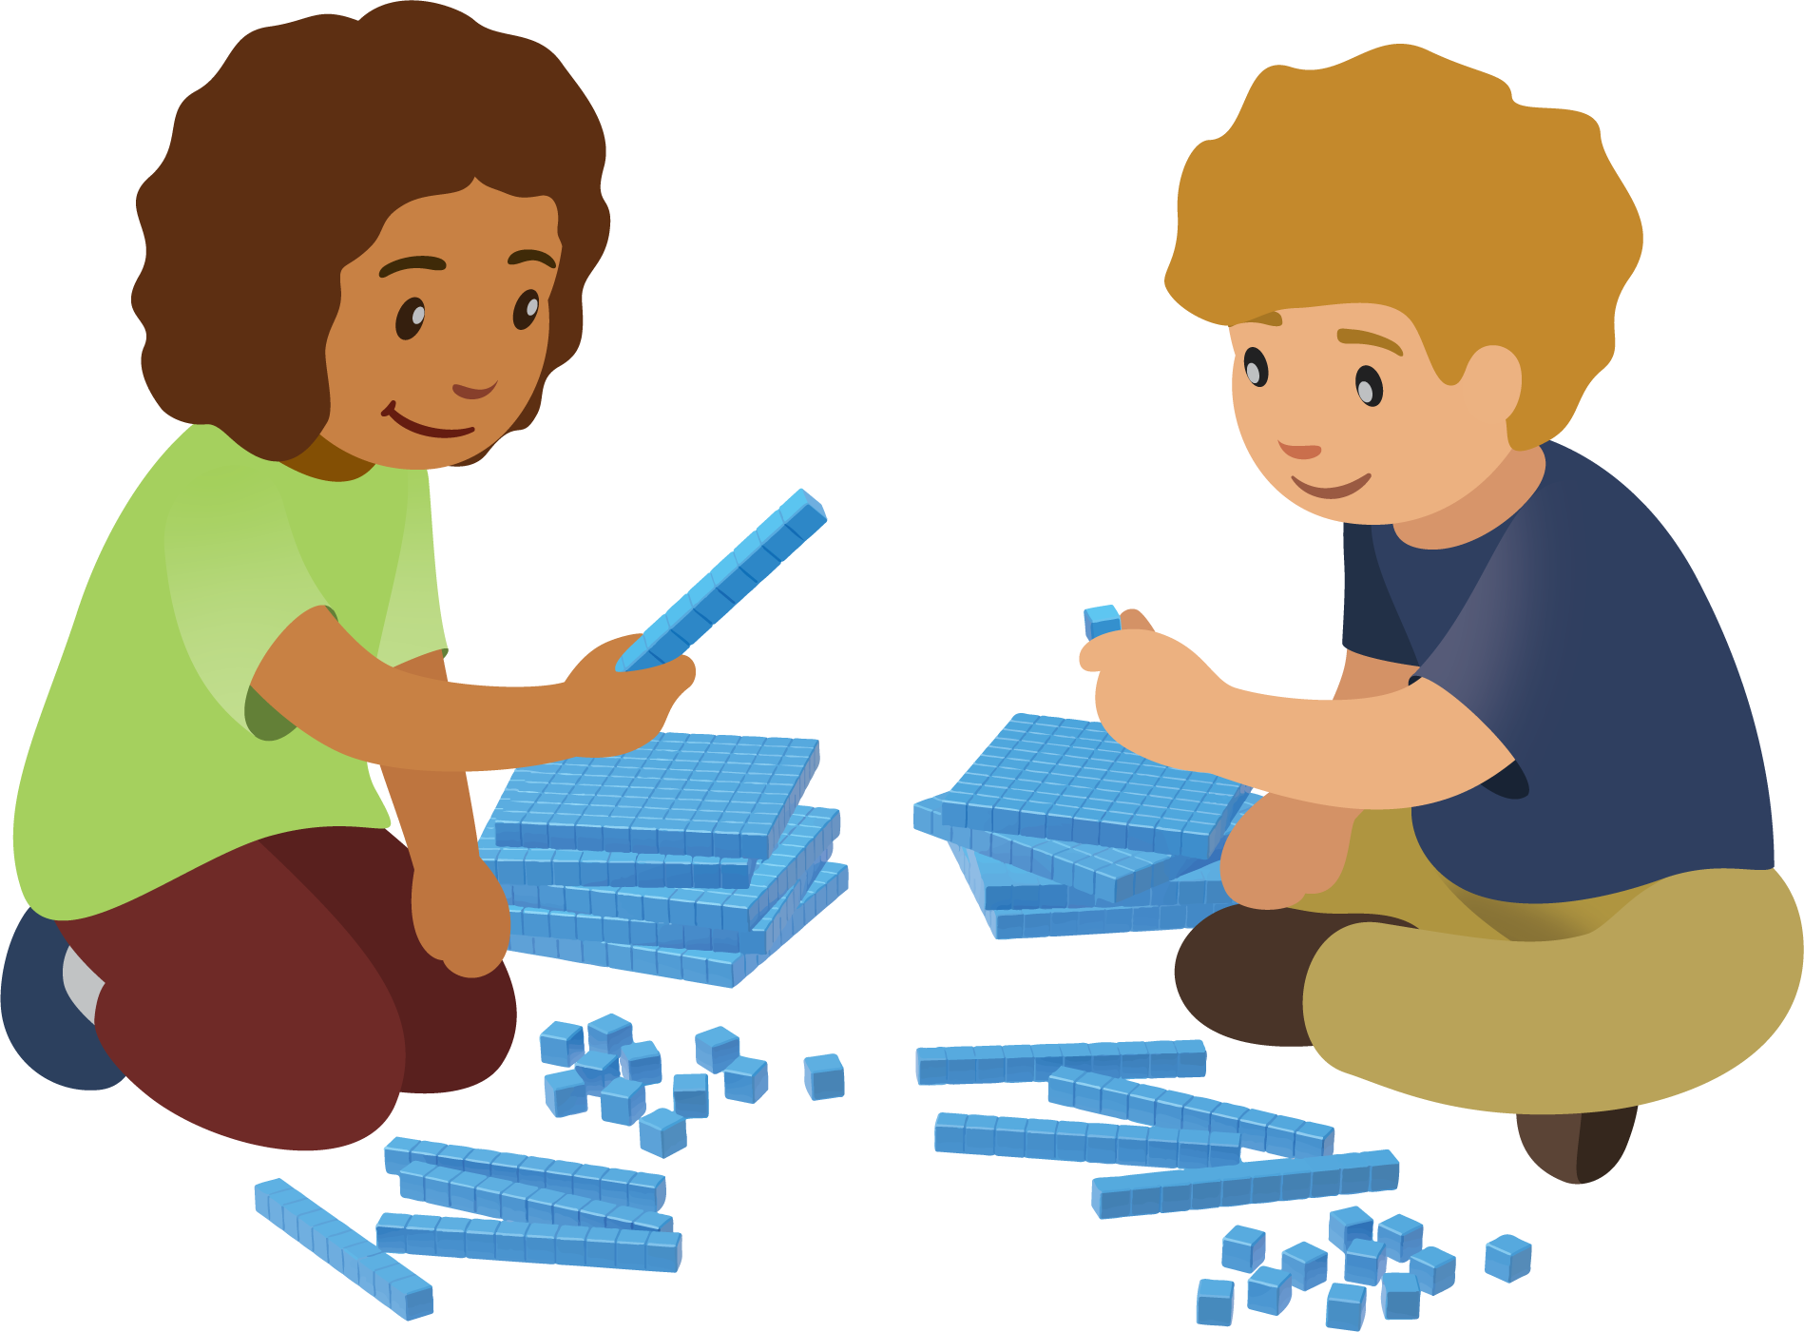

2 Compare Hundreds, Tens, and Ones

Student Task Statement
Compare the base-ten diagrams. Write each value as a three-digit number. Use the symbols $>$, $<$, or $=$ to compare the numbers.
- 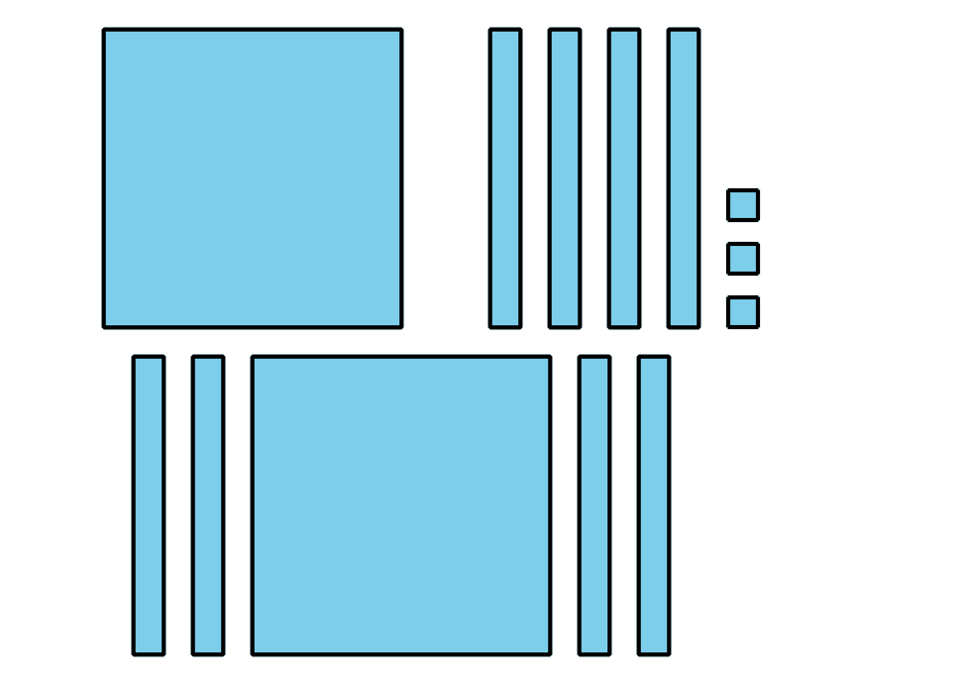
- 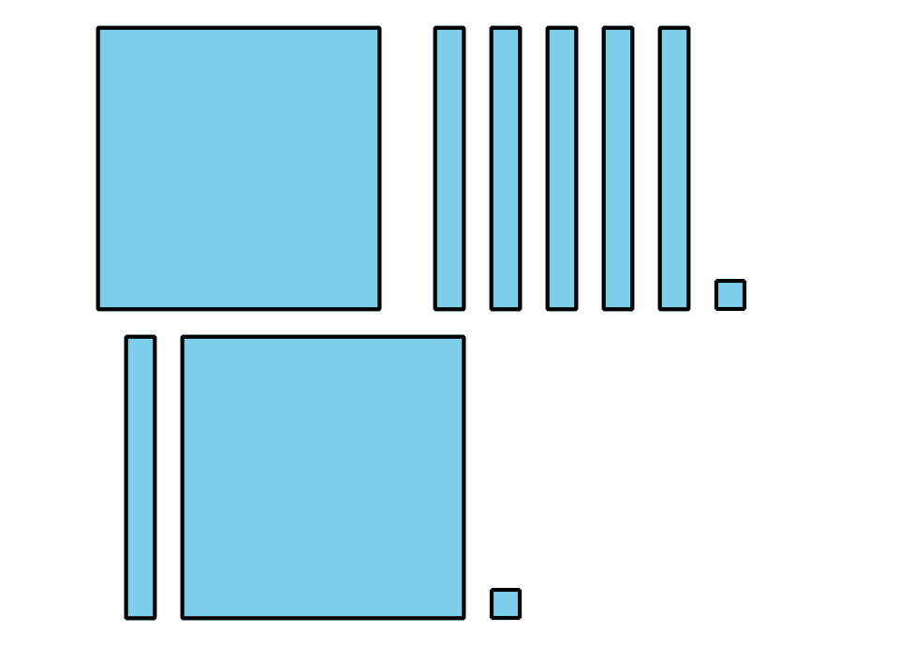
- _3333 _
- 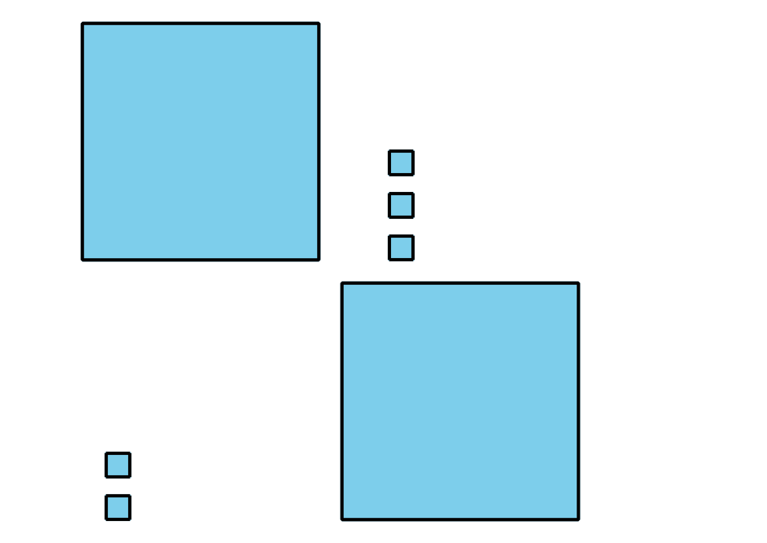
- 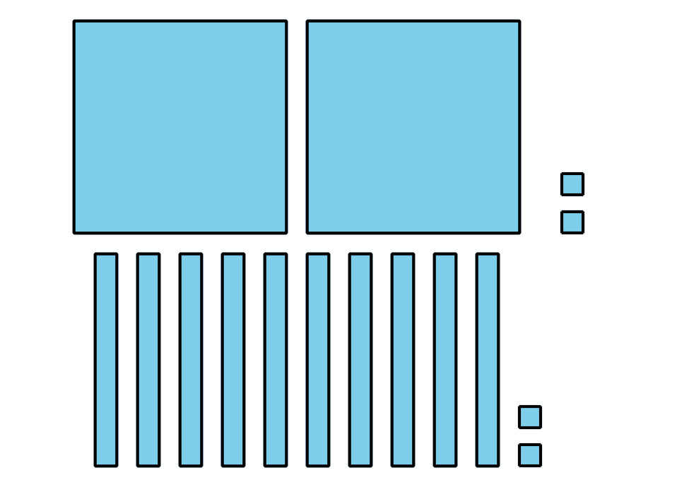
- _3333 _
- 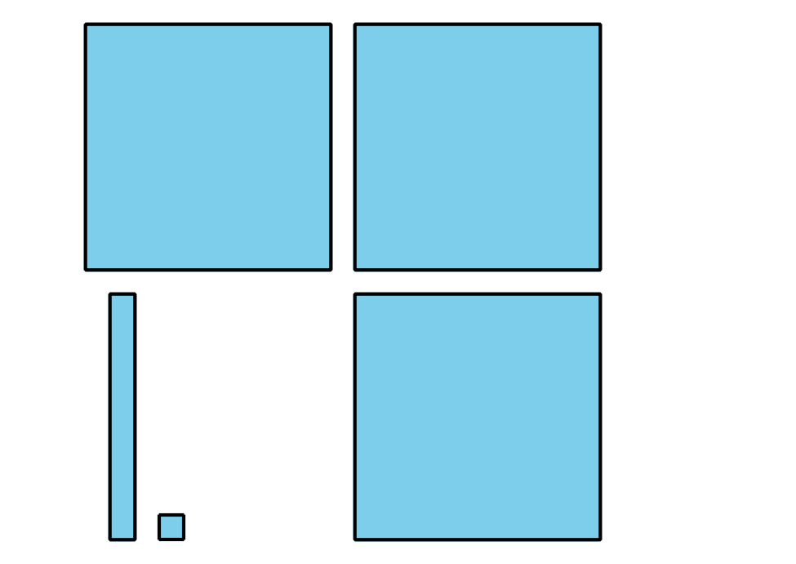
- 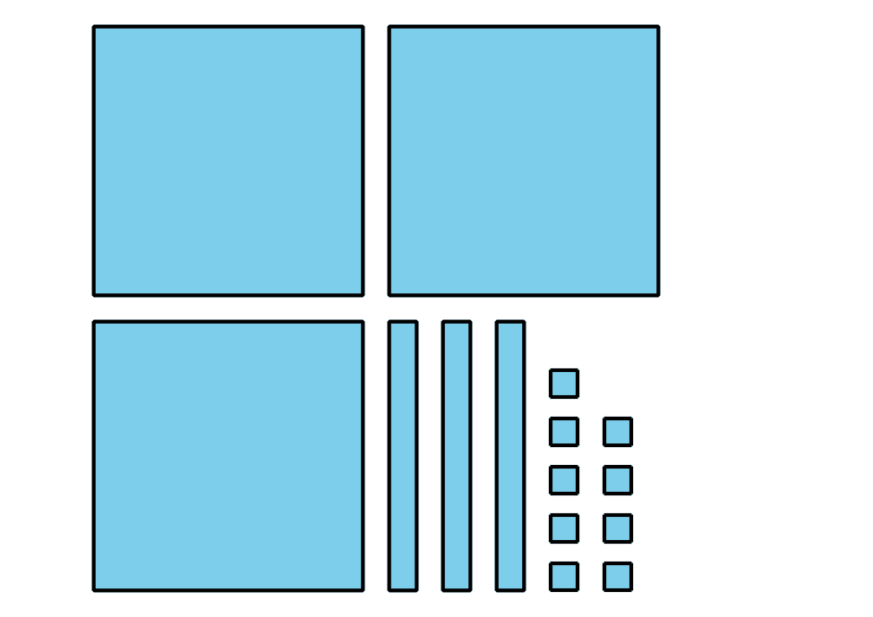
- _3333 _
- 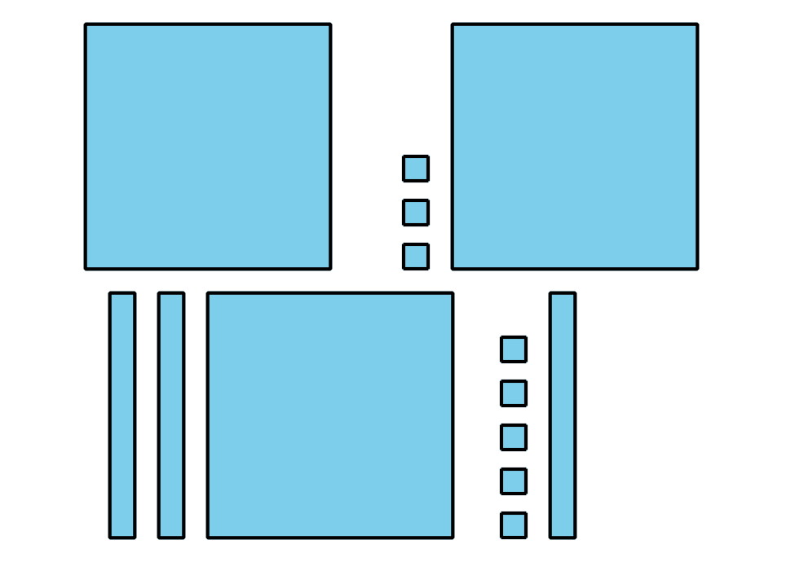
- 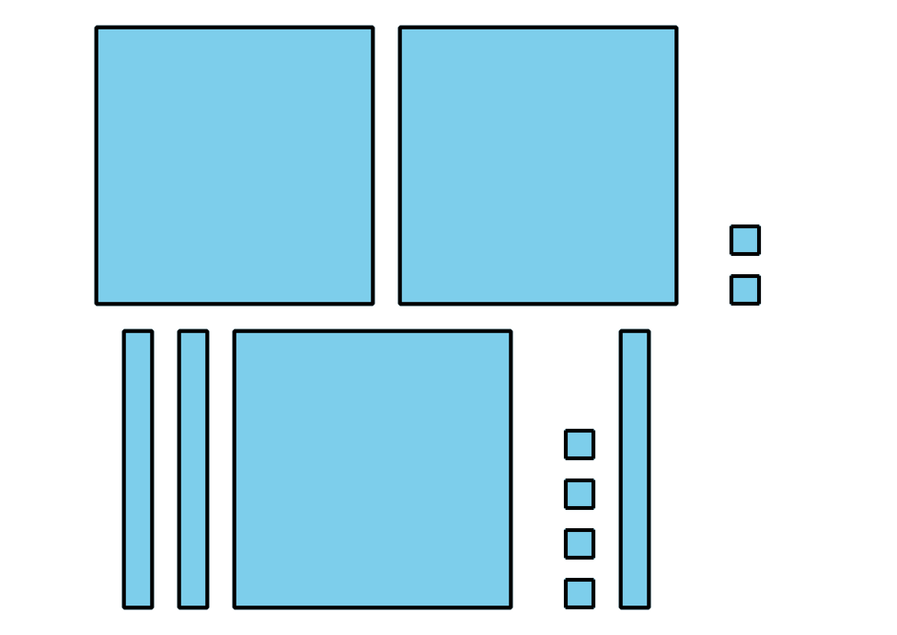
- _3333 _
- In the last problem, how do you know which value was greater?

Images for Activity Synthesis
Mai
Tyler
© CC BY 2021 Illustrative Mathematics®

