Lesson 28: Around the Room
- Let’s write addition and subtraction story problems.

Warm-up: Notice and Wonder: Counting Things in the Classroom
What do you notice?
What do you wonder?
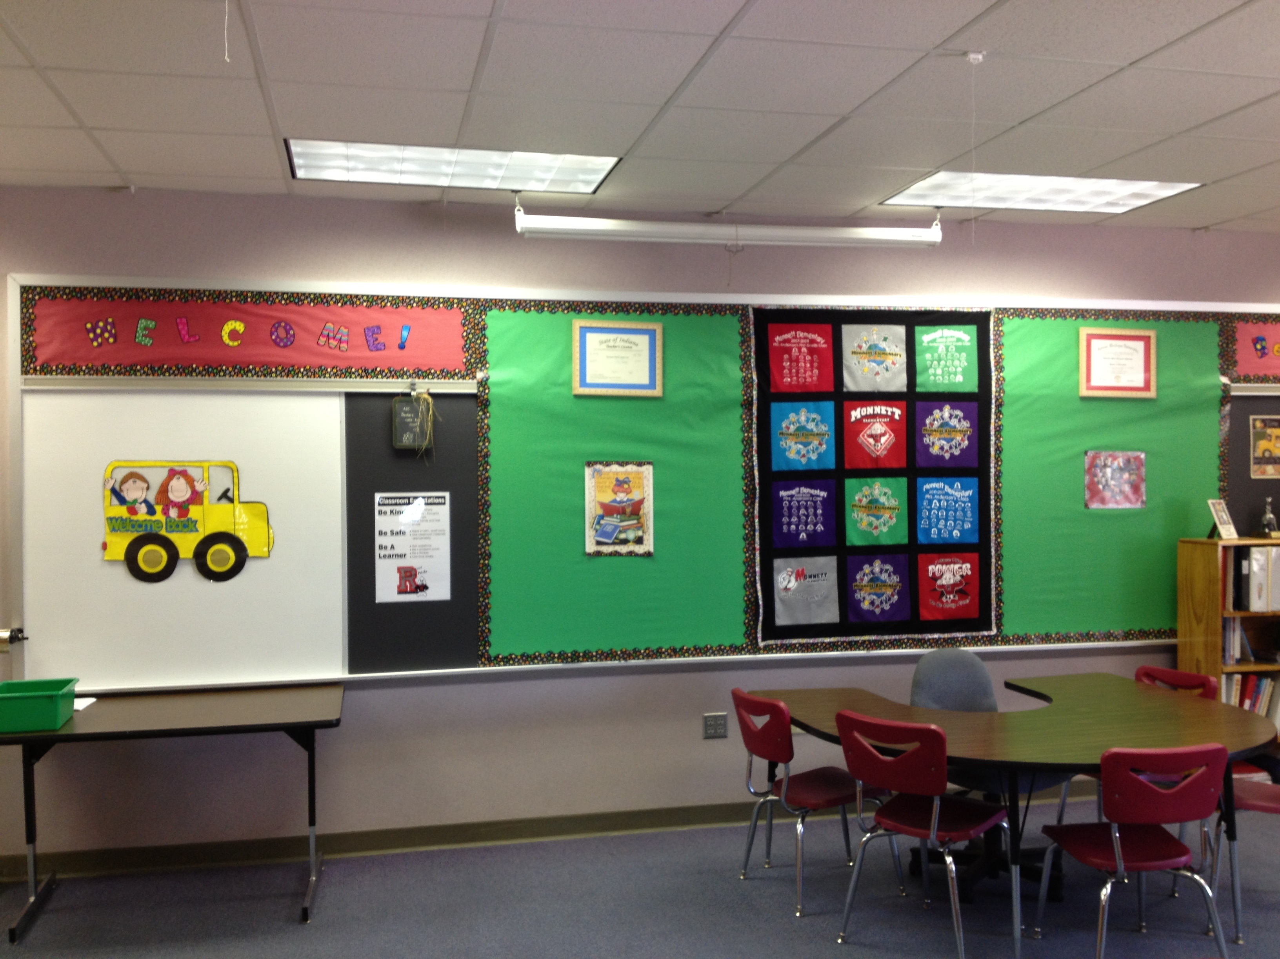

28.1: Writing Classroom Story Problems
Noah had 8 pencils.
Elena had 5 pencils.
Han had 4 pencils.
- Addition story problem:
- Solve the story problem.
Show your thinking using drawings, numbers, or words.
- Equation: ________________________________
- Subtraction story problem:
- Solve the story problem.
Show your thinking using drawings, numbers, or words.
- Equation: ________________________________

28.3: Poster Gallery Walk
Let’s solve our classmates’ story problems.
- Solve the story problem using drawings, numbers, or words.
- Equation: ________________________________
- Solve the story problem using drawings, numbers, or words.
- Equation: ________________________________
- Solve the story problem using drawings, numbers, or words.
- Equation: ________________________________
- Solve the story problem using drawings, numbers, or words.
- Equation: ________________________________
© CC BY 2021 Illustrative Mathematics®

