Unit 6 Lesson 12: Compare Measurements

WU Notice and Wonder: 6, 8, and 14 (Warm up)

Student Task Statement
What do you notice?
What do you wonder?
$6+8=14$
$8+6=14$
$14−6=8$
14−8=aaaiaaai

1 Friendship Bracelets

Student Task Statement
Priya and Han are comparing the lengths of their friendship bracelets.
Han’s bracelet is 14 cubes long.
The length of Priya’s bracelet is 4 cubes fewer than Han’s bracelet.
How long is Priya’s bracelet?
Show your thinking using drawings, numbers, or words.
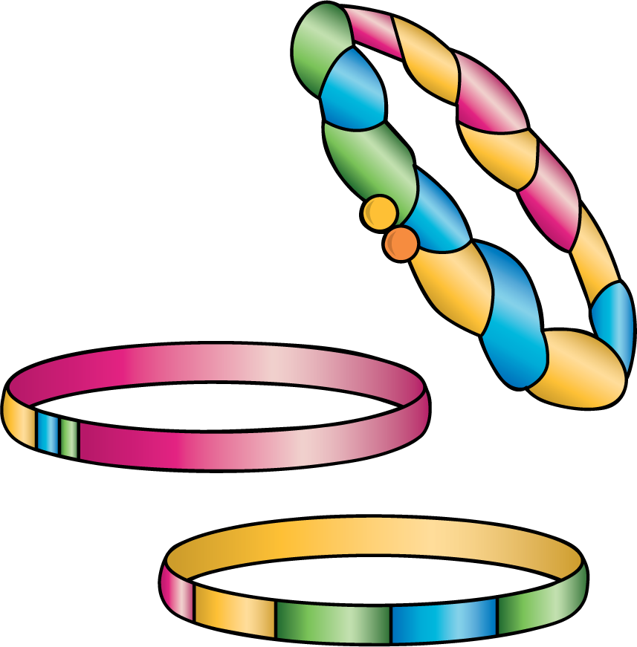

2 Same Bracelets, Different Story

Student Task Statement
Han’s bracelet is 4 cubes longer than Priya’s bracelet.
Priya’s bracelet is 10 cubes long.
How long is Han’s bracelet?
Show your thinking using drawings, numbers, or words.

3 Introduce Write Numbers, Numbers to 120 by 1

Student Task Statement
© CC BY 2021 Illustrative Mathematics®

