Unit 3 Lesson 10: The Numbers in Subtraction

WU Number Talk: Groups of Twelfths (Warm up)

Student Task Statement
Find the value of each expression mentally.
- $2×\frac{3}{12}$
- $6×\frac{3}{12}$
- $12×\frac{3}{12}$
- $12×\frac{30}{12}$

1 What’s Left?

Student Task Statement
- A pitcher contains 3 cups of watermelon juice.
- How many cups will be left in the pitcher if we pour each of the following amounts from the full amount?
- 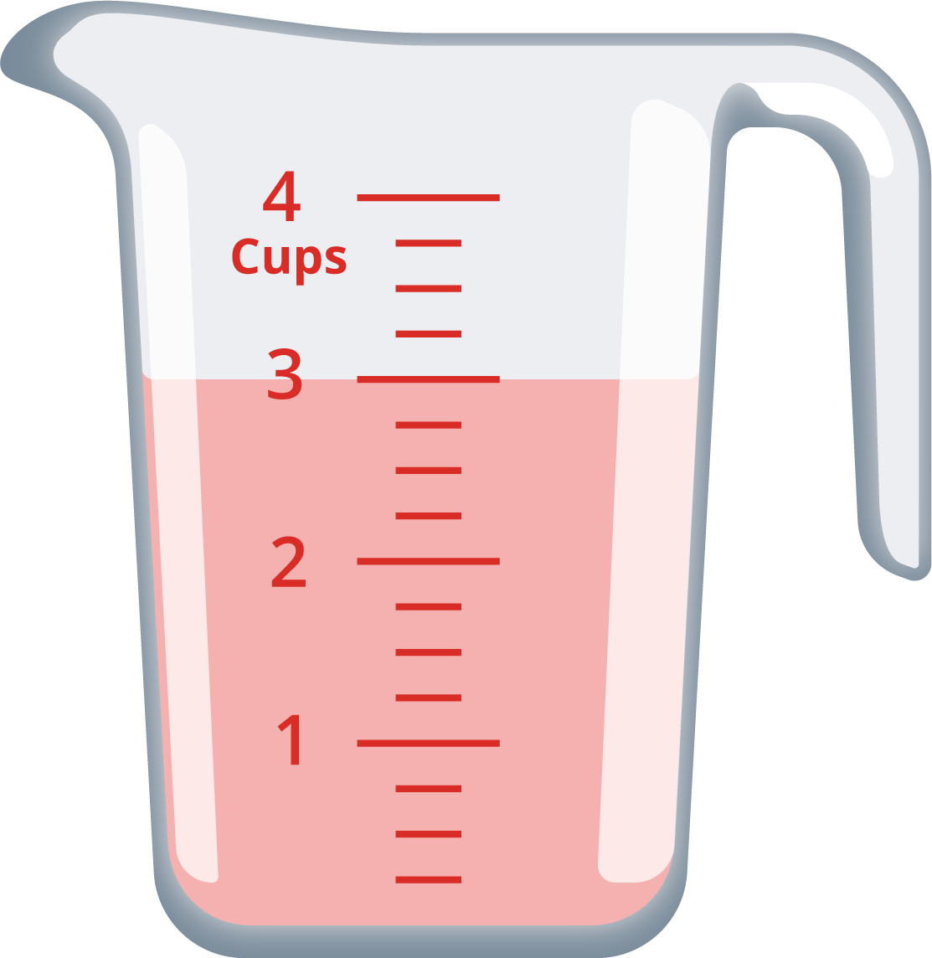
  - $\frac{1}{4}$ cup
  - $\frac{5}{4}$ cups
  - $1\frac{1}{4}$ cups
  - $2\frac{2}{4}$ cups
- A second pitcher contains 4 cups of water. How many cups will be left in that pitcher if we pour each of the following amounts from the full amount?
Explain or show your reasoning. Use diagrams or equations, if they are helpful.
  - $\frac{1}{3}$ cup
  - $\frac{5}{3}$ cups
  - $2\frac{2}{3}$ cups

2 Card Sort: Twelfths

Student Task Statement
- Sort the cards from your teacher into two groups. Record your sorted expressions. Be prepared to explain why the cards in each group belong together.
- Find the value of each difference. Show your reasoning.
  - $1−\frac{5}{8}$
  - $2−\frac{7}{8}$
  - $3−\frac{9}{8}$
© CC BY 2021 Illustrative Mathematics®

