Unit 9 Lesson 9: Create Word Problems

WU Number Talk: Difference and Thousands (Warm up)

Student Task Statement
Find the value of each expression mentally.
- $5,​000−403$
- $5,​300−473$
- $25,​300−493$
- $26,​000−1,​493$

1 What’s the Question?

Student Task Statement
George Meegan walked 19,019 miles between 1977 and 1983. He finished at age 31. He wore out 12 pairs of hiking boots.
Jean Beliveau walked 46,900 miles between 2000 and 2011 and finished at age 56.
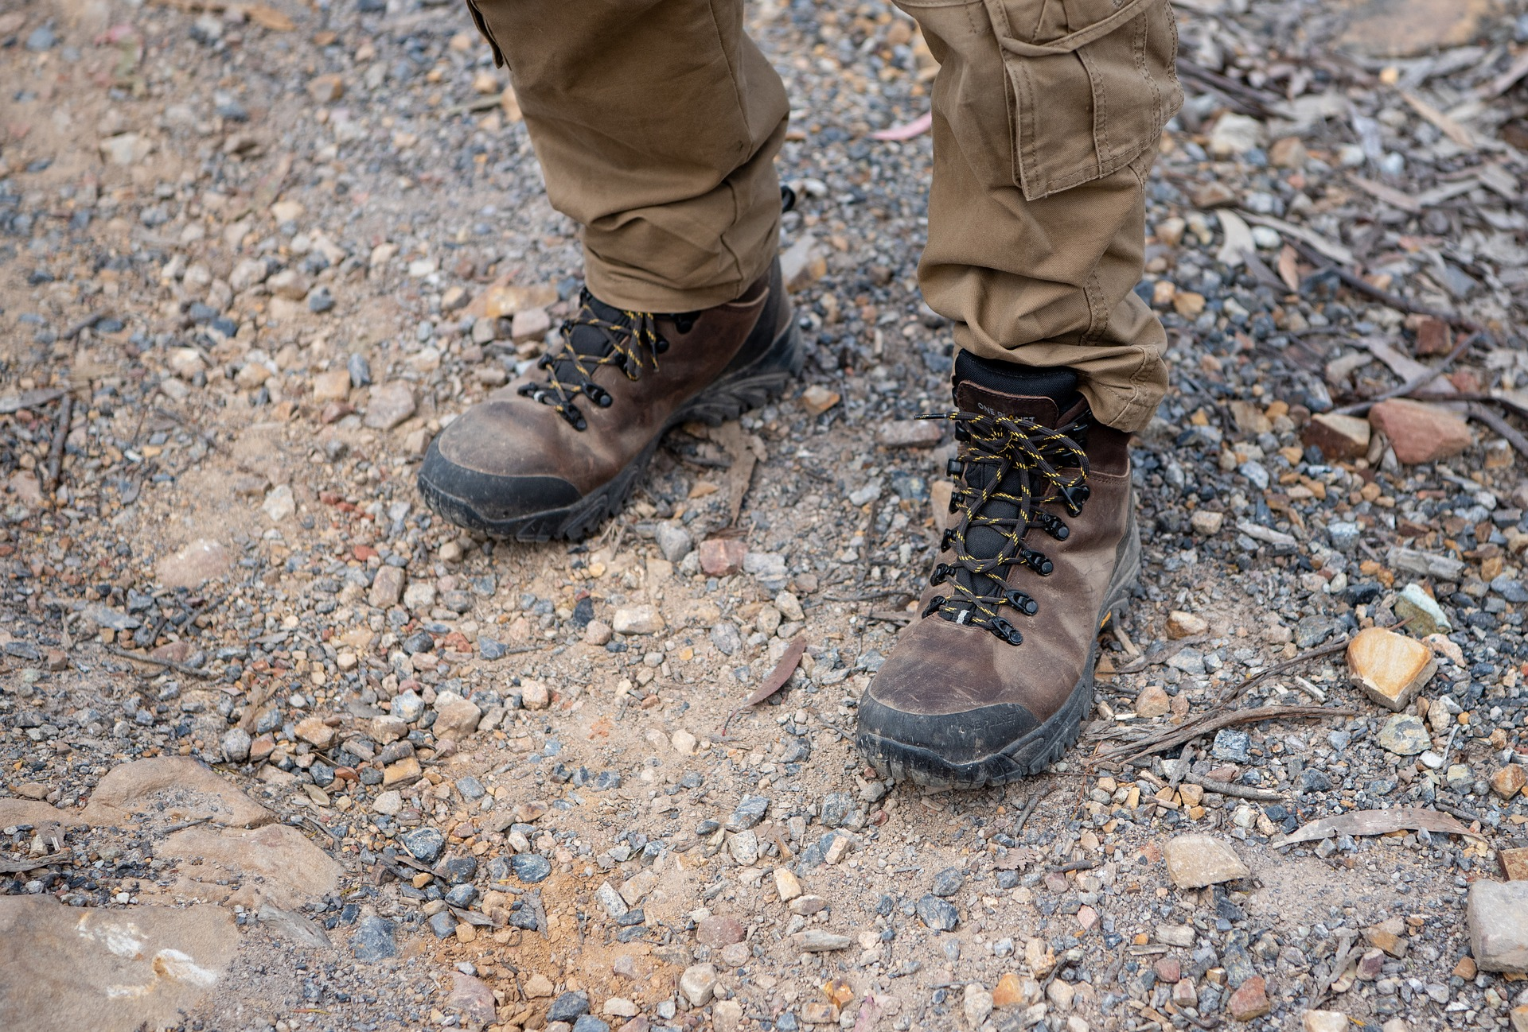
Here are the responses Kiran gave to answer some questions about the situation.
Write the question that Kiran might be answering. In the last row, write a new question about the situation and show the answer, along with your reasoning.
question | response and reasoning
1. | $1983−1977=6$  $12÷6=2$  2 pairs of hiking boots
2. | $56−31=23$  23 years
3. | $2011−2000=11$  11 years  $11×\underset{_}{}=46,​900$  $11×4,​000=44,​000$  $11×200=2,​200$  $11×70=770$  $44,​000+2,​200+770=46,​970$  $4,​000+200+70=4,​270$  4,270 miles
4.

2 What’s the Problem?

Student Task Statement
Elena, Noah, and Han each created a problem with an answer of 1,564.
- Elena used multiplication.
- Noah used multi-digit numbers and addition only.
- Han used multiplication and subtraction.
Write a problem that each student could have written. Show that the answer to the question is 1,564.
- Elena‘s problem:
Solution:
- Noah‘s problem:
Solution:
- Han‘s problem:
Solution:
© CC BY 2021 Illustrative Mathematics®

