Lesson 2: Naming the Moves
Let’s be more precise about describing moves of figures in the plane.

2.1: A Pair of Quadrilaterals
Quadrilateral A can be rotated into the position of Quadrilateral B.
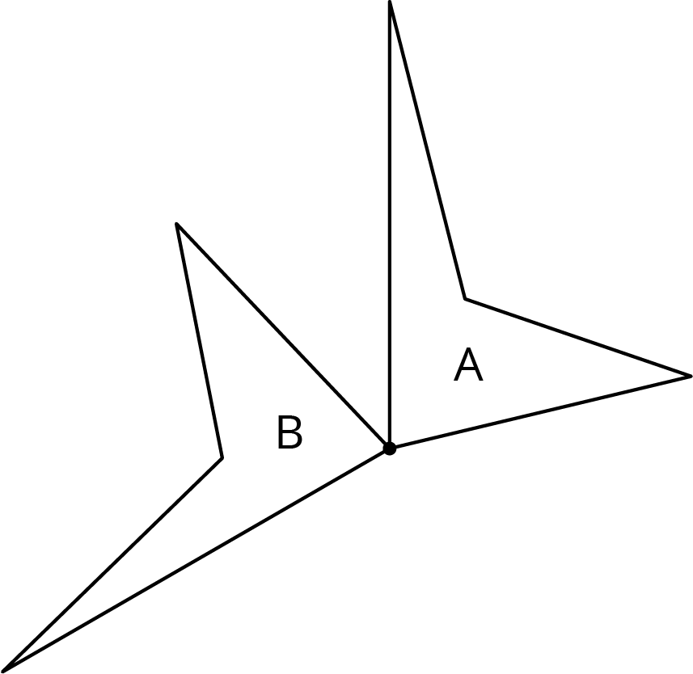
Estimate the angle of rotation.

2.2: How Did You Make That Move?
Here is another set of dance moves.
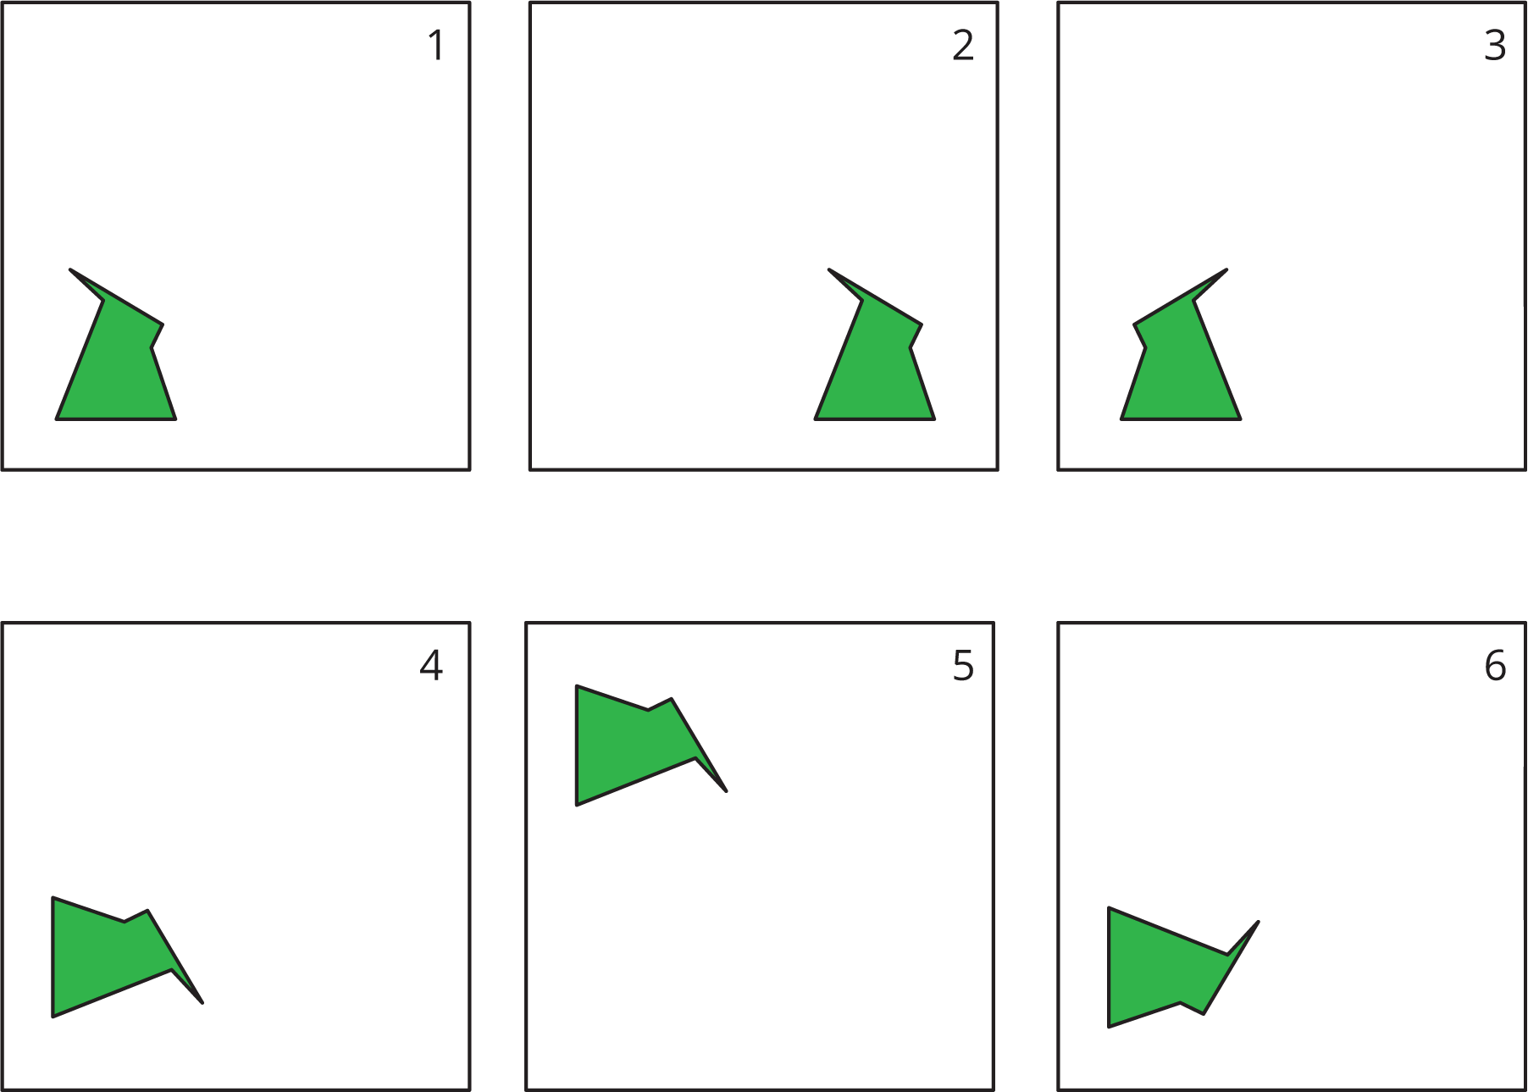
- Describe each move or say if it is a new move.
  - Frame 1 to Frame 2.
  - Frame 2 to Frame 3.
  - Frame 3 to Frame 4.
  - Frame 4 to Frame 5.
  - Frame 5 to Frame 6.
- How would you describe the new move?

2.3: Card Sort: Move
Your teacher will give you a set of cards. Sort the cards into categories according to the type of move they show. Be prepared to describe each category and why it is different from the others.

Lesson 2 Summary
Here are the moves we have learned about so far:
- A translation slides a figure without turning it. Every point in the figure goes the same distance in the same direction. For example, Figure A was translated down and to the left, as shown by the arrows. Figure B is a translation of Figure A.
- 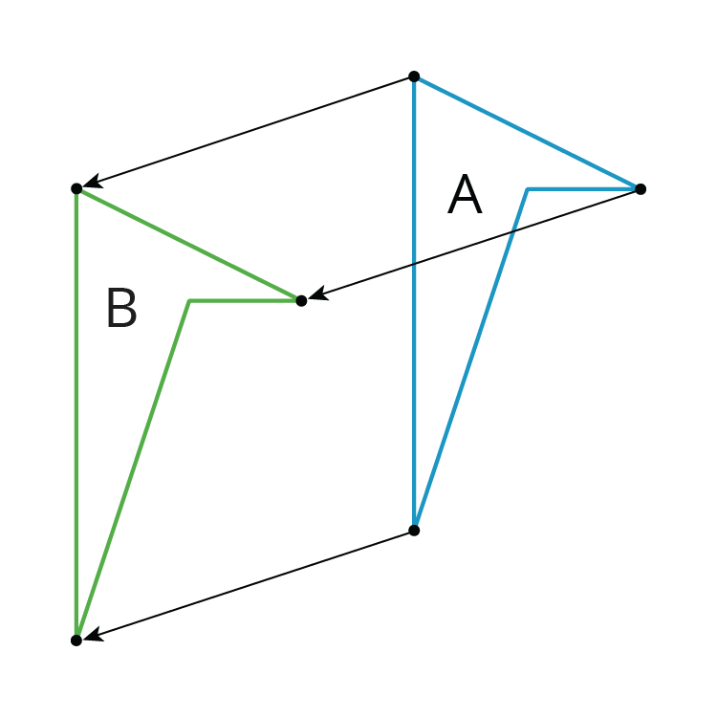
- A rotation turns a figure about a point, called the center of the rotation. Every point on the figure goes in a circle around the center and makes the same angle. The rotation can be clockwise, going in the same direction as the hands of a clock, or counterclockwise, going in the other direction. For example, Figure A was rotated ${45}^{∘}$ clockwise around its bottom vertex. Figure C is a rotation of Figure A.
- 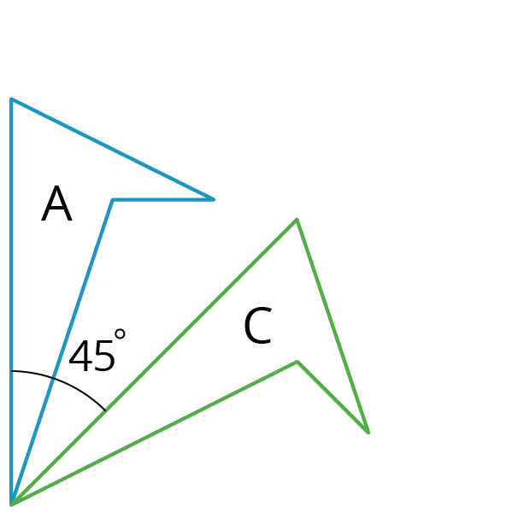
- A reflection places points on the opposite side of a reflection line. The mirror image is a backwards copy of the original figure. The reflection line shows where the mirror should stand. For example, Figure A was reflected across the dotted line. Figure D is a reflection of Figure A.
- 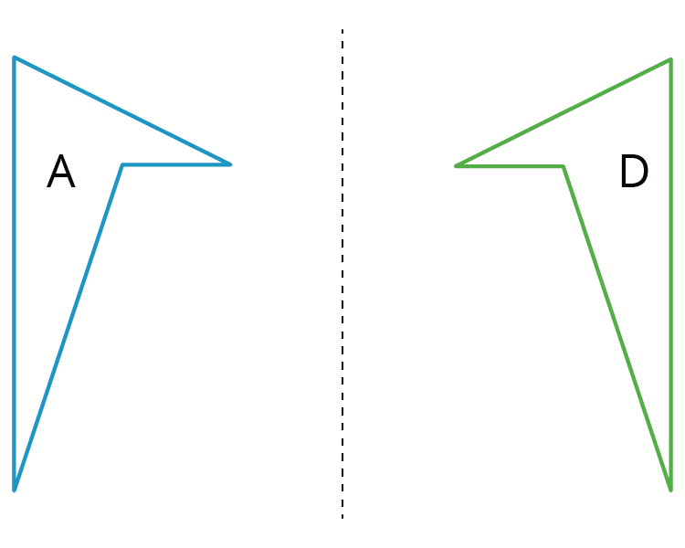
We use the word image to describe the new figure created by moving the original figure. If one point on the original figure moves to another point on the new figure, we call them corresponding points.
© CC BY Open Up Resources. Adaptations CC BY IM.

