Unit 3 Lesson 10: Fossils and Flags

1 A Fossil Puzzle (Optional)

Student Task Statement
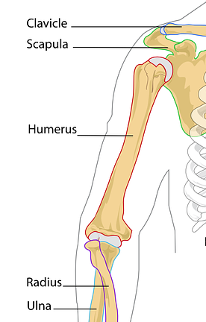
An anthropologist finds a fossilized humerus bone of an ancient human ancestor. The humerus is an arm bone running from the shoulder to the elbow. It is 24 centimeters in length. Use data from your classmates to estimate the height of this ancient human.

2 Playing Dirty (Optional)

Student Task Statement
- Before researching data, do you think the number of penalties a team gets in a season is correlated to the number of wins the team gets in that season? Do you think it is a positive or negative relationship? Do you think the relationship is weak or strong? Explain your reasoning.
- Is there a relationship between the number of penalties a team gets in a season and the number of wins in that season? Show any mathematical work that leads to your answer.
- Do penalties cause a change in wins or wins cause a change in penalties or neither? Explain your reasoning.
© CC BY 2019 by Illustrative Mathematics®

