Lesson 3: Groups that Look Very Different
- Let’s figure out if there are more green triangles or more orange squares.

3.3: Introduce Number Race, Numbers 1–10
Choose a center.
Number Race
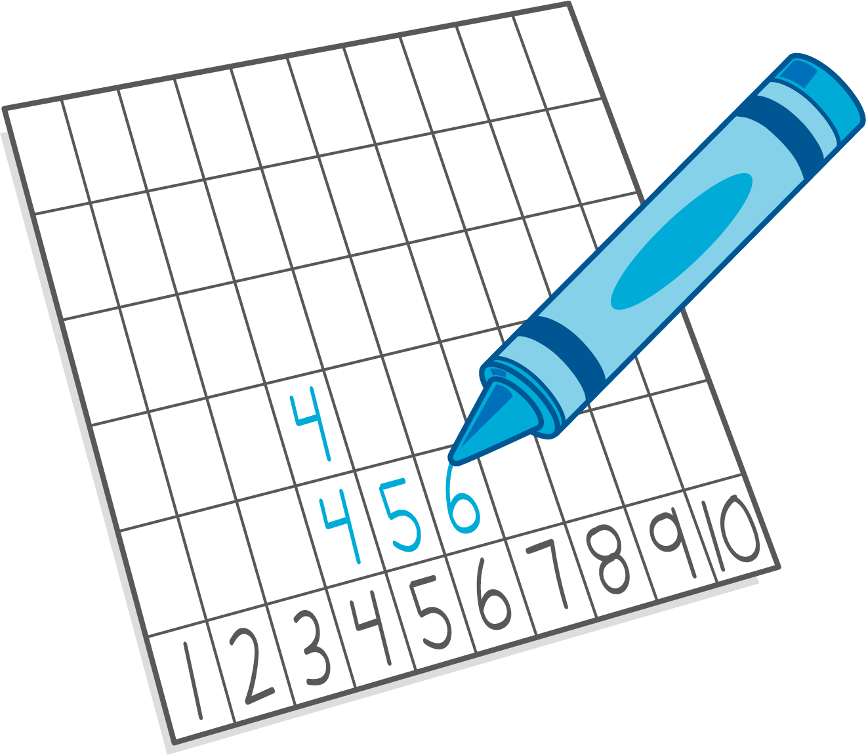
Shake and Spill
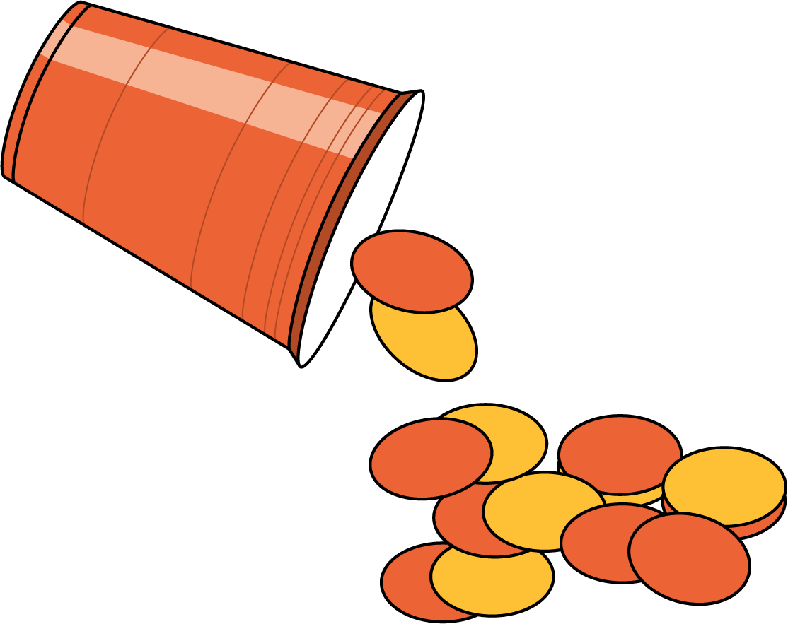
Math Fingers
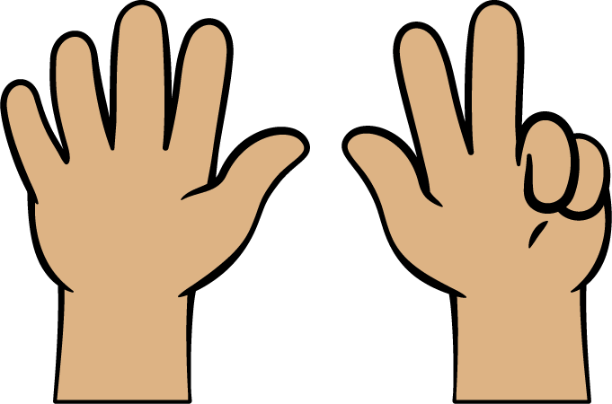
Pattern Blocks
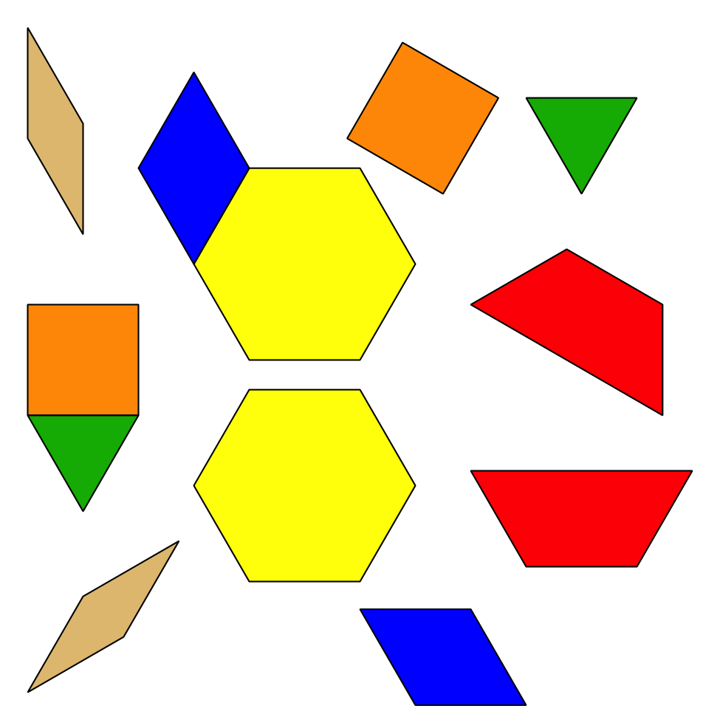
Picture Books
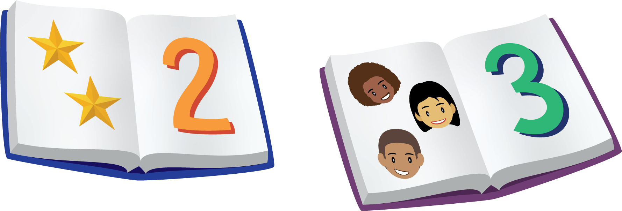
© CC BY 2021 Illustrative Mathematics®

