Lesson 12 Practice Problems
- Here is a graph of $f$ given by $f\left(θ\right)=tan\left(θ\right)$.
  - Are $\frac{π}{2}$ and $\frac{3π}{2}$ in the domain of $f$? Explain how you know.
  - What are the $θ$-intercepts of the graph of $f$? Explain how you know.
- 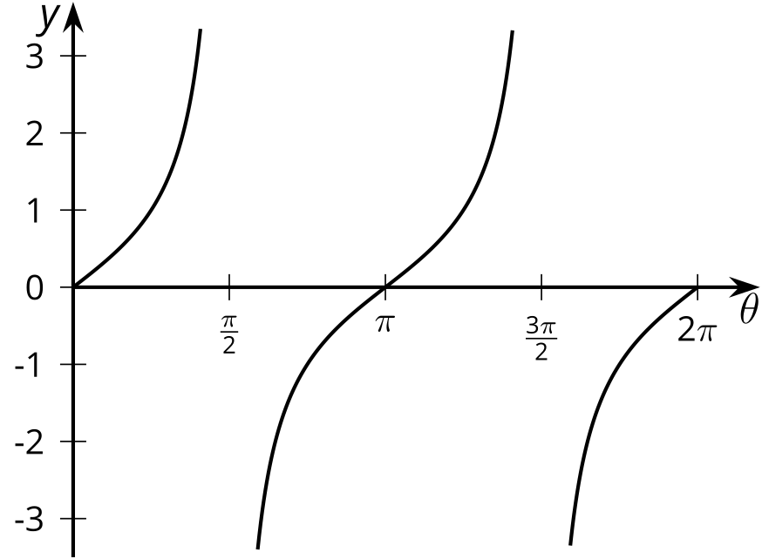
- The function $f$ is given by $f\left(θ\right)=tan\left(θ\right)$. Which of the statements are true? Select all that apply.
  - $f$ is a periodic function
  - The domain of $f$ is all real numbers.
  - The range of $f$ is all real numbers.
  - The period of $f$ is $2π$.
  - The period of $f$ is $π$.
- Here is the unit circle.
- If $tan\left(a\right)>1$ where could angle $a$ be on the unit circle?
- 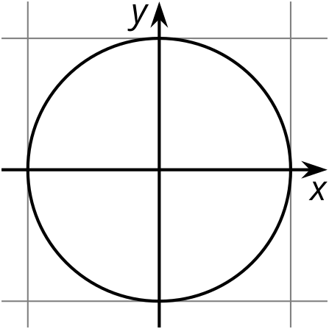
- Here is a point on the unit circle.
  - Explain why the line going through $\left(0,0\right)$ and $P$ has slope $\frac{1}{2}$.
  - What is the tangent of the angle represented by $P$? Explain how you know.
- 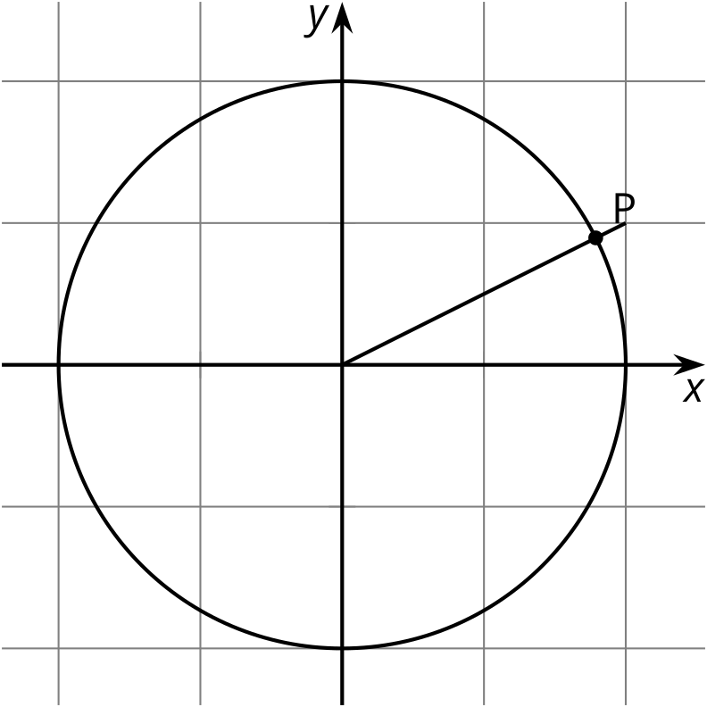
- For which angles $θ$ between 0 and $2π$ is $cos\left(θ\right)<0$? Explain how you know.
- (From Unit 6, Lesson 9.)
- It is 3:00 a.m.
- 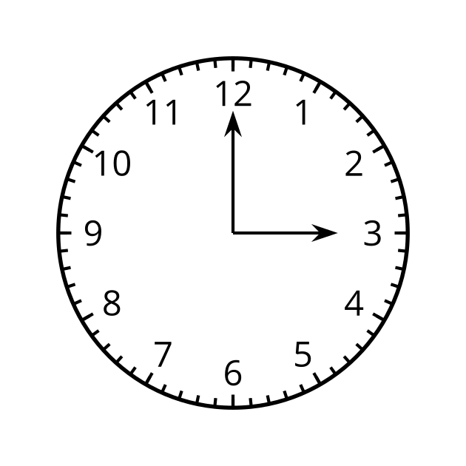
  - What angle will the hour hand rotate through in the next hour? Explain how you know.
  - What angle will the hour hand rotate through in the next 12 hours? Explain how you know.
  - What angle will the hour hand rotate through in the next 24 hours? Explain how you know.
- (From Unit 6, Lesson 11.)
- The function $f$ is given by $f\left(x\right)=x^{2}$.
  - Write an equation for the function $g$ whose graph is the graph of $f$ translated 3 units left and then reflected over the $y$-axis.
  - Write an equation for the function $h$ whose graph is the graph of $f$ reflected over the $y$-axis and then translated 3 units to the left.
  - Do $g$ and $h$ have the same graph? Explain your reasoning.
- (From Unit 5, Lesson 7.)
© CC BY 2019 by Illustrative Mathematics®

