Unit 5 Lesson 12: Estimate and Add

WU Number Talk: 99 Hundredths (Warm up)

Student Task Statement
Find the value of each expression mentally.
- $1.00+0.99+0.02$
- $1.99+0.02$
- $1.99+0.03$
- $1.99+0.13$

1 Use the Standard Algorithm to Add Decimals

Student Task Statement
- Find the value of $5.61+2.53$. Explain or show your reasoning.
- Han used the standard algorithm to add decimals. This is Han’s work. Describe what Han did in each step.
- 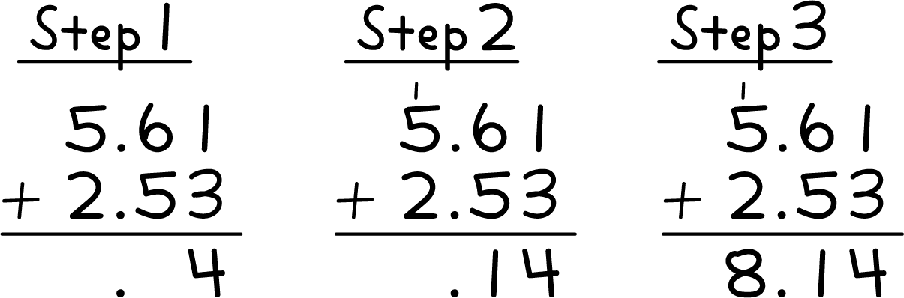
- Use the standard algorithm to find the value of $6.62+3.74$.

2 Estimate and Find the Value

Student Task Statement
- Which whole number is the sum $2.82+5.2$ closest to? Explain or show your reasoning.
- What is the value of $2.82+5.2$? Explain or show your reasoning. Use the standard algorithm if it is helpful.
- Which whole number is the sum $6.8+4.97$ closest to? Explain or show your reasoning.
- What is the value of $6.8+4.97$? Explain or show your reasoning. Use the standard algorithm if it is helpful.
© CC BY 2021 Illustrative Mathematics®

