Unit 8 Lesson 9: Problem Solving with Volume: Water

WU Notice and Wonder: Cubic Centimeters and Grams (Warm up)

Student Task Statement
What do you notice? What do you wonder?
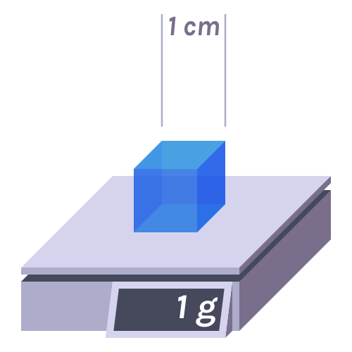

1 Catching Rainfall

Student Task Statement
Here is a diagram showing the roof of a house.
- What is the area of the roof?
- 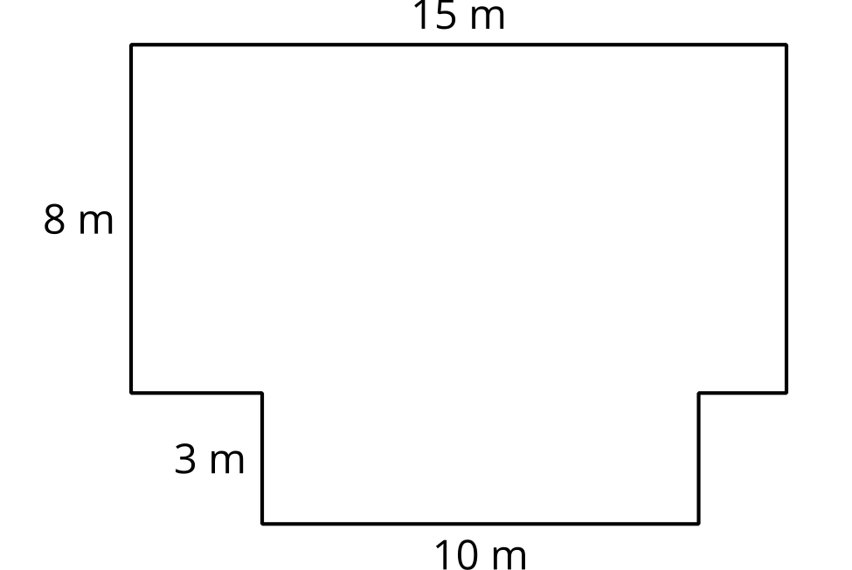
- Each month an average of 5 cm of rain falls on the house. How many cubic cm of rain is that?
- There are 1,000 cubic cm in 1 liter. How many liters of water fall on the house?
- You want to build a reservoir to catch the rain that falls so you can use the water. What side lengths would you suggest for the reservoir? Explain or show your reasoning.

2 How Much Water?

Student Task Statement
- What are some of the ways you use water at home?
- Estimate how much water you use at your home in a month.
- How much rain would need to fall on your home each month to supply all of your water needs?
- What challenges might come up if you tried to use the rainwater that falls on the roof of your home? Do you think it makes sense to try to capture the rain that falls on your home?
© CC BY 2021 Illustrative Mathematics®

