Lesson 2: Measure in Centimeters

Standards Alignments
Addressing | 2.MD.A.1, 2.MD.A.4

Teacher-facing Learning Goals
- Measure length in centimeters.

Student-facing Learning Goals
- Let’s measure in centimeters.

Lesson Purpose
The purpose of this lesson is for students to measure in centimeters.
In an earlier lesson, students learned the importance of using a standard unit to ensure that they can communicate clearly about their measurements. They learned that a single base-ten block is a centimeter cube because each edge of the cube is 1 centimeter long.
The purpose of this lesson is for students to measure in centimeters and consider more efficient ways to measure. Students use tools (base-ten blocks) that have lengths of 1 centimeter and 10 centimeters to measure the length of objects. In the warm-up and Activity 1, students begin a transition from describing their measurements of length based on the number of objects they use to describing the number of standard length units (centimeters) the objects represent. In Activity 2, students choose to measure with centimeter cubes or 10-centimeter tools (base-ten block “tens”) and explain their choices (MP5).
Give students access to base-ten blocks during the cool-down.

Access for:

Students with Disabilities
- Action and Expression (Activity 1)

English Learners
- MLR8 (Activity 2)

Instructional Routines
Notice and Wonder (Warm-up)

Materials to Gather
- Base-ten blocks: Activity 1, Activity 2
- Base-ten blocks: Warm-up

Materials to Copy
- Bearded Dragon (groups of 1): Activity 1
- Reptile Length (groups of 1): Activity 2

Lesson Timeline
Warm-up | 10 min
Activity 1 | 20 min
Activity 2 | 15 min
Lesson Synthesis | 10 min
Cool-down | 5 min

Teacher Reflection Question
What evidence have students given that shows they understand that a centimeter is a length unit? What language do they use to describe how they measure a length in centimeters?

Cool-down
(to be completed at the end of the lesson) 5min
Measure with Centimeters

Standards Alignments
Addressing | 2.MD.A.1

Student-facing Task Statement
- Measure the length of the reptiles in centimeters.
  - 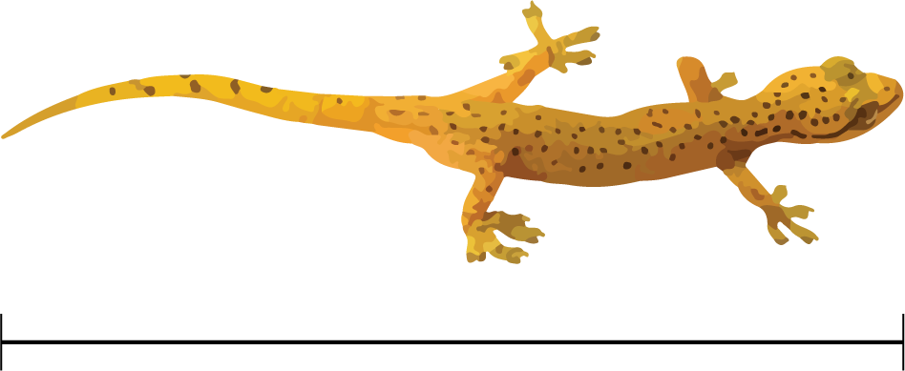
  - 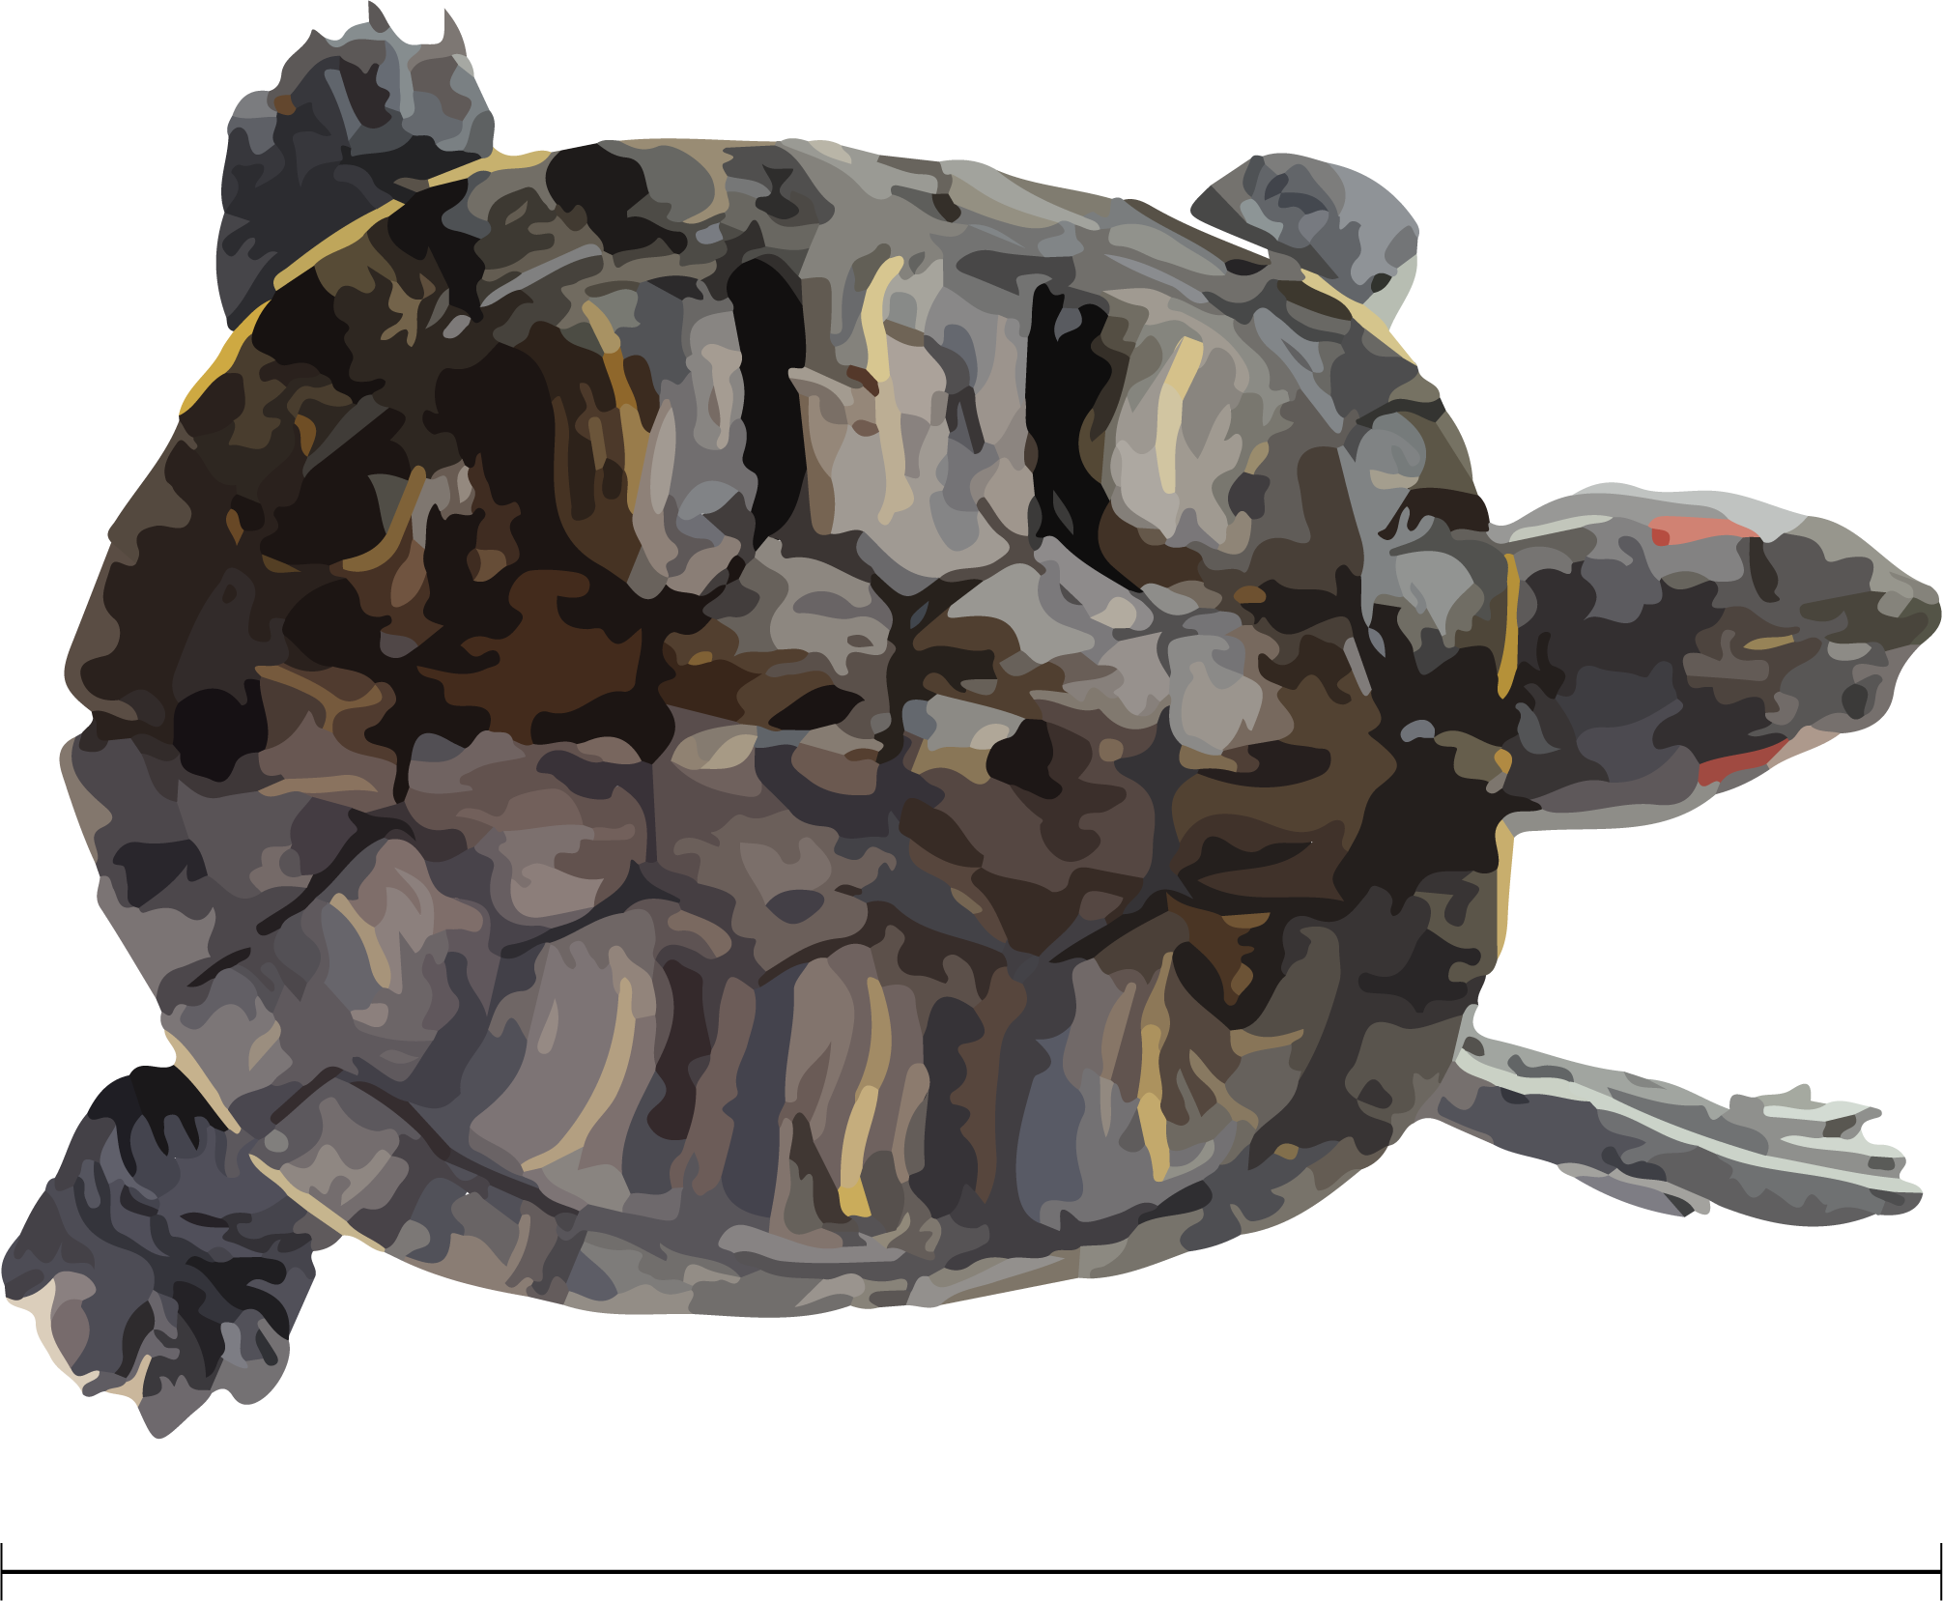

Student Responses
- 7 cm
- 13 cm

