Unit 9 Lesson 10: Estimation Exploration

WU Estimation Exploration: No Driver Required (Warm up)

Student Task Statement
Here are pictures showing the exterior and interior of a parking tower in Wolfstadt, Germany. The parking is automated: each car goes up on a lift and is then placed in a parking space.
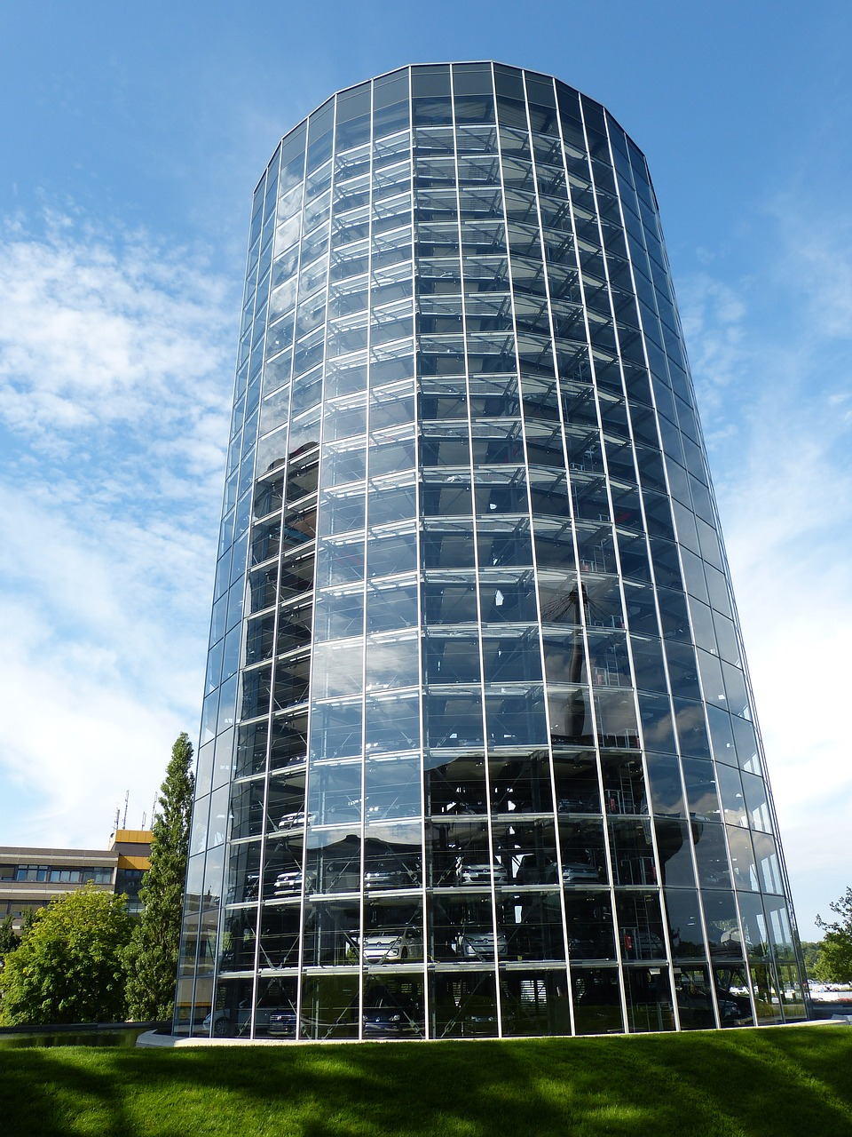
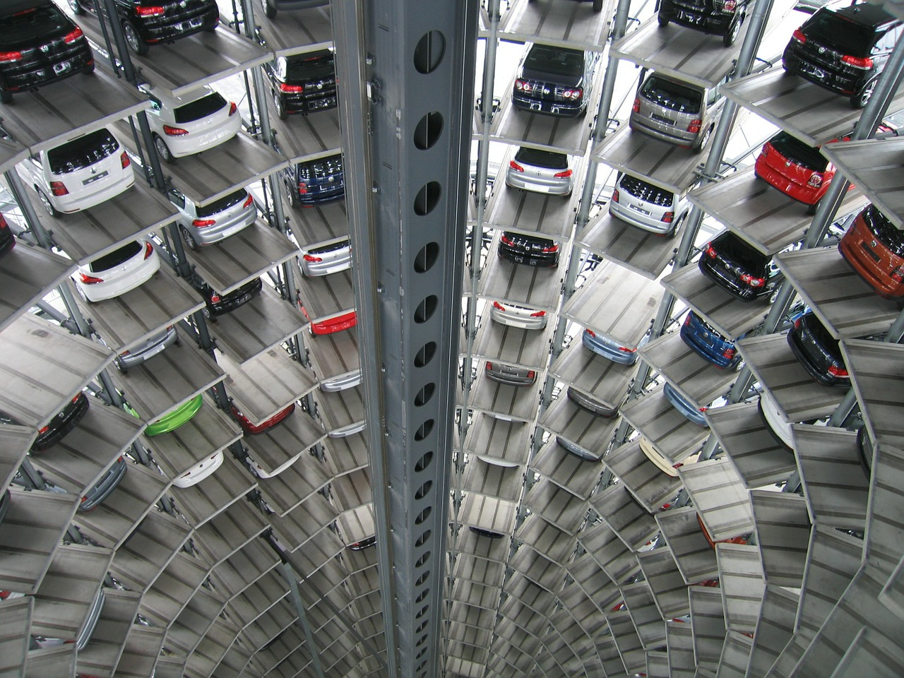
How many cars can fit in the tower?
Record an estimate that is:
too low | about right | too high

1 Dental Care

Student Task Statement
Jada brushes for 2 minutes, twice a day. She changes her toothbrush every 3 months.​​​​​​
Based on this information, make some estimates and show your reasoning:
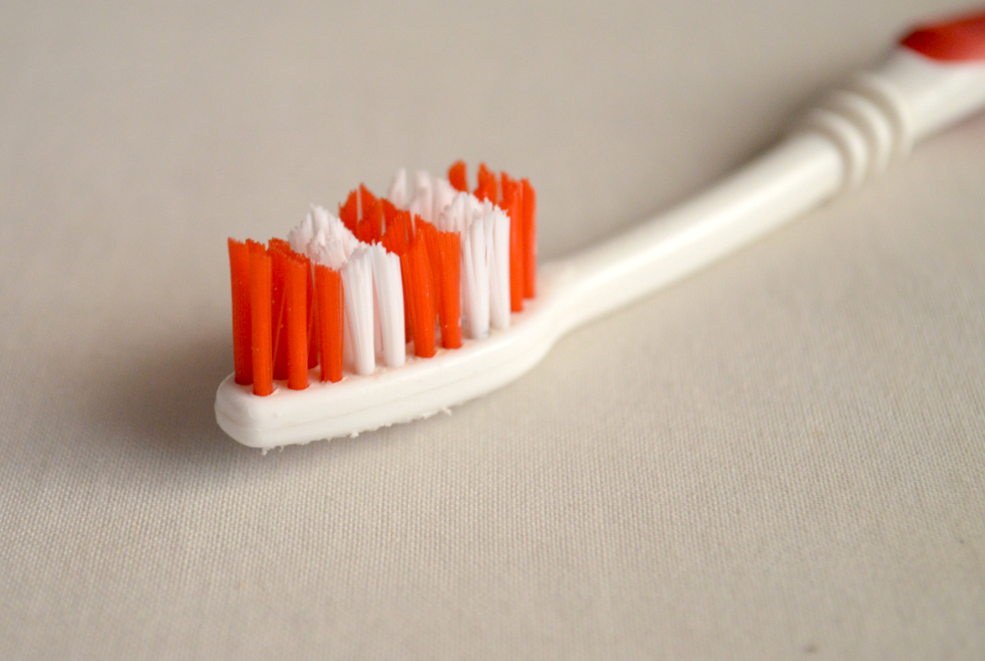
- In a lifetime, approximately:
  - How many toothbrushes will she use?
  - How many dollars will she spend on toothbrushes?
- About how many minutes would she spend brushing her teeth:
  - in a year?
  - in a lifetime?
- Think of another estimation question you could ask about this situation.

2 Get Your Classmates to Estimate

Student Task Statement
It’s your turn to create an estimation problem.
- Think of situations or look around for images that would make interesting estimation problems. Write down 4–5 ideas or possible topics.
- Choose your favorite idea. Then:
  - Write an estimation question that would encourage others to use multiplication of multi-digit numbers to answer.
  - Record an estimate that is:
- too low | - about right | - too high
  - Be prepared to explain your reasoning.

3 Facilitate Your “Estimation Exploration” Activity

Student Task Statement
Follow these steps to facilitate your Estimation Exploration activity for another group:
- Display your image or present your scenario.
- Ask your classmates: “What is an estimate that’s too high? Too low? About right?”
- Give them 1 minute of quiet think time.
- Give them 1–2 minutes to discuss together.
- Invite them to share their estimates and how they made them. Record their ideas.
- If you know the actual number or quantity, consider revealing it.
© CC BY 2021 Illustrative Mathematics®

