Lesson 11: What Is the Same?

11.1: Find the Right Hands
A person’s hands are mirror images of each other. In the diagram, a left hand is labeled. Shade all of the right hands.
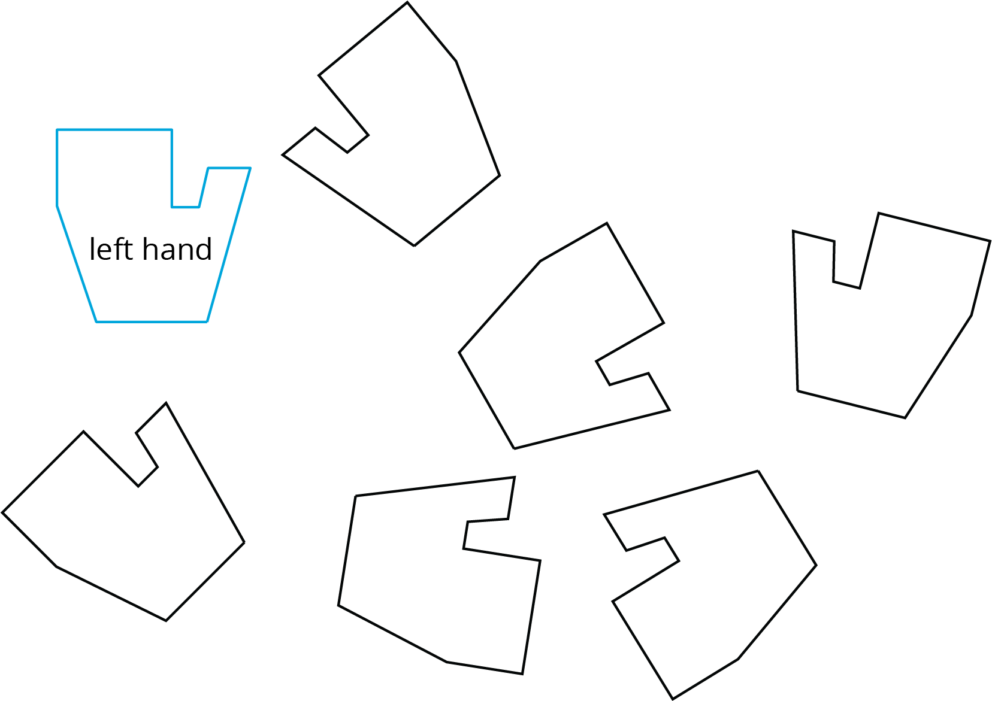

11.2: Are They the Same?
For each pair of shapes, decide whether or not they are the same.
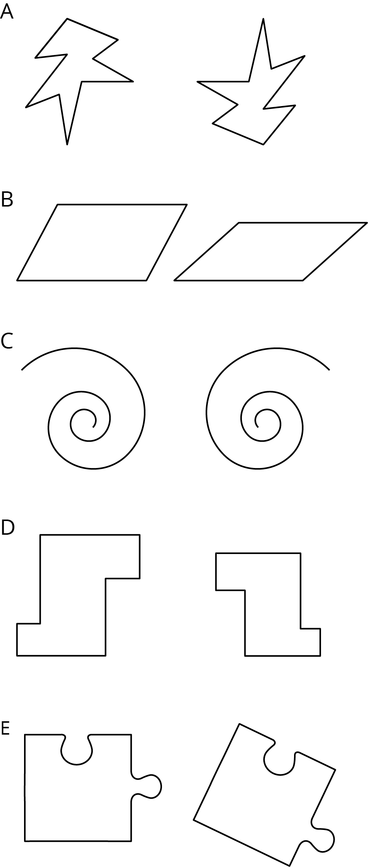

11.3: Area, Perimeter, and Congruence
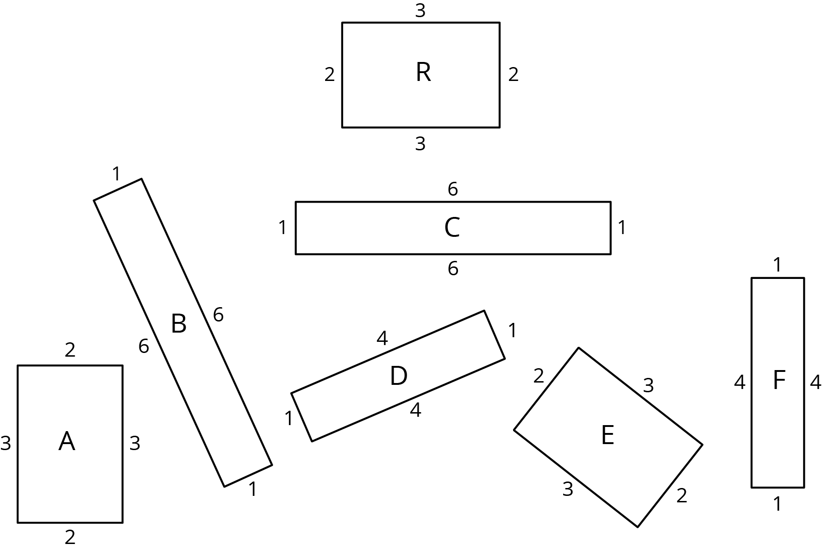
- Which of these rectangles have the same area as Rectangle R but different perimeter?
- Which rectangles have the same perimeter as Rectangle R but different area?
- Which have the same area and the same perimeter as Rectangle R?
- Use materials from the geometry tool kit to decide which rectangles are congruent. Shade congruent rectangles with the same color.

Are you ready for more?
In square $ABCD$, points $E$, $F$, $G$, and $H$ are midpoints of their respective sides. What fraction of square $ABCD$ is shaded? Explain your reasoning.
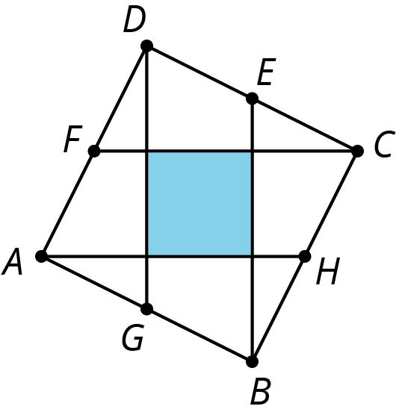

Lesson 11 Summary
Congruent is a new term for an idea we have already been using. We say that two figures are congruent if one can be lined up exactly with the other by a sequence of rigid transformations. For example, triangle $EFD$ is congruent to triangle $ABC$ because they can be matched up by reflecting triangle $ABC$ across $AC$ followed by the translation shown by the arrow. Notice that all corresponding angles and side lengths are equal.
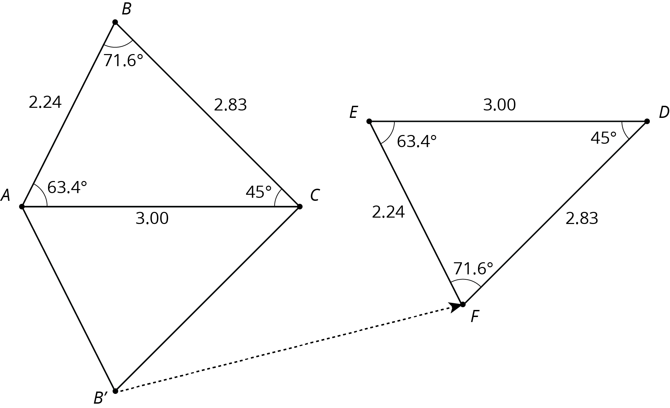
Here are some other facts about congruent figures:
- We don’t need to check all the measurements to prove two figures are congruent; we just have to find a sequence of rigid transformations that match up the figures.
- A figure that looks like a mirror image of another figure can be congruent to it. This means there must be a reflection in the sequence of transformations that matches up the figures.
- Since two congruent polygons have the same area and the same perimeter, one way to show that two polygons are not congruent is to show that they have a different perimeter or area.
© CC BY Open Up Resources. Adaptations CC BY IM.

