Lesson 9: Measure Figures Made From Prisms

Standards Alignments
Addressing | 5.MD.C.5.c, 5.OA.A.2
Building Towards | 5.NBT.A.2

Teacher-facing Learning Goals
- Find the volume of a figure composed of rectangular prisms in which unit cubes are not shown.

Student-facing Learning Goals
- Let’s find the volume of more figures.

Lesson Purpose
The purpose of this lesson is for students to find the volume of figures composed of two non-overlapping right rectangular prisms by adding the volumes of the non-overlapping parts.
In the previous lesson, the figures students worked with showed the unit cubes, providing the opportunity to visualize the number of unit cubes and find volume in a variety of ways. In this lesson, the figures composed of two non-overlapping right rectangular prisms do not show the individual cubes. This encourages students to apply the volume formulas and make connections between expressions and the way the figures can be decomposed. Given an expression and a solid figure composed of two rectangular prisms, students determine how to decompose the figure to match the given expression (MP2, MP7).

Access for:

Students with Disabilities
- Representation (Activity 1)

English Learners
- MLR7 (Activity 2)

Instructional Routines
Number Talk (Warm-up)

Materials to Copy
- Isometric Dot Paper Standard (groups of 1): Activity 1

Lesson Timeline
Warm-up | 10 min
Activity 1 | 20 min
Activity 2 | 15 min
Lesson Synthesis | 10 min
Cool-down | 5 min

Teacher Reflection Question
What connections did students make between the different strategies shared? What questions did you ask to help make the connections more visible?

Cool-down
(to be completed at the end of the lesson) 5min
Find the Volume of a Figure

Student-facing Task Statement
Find the volume of the figure. Explain or show your reasoning.
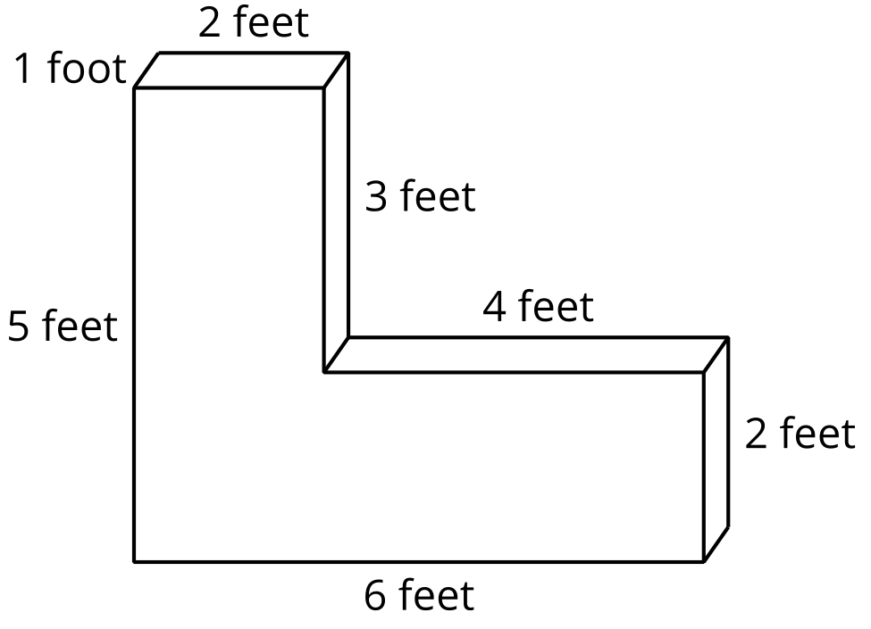

Student Responses
Sample response 1: Cutting the figure vertically makes a 5 by 2 by 1 prism on the left and a 4 by 2 by 1 prism on the right. The total volume is $\left(5×2×1\right)+\left(4×2×1\right)$ cubic feet, which is $10+8$ or 18 cubic feet.
Sample response 2: Cutting the figure horizontally makes a 3 foot by 2 foot by 1 foot prism on top and a 6 foot by 2 foot by 1 foot prism on bottom. The volume is $\left(3×2×1\right)+\left(6×2×1\right)$ cubic feet, which is $6+12$ or 18 cubic feet.

