Unit 2 Lesson 1: One of These Things Is Not Like the Others

1 Remembering Double Number Lines (Warm up)

Student Task Statement
- Complete the double number line diagram with the missing numbers.
- 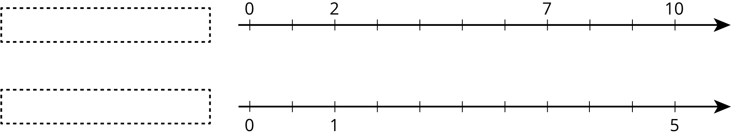
- What could each of the number lines represent? Invent a situation and label the diagram.
- Make sure your labels include appropriate units of measure.

2 Mystery Mixtures

Images for Launch
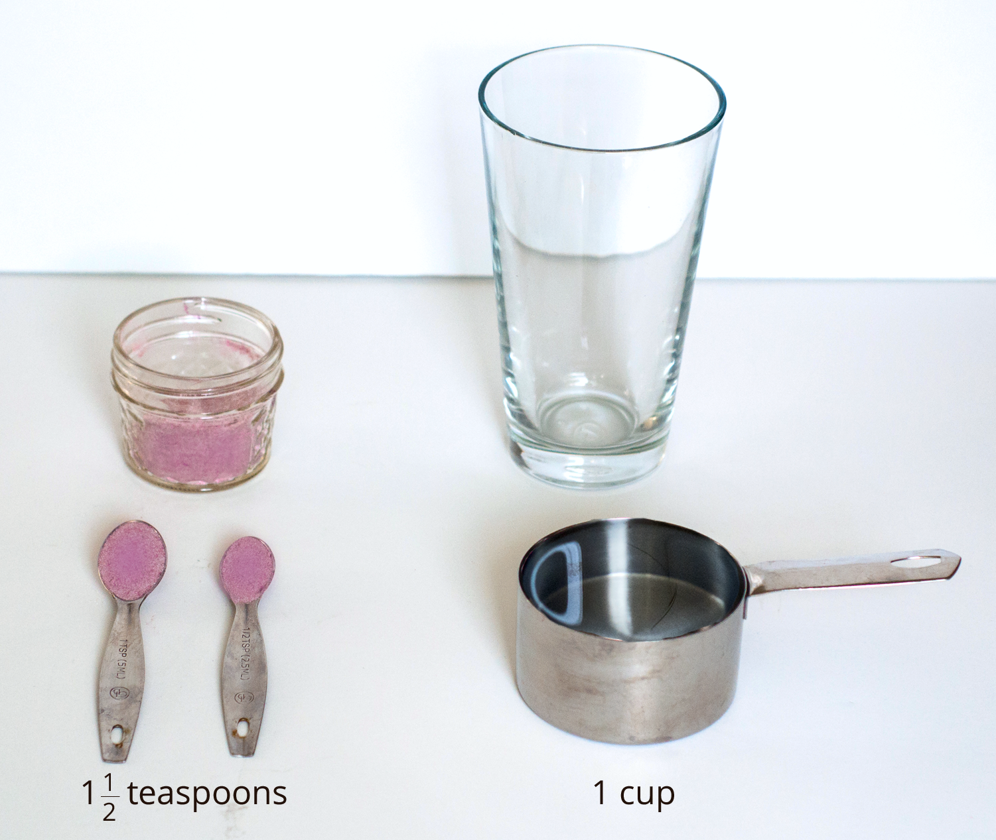
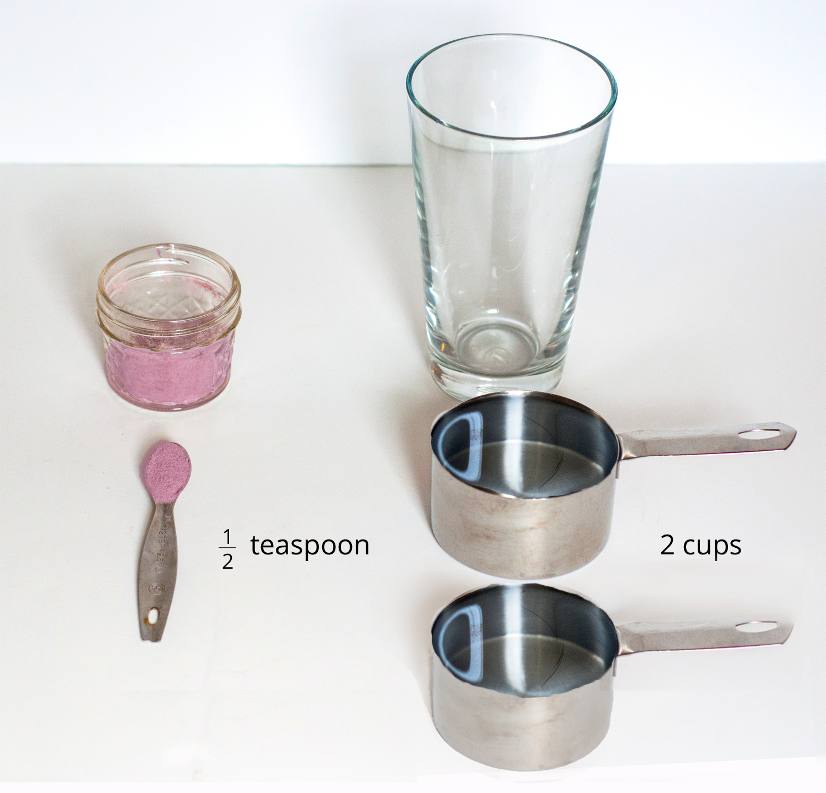
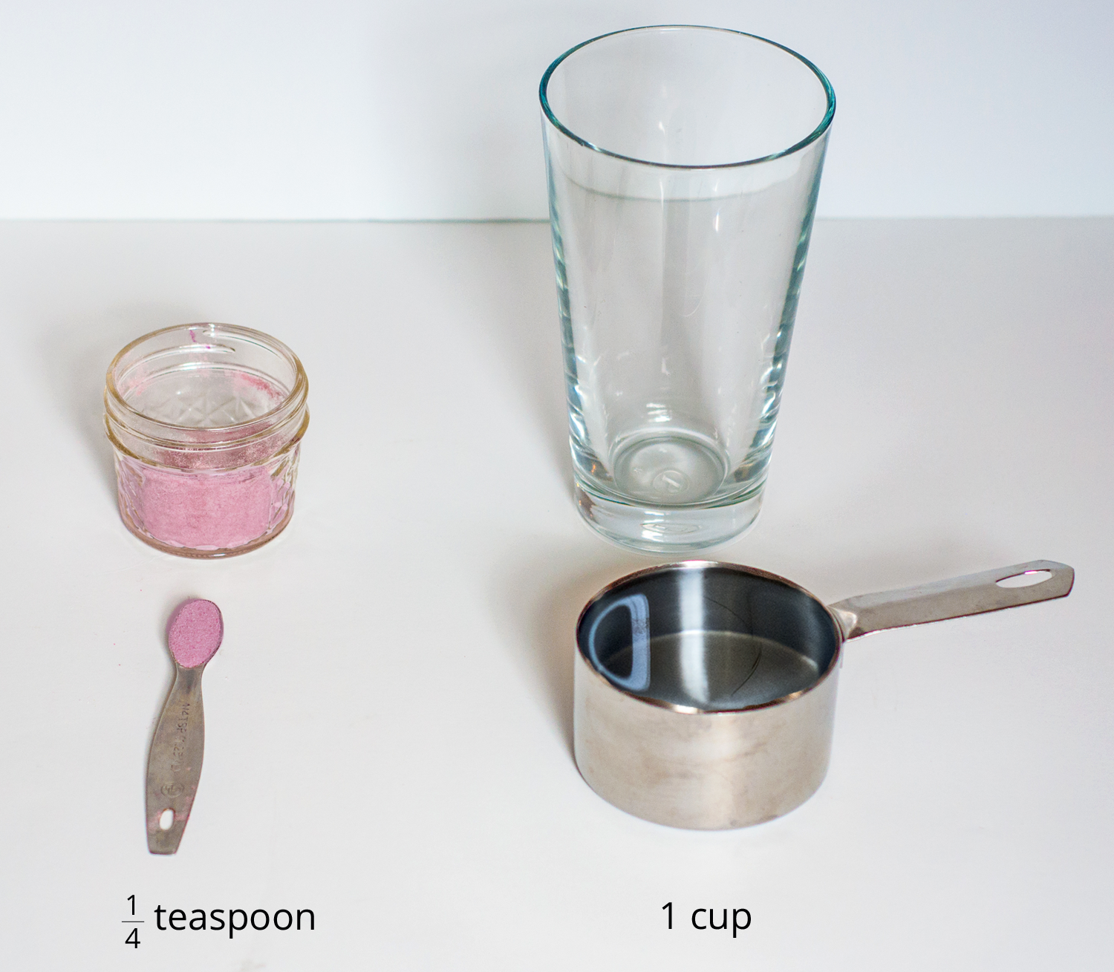
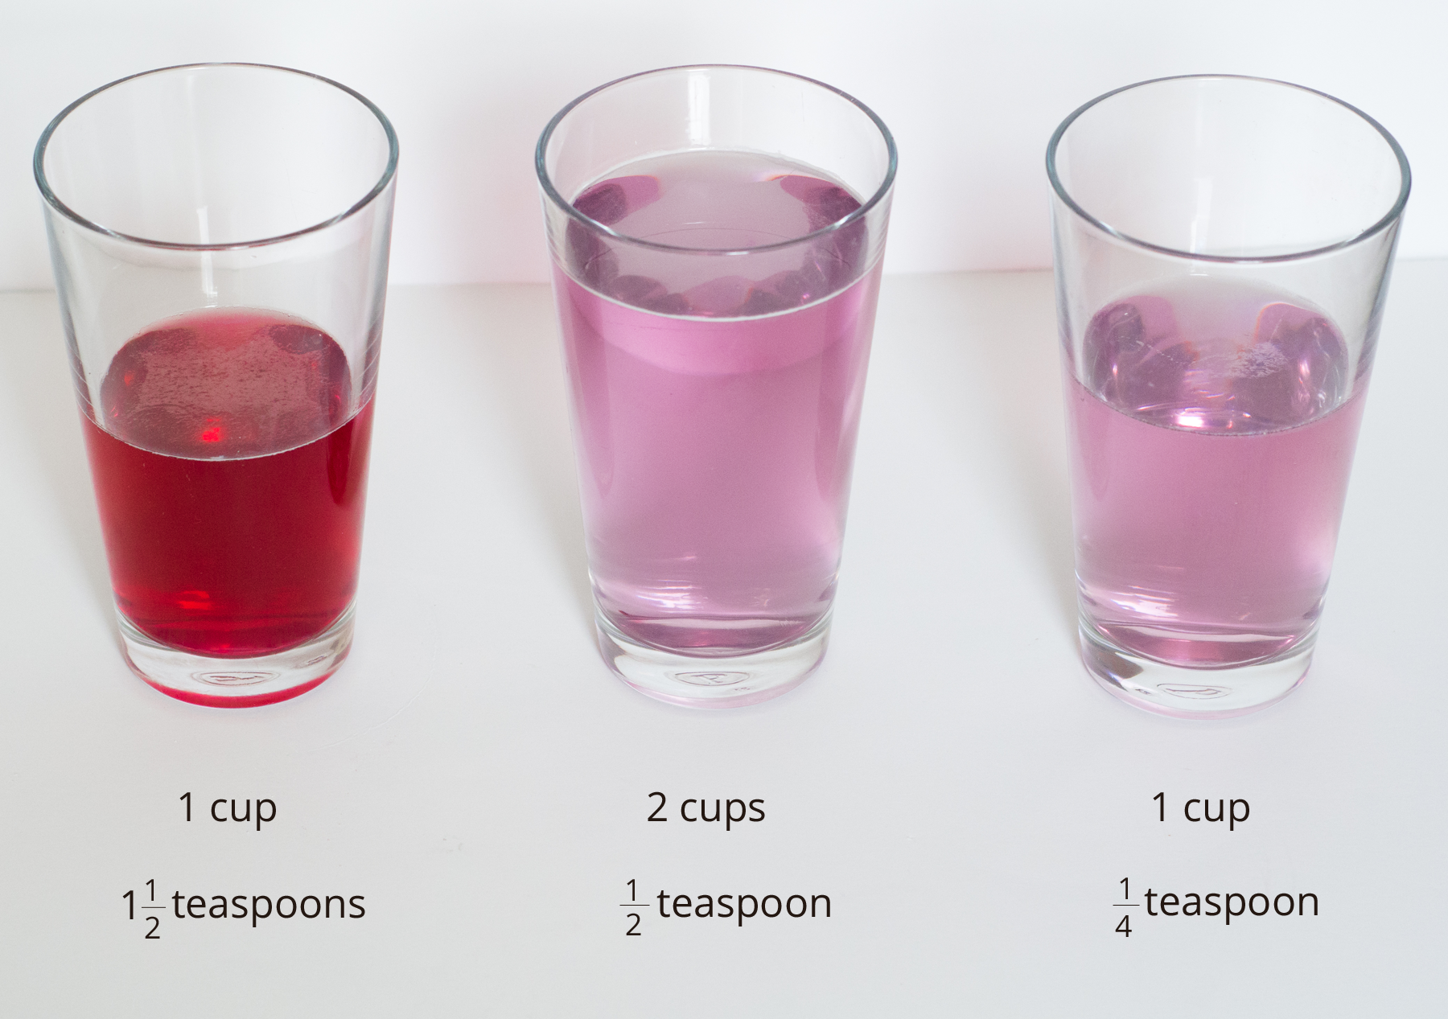

Student Task Statement
Your teacher will show you three mixtures. Two taste the same, and one is different.
- Which mixture tastes different? Describe how it is different.
- Here are the recipes that were used to make the three mixtures:
  - 1 cup of water with $1\frac{1}{2}$ teaspoons of powdered drink mix
  - 2 cups of water with $\frac{1}{2}$ teaspoon of powdered drink mix
  - 1 cup of water with $\frac{1}{4}$ teaspoon of powdered drink mix
- Which of these recipes is for the stronger tasting mixture? Explain how you know.

Activity Synthesis
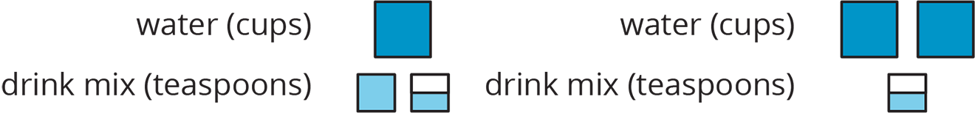
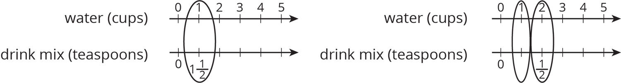

3 Crescent Moons

Student Task Statement
Here are four different crescent moon shapes.
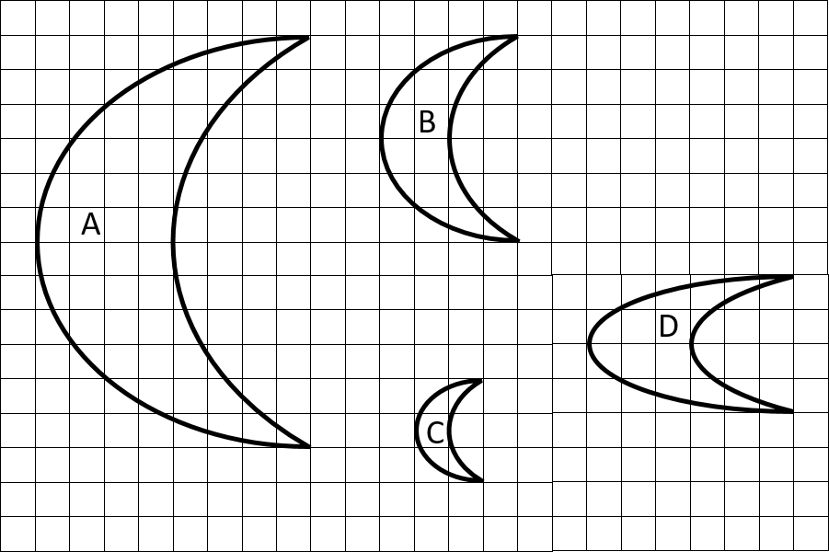
- What do Moons A, B, and C all have in common that Moon D doesn’t?
- Use numbers to describe how Moons A, B, and C are different from Moon D.
- Use a table or a double number line to show how Moons A, B, and C are different from Moon D.
© CC BY Open Up Resources. Adaptations CC BY IM.

