Unit 2 Lesson 18: Inequalities in Context

1 Inequalities (Warm up)

Student Task Statement
Place a < or > to correctly complete the inequality.
1. 5 $\underset{_}{​}$10
2. 5 $\underset{_}{​}$ -10
3. -5 $\underset{_}{​}$ -10
4. $\frac{1}{5}$ $\underset{_}{​}$ $\frac{1}{10}$
5.$\frac{−1}{5}$ $\underset{_}{​}$ $\frac{−1}{10}$

2 Sweater Weather

Student Task Statement
Elena and Lin are planning some cold-weather camping and are studying jackets and sleeping bags. Here is what they learned about some different equipment.
- A down jacket is rated as comfortable when the temperature is between $\text{-}{20}^{∘}\text{F}$ and ${20}^{∘}\text{F}$.
- A down sleeping bag is rated as comfortable when the temperature is $\text{-}{20}^{∘}\text{F}$ or above.
- A synthetic sleeping bag is rated as comfortable when the temperature is ${20}^{∘}\text{F}$ or above.
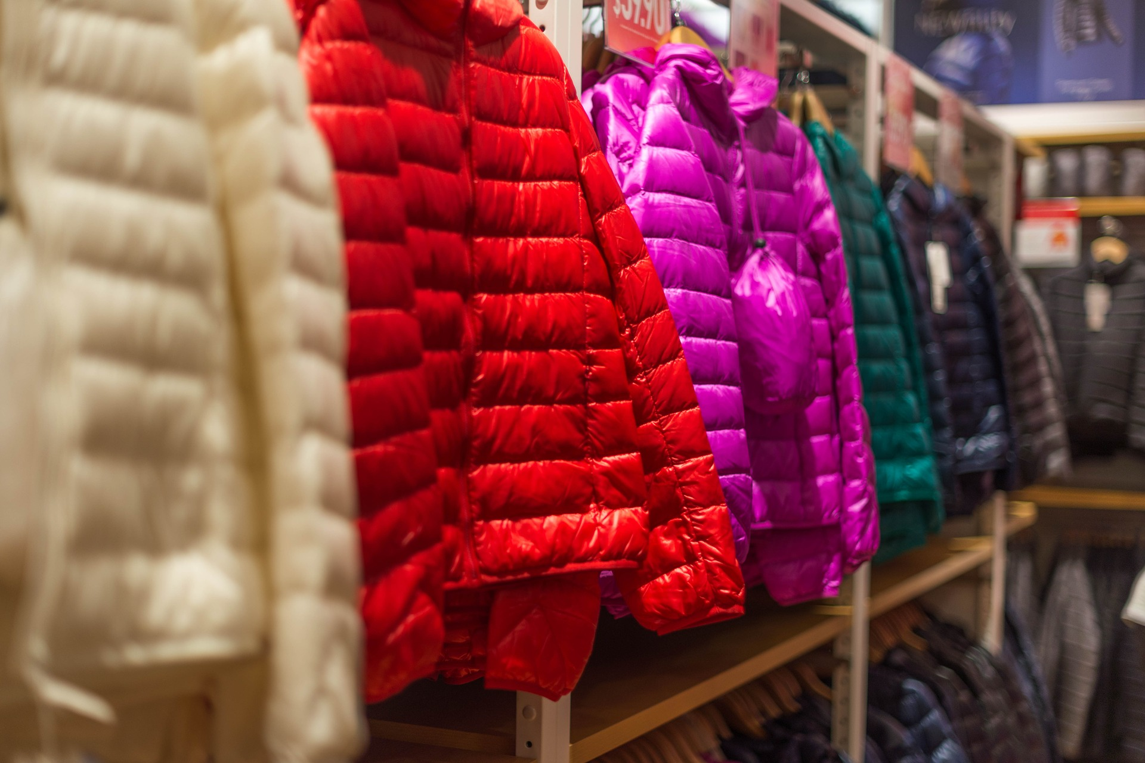
- What are 2 examples of temperatures that are comfortable for the down jacket?
- For which gear would a temperature of $\text{-}{16.5}^{∘}\text{F}$ be comfortable?
- Is it possible to list all the temperatures for which the down jacket is comfortable? Explain your reasoning.
- Which item's comfort rating matches each inequality?
  - $x≥20$
  - $\text{-}20≤x$
  - $\text{-}20≤x$ and $x≤20$
- Here are five graphs of inequalities. Match each graph to a situation in this activity.

- A

- B

- C

- D

- E
- Are there any temperatures at which the sleeping bags and the jacket would all be comfortable?
- Write one or more inequalities representing the range of temperatures in your area in the winter. Which gear, if any, would you recommend based on that?

3 Representing Inequalities

Student Task Statement
For each statement, write an inequality to represent it. If a variable is used, be prepared to explain what it represents.
- Han has 5 pencils, and Andre has 8.
- Noah has more books than Kiran.
- Clare has more than $200 in her savings account.
- The most the mechanic will charge for an oil change is $60.
- Diego scored 1,200 points in a game, breaking the record for highest score.
- Jada is younger than Tyler.
- Animal World has at least 400 different species of animals.
- Mai’s bowling score is more than Clare’s and Han’s combined.
© CC BY 2019 by Illustrative Mathematics®

