Lesson 4: Area of Rectangles
- Let’s find the area of more rectangles.

Warm-up: Which One Doesn’t Belong: Area and Arrays
Which one doesn’t belong?
A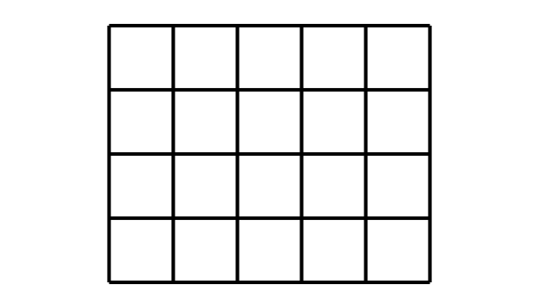
B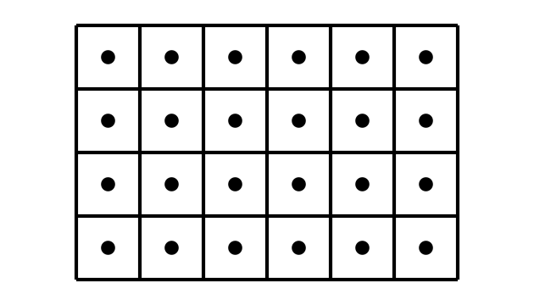
C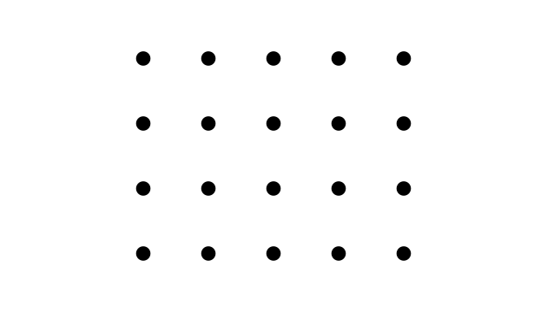
D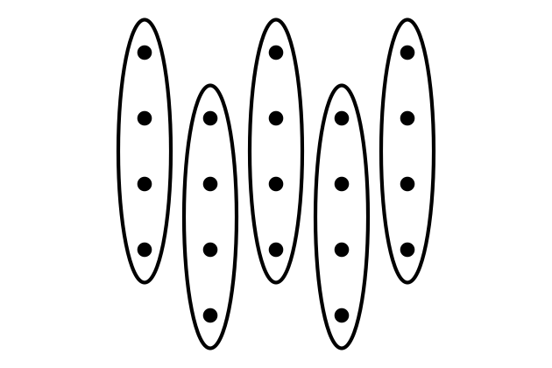

4.1: What Did I Create?
- Can you and your partner draw the same rectangle without looking at each other's drawing?
  - Partner A: Draw a rectangle on one of the grids provided. Describe it to your partner without telling them the total number of squares.
  - Partner B: Draw the rectangle your partner describes to you.
- Place your two rectangles next to each other. Discuss: What is the same? What is different?
- Switch roles and repeat.
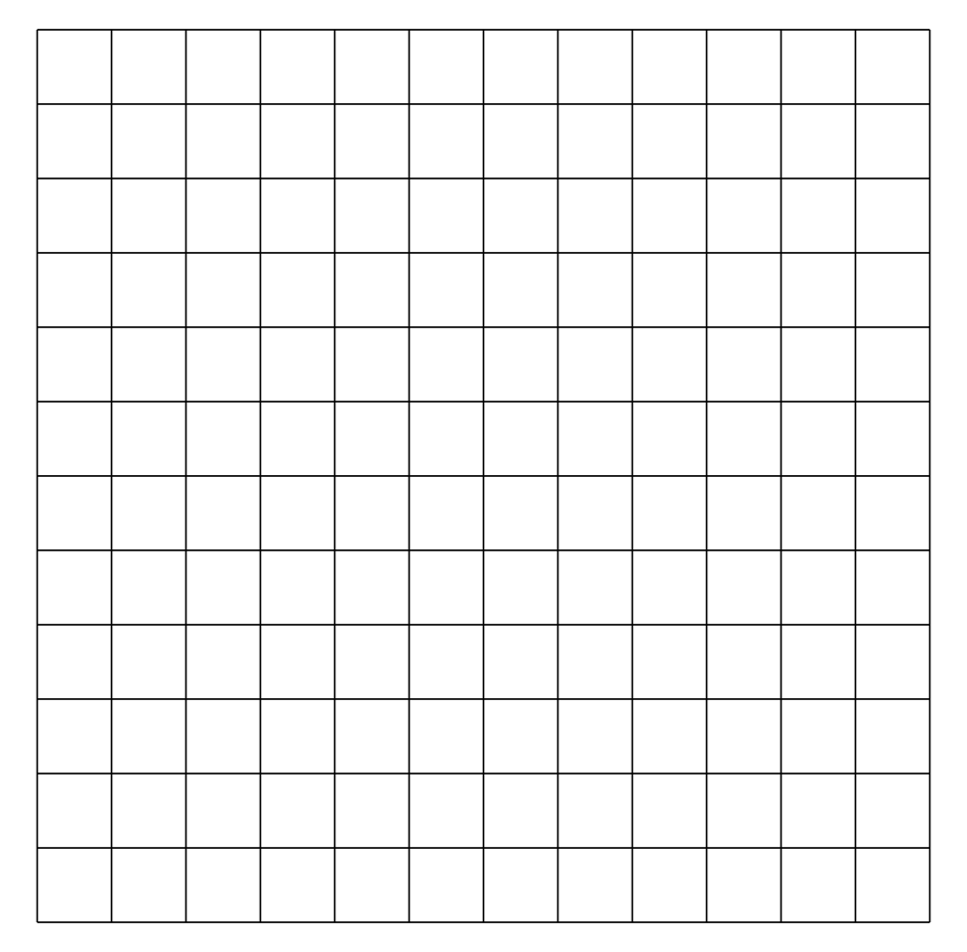

4.2: Find the Area
Find the area of each rectangle and include the units. Explain or show your reasoning.

- 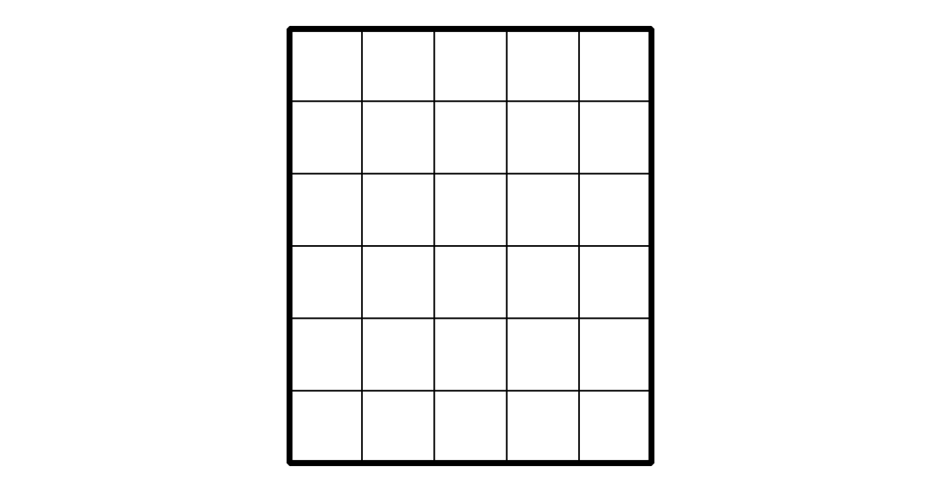

- 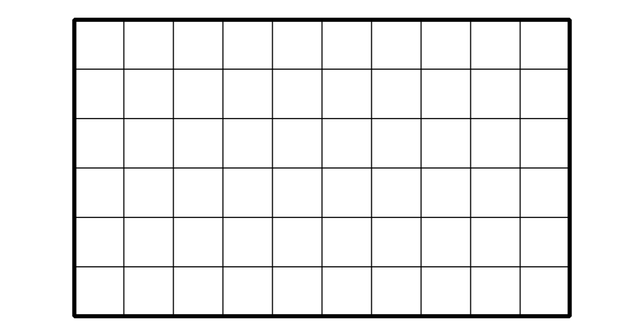

- 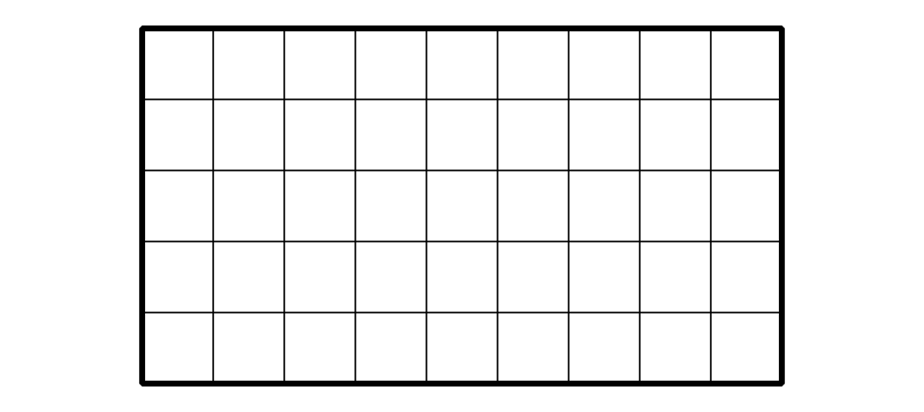

Section Summary
Section Summary
In this section, we learned that area is the amount of space covered by a shape.
We saw that we can count squares to measure area. When we tile a shape, we need to make sure that the squares are covering the whole shape without gaps or overlaps.
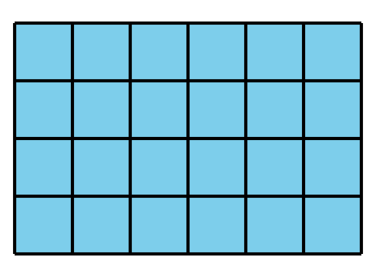
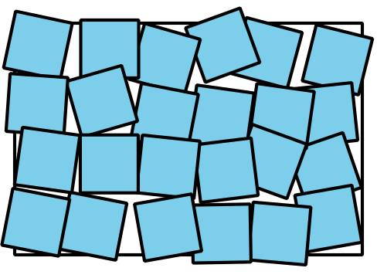
Area is measured in square units. The area of the tiled rectangle here is 24 square units.
© CC BY 2021 Illustrative Mathematics®

