Unit 6 Lesson 16: Design a Carnival Game

WU Notice and Wonder: Carnival Games (Warm up)

Student Task Statement
What do you notice? What do you wonder?
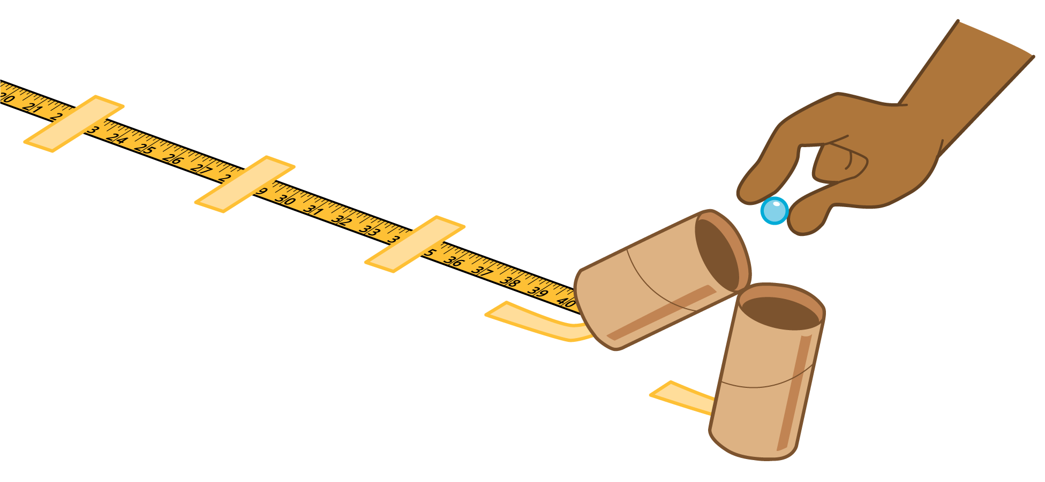
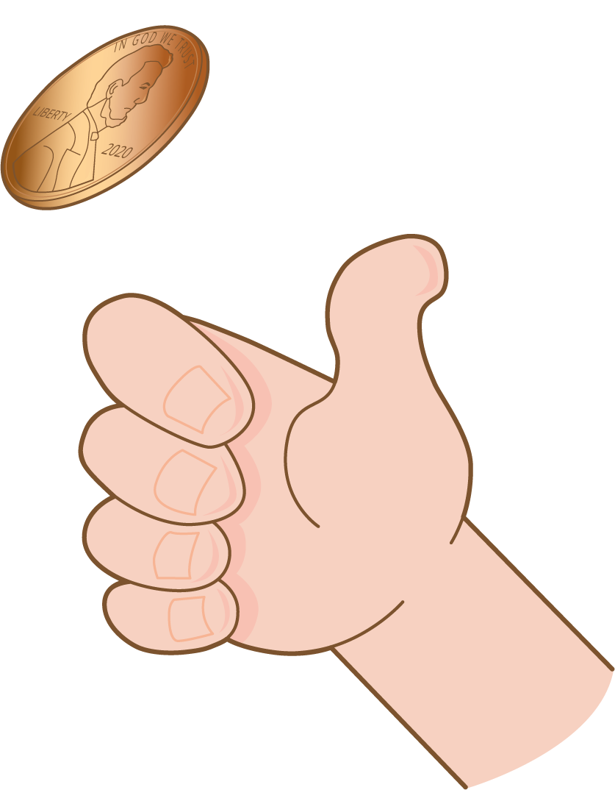

1 Create Your Own Carnival Game

Student Task Statement
- Use the materials to design your own carnival game.
  - What are the rules of your game?
  - How does someone win the game?
- Test out your game at least one time.
- Redesign your game to include at least 2 of the following:
  - length or distance measurement in inches
  - time that has passed
  - multiplication and division within 100
  - addition and subtraction within 1,000
If you have time, play the new and improved game.
© CC BY 2021 Illustrative Mathematics®

