Unit 7 Lesson 9: Use a Protractor to Measure Angles

WU True or False: There's Something about 45 (Warm up)

Student Task Statement
Decide if each statement is true or false. Be prepared to explain your reasoning.
- $2×45=6×15$
- $4×45=2×90$
- $3×45=180−90$
- $6×45=45+90+135$

1 How Large is a $1^{∘}$ Angle?

Student Task Statement
- A ray that turns all the way around its endpoint and back to its starting place has made a full turn or has turned ${360}^{∘}$.
- 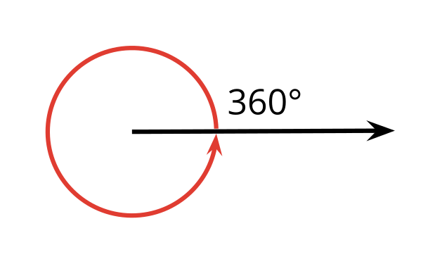
- What fraction of a full turn is each of the following angle measurements?
  - ${120}^{∘}$
  - ${60}^{∘}$
  - ${45}^{∘}$
  - ${30}^{∘}$
  - ${10}^{∘}$
  - $1^{∘}$
- Your teacher will give you a protractor, a tool for measuring the number of degrees in an angle.
  - How is $1^{∘}$ shown on the protractor?
  - How many $1^{∘}$ measurements do you see?
- A protractor with no numbers has been placed over an angle.
  - The center of the protractor is lined up with the vertex of the angle.
  - The straight edge of the protractor is lined up with a ray of the angle.
- How many degrees is this angle? Explain how you know.
- 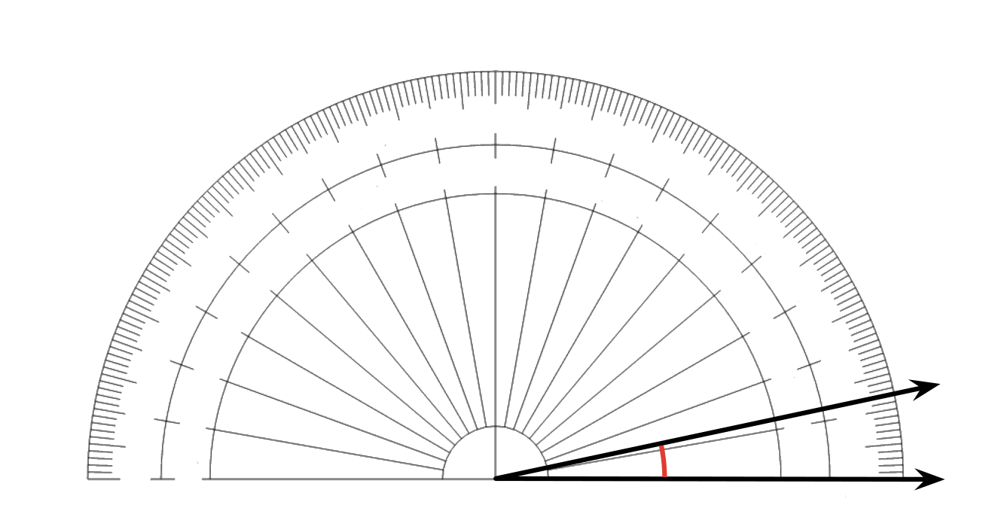
- An angle contains thirty $1^{∘}$ angles, as shown. How many degrees is this angle?
- 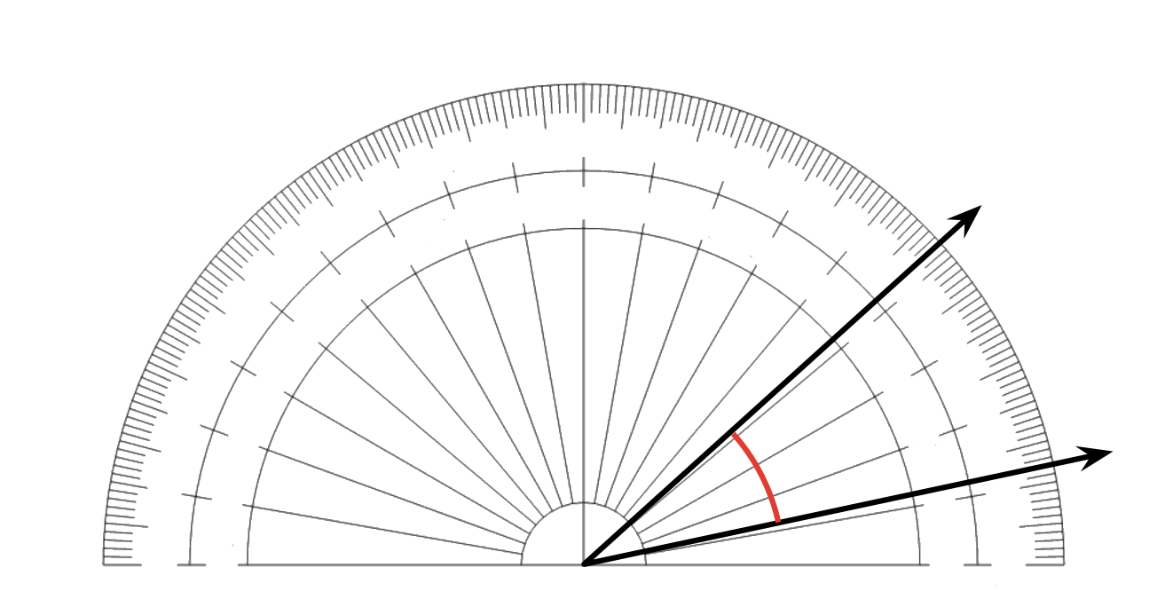

2 Use a Protractor

Student Task Statement
- Here are four angles whose sizes you may have estimated earlier. A protractor has been placed over each angle. Measure the size of each angle in degrees.

  - 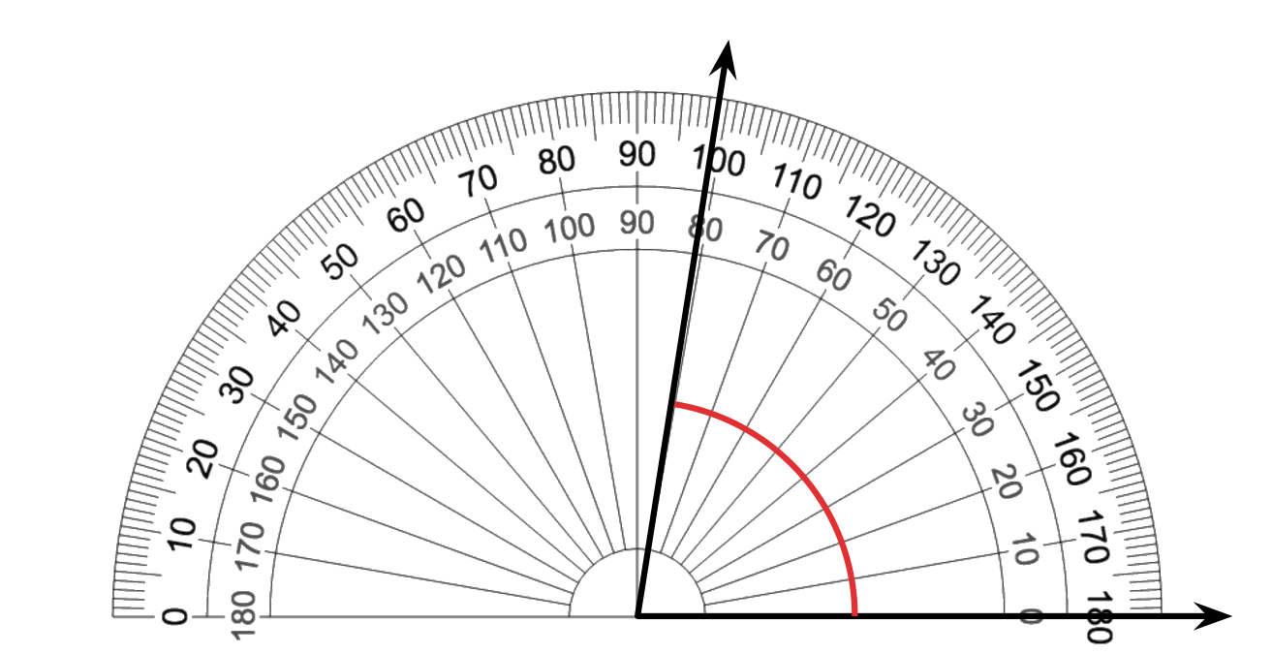

  - 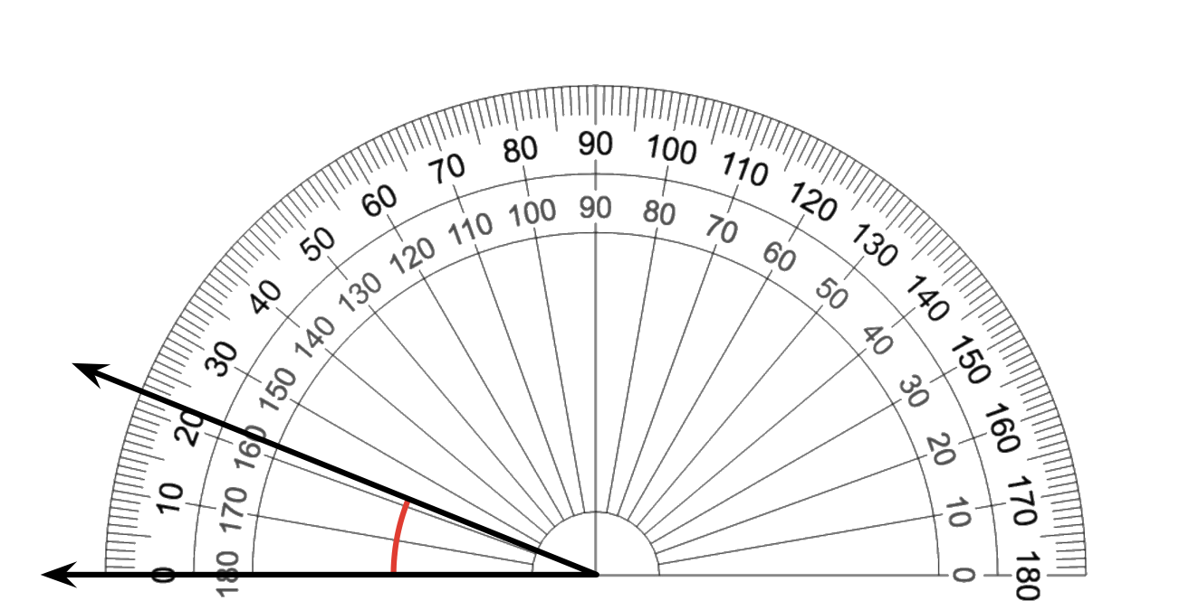

  - 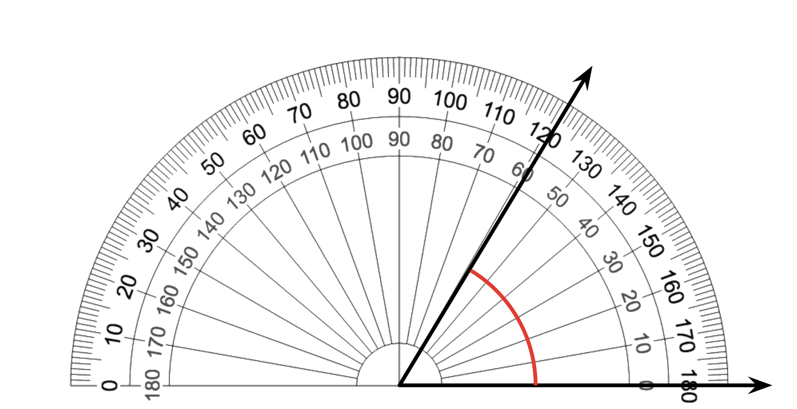

  - 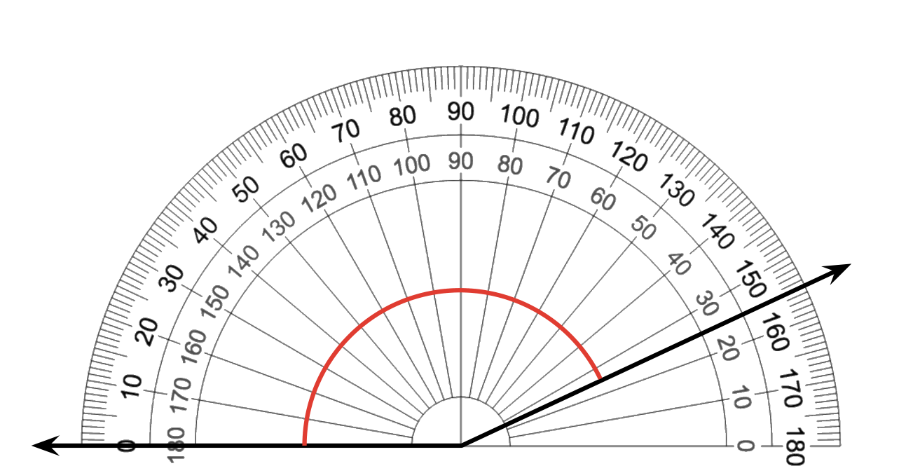
- Elena and Kiran are measuring an angle with a protractor. Elena says the angle is ${80}^{∘}$. Kiran says it shows ${100}^{∘}$. Why might they end up with different measurements? Which one is correct? Explain your reasoning.
- 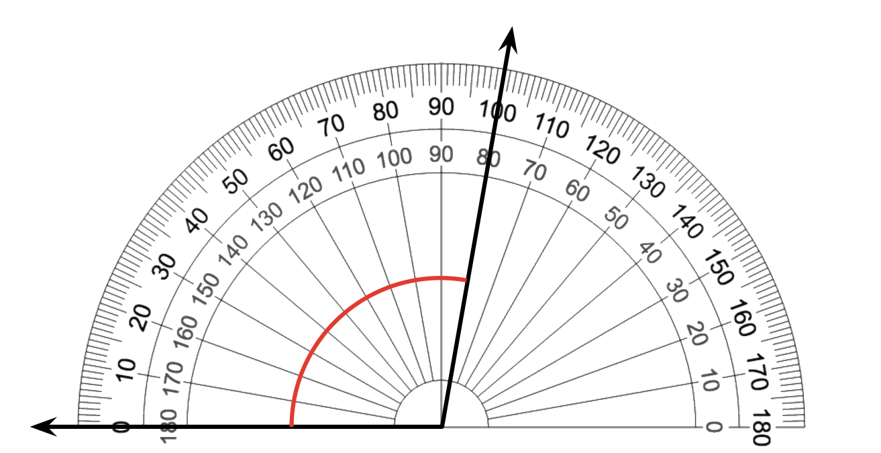

Images for Activity Synthesis
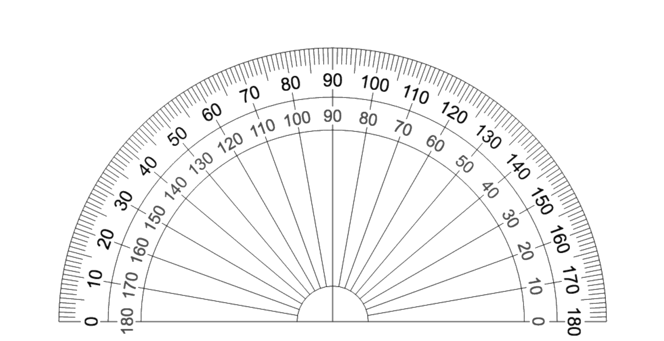
© CC BY 2021 Illustrative Mathematics®

