Lesson 22: The Pizzeria
- Let’s count pizza toppings.

Warm-up: Notice and Wonder: Pizza Toppings
What do you notice?
What do you wonder?
Jada's Pizza
Diego's Pizza
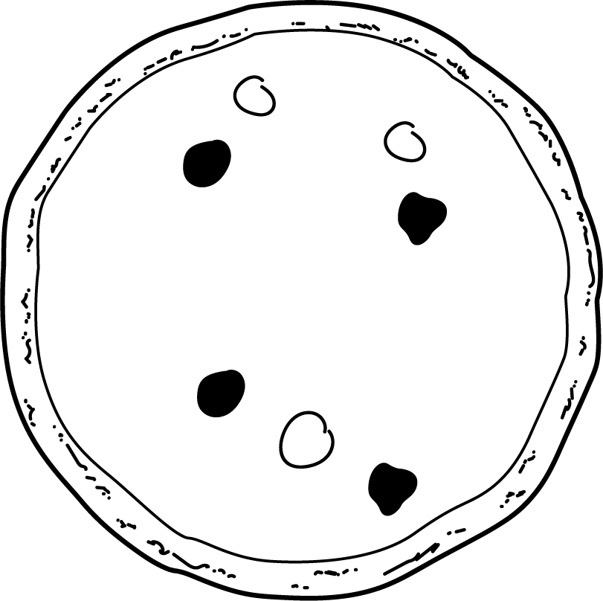
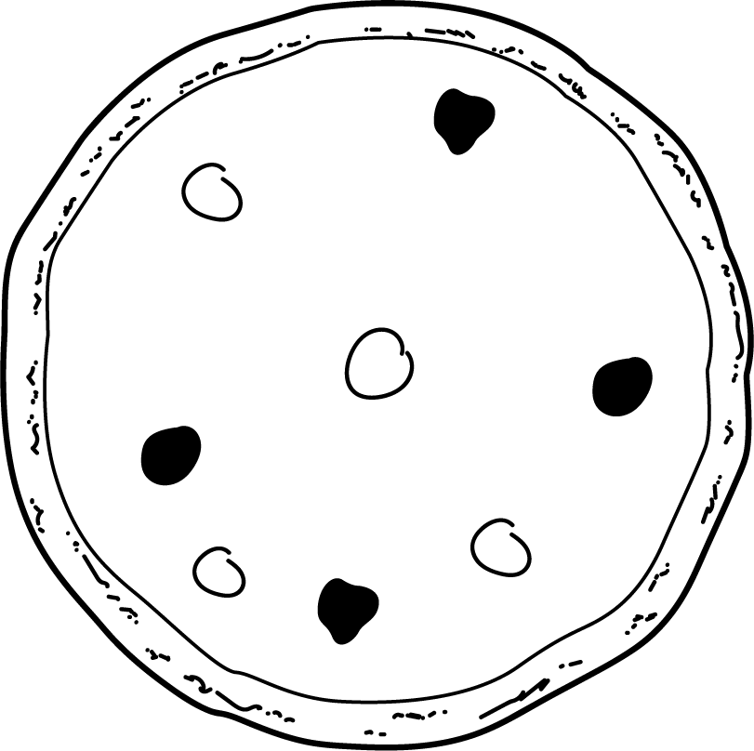

22.1: Class Pizza Order
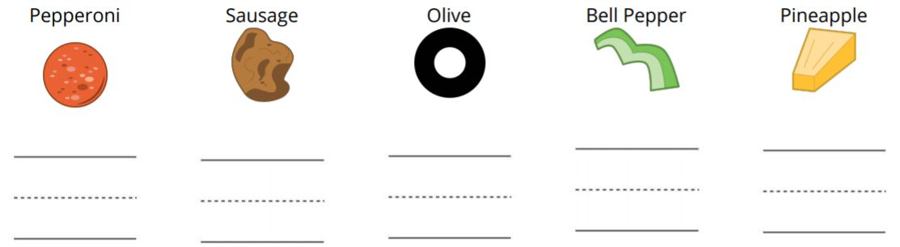

22.2: More Pizza Orders
© CC BY 2021 Illustrative Mathematics®

