Lesson 15 Practice Problems
- Select all the expressions that are equivalent to $\left(3−5i\right)\left(\text{-}8+2i\right)$.
  - $\text{-}24+6i−40i+10i^{2}$
  - $\text{-}24+46i−10$
  - $\text{-}24+6i+40i−10i^{2}$
  - $\text{-}14−34i$
  - $\text{-}34−34i$
  - $\text{-}24+46i+10$
  - $46i−14$
  - $\text{-}34+46i$
- Explain or show how to write $\left(20−i\right)\left(8+4i\right)$ in the form $a+bi$, where $a$ and $b$ are real numbers.
- Without going through all the trouble of writing the left side in the form $a+bi$, how could you tell that this equation is false?
- $\left(\text{-}9+2i\right)\left(10−13i\right)=\text{-}68−97i$
- Andre spilled something on his math notebook and some parts of the problems he was working on were erased. Here is one of the problems:
- $\left( −2i\right)\left( +2i\right)= −10i$
  - What could go in the blanks?
  - Could other numbers work, or is this the only possibility? Explain your reasoning.
- Find the exact solution(s) to each of these equations, or explain why there is no solution.
  - $x^{2}=49$
  - $x^{3}=49$
  - $x^{2}=\text{-}49$
  - $x^{3}=\text{-}49$
- (From Unit 3, Lesson 8.)
- Write each expression in the form $a+bi$, where $a$ and $b$ are real numbers. Optionally, plot $3+2i$ in the complex plane. Then plot and label each of your answers.
  - $2\left(3+2i\right)$
  - $i\left(3+2i\right)$
  - $\text{-}i\left(3+2i\right)$
  - $\left(3−2i\right)\left(3+2i\right)$
- 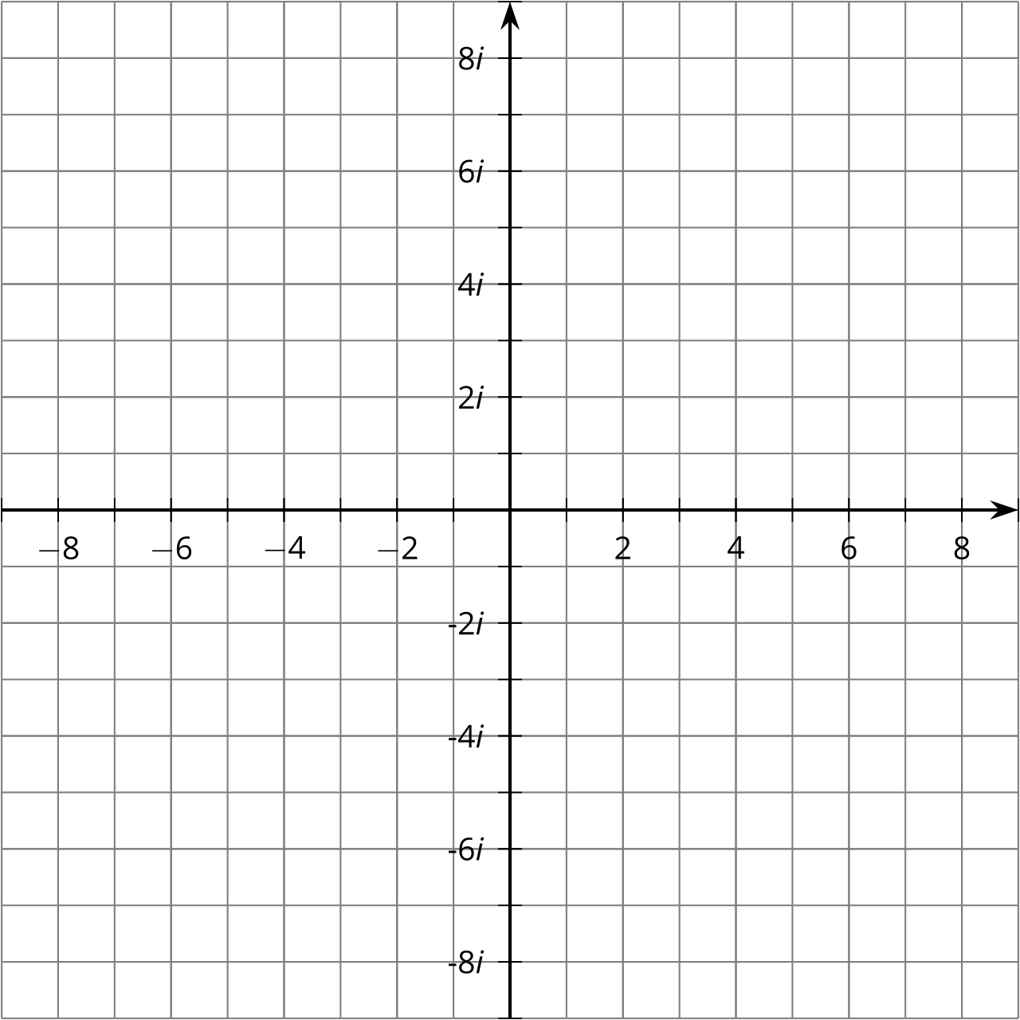
- (From Unit 3, Lesson 13.)
- The table shows two investment account balances growing over time.
- time  (years since 2000) | - account $A$  (thousands of dollars) | - account $B$  (thousands of dollars)
- 0 | - 5 | - 10
- 1 | - 5.1 | - 10.15
- 2 | - 5.2 | - 10.3
- 3 | - 5.3 | - 10.45
- 4 | - 5.4 | - 10.6
  - Describe a pattern in how each account balance changed from one year to the next.
  - Define the amount of money, in thousands of dollars, in accounts $A$ and $B$ as functions of time $t$, where $t$ is years since 2000, using function notation.
  - Will account $A$ ever have the same balance as account $B$? If so, when? Explain how you know.
- (From Unit 1, Lesson 10.)
© CC BY 2019 by Illustrative Mathematics®

