Lesson 13 Practice Problems
- Three drivers competed in the same fifteen drag races. The mean and standard deviation for the race times of each of the drivers are given.
- Driver A had a mean race time of 4.01 seconds and a standard deviation of 0.05 seconds.
- Driver B had a mean race time of 3.96 seconds and a standard deviation of 0.12 seconds.
- Driver C had a mean race time of 3.99 seconds and a standard deviation of 0.19 seconds.
  - Which driver had the fastest typical race time?
  - Which driver’s race times were the most variable?
  - Which driver do you predict will win the next drag race? Support your prediction using the mean and standard deviation.
- The widths, in millimeters, of fabric produced at a ribbon factory are collected. The mean is approximately 23 millimeters and the standard deviation is approximately 0.06 millimeters.
- Interpret the mean and standard deviation in the context of the problem.
- Select all the statements that are true about standard deviation.
  - It is a measure of center.
  - It is a measure of variability.
  - It is the same as the MAD.
  - It is calculated using the mean.
  - It is calculated using the median.
- The number of different species of plants in some gardens is recorded.
- 1 | - 2 | - 3 | - 4 | - 4 | - 5 | - 5 | - 6
- 7 | - 8

  - What is the mean?
  - What is the standard deviation?
- (From Unit 1, Lesson 12.)
- A set of data has ten numbers. The mean of the data is 12 and the standard deviation is 0. What values could make up a data set with these statistics?
- (From Unit 1, Lesson 12.)
- Which box plot has the largest interquartile range?
  - 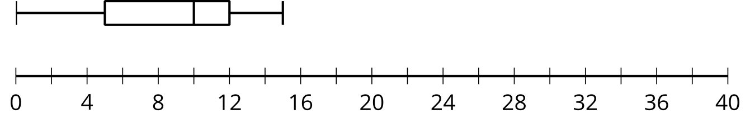
  - 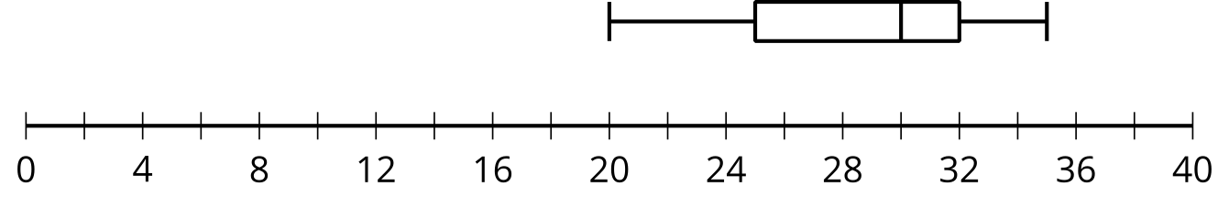
  - 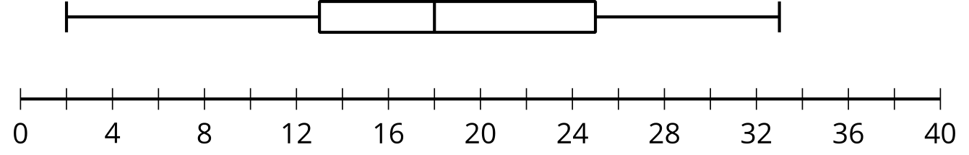
  - 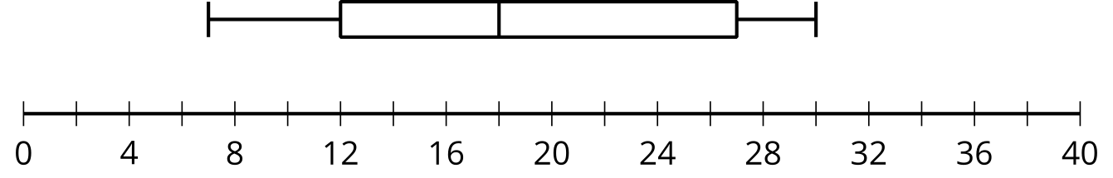
- (From Unit 1, Lesson 11.)

  - What is the five-number summary for 1, 3, 3, 3, 4, 8, 9, 10, 10, 17?
  - When the maximum, 17, is removed from the data set, what is the five-number summary?
- (From Unit 1, Lesson 9.)
© CC BY 2019 by Illustrative Mathematics®

