Unit 6 Lesson 2: How Does it Change?

1 Squares in a Figure (Warm up)

Student Task Statement
How does each expression represent the number of small squares in the figure?
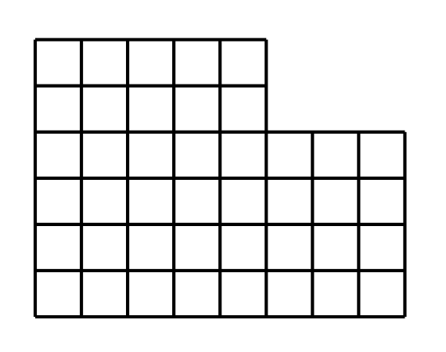
- Expression A: $6⋅8−2⋅3$
- Expression B: $4⋅8+2⋅5$
- Expression C: $8+8+8+8+5+5$
- Expression D: $5⋅6+3⋅4$

2 Patterns of Dots

Student Task Statement

Pattern 1
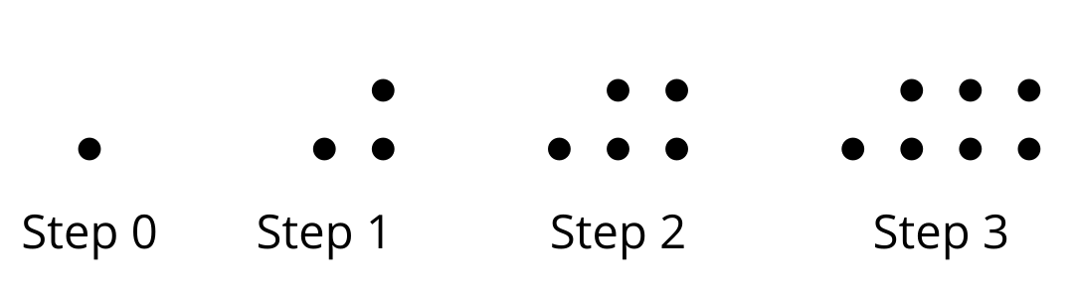

Pattern 2
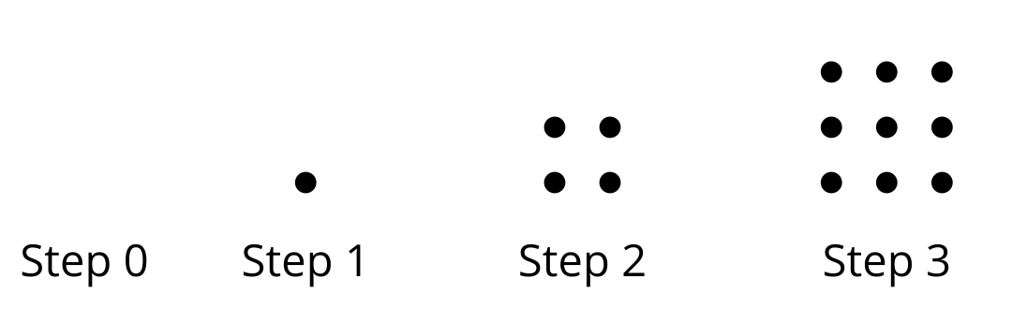
- Study the 2 patterns of dots.
  - How are the number of dots in each pattern changing?
  - How would you find the number of dots in the 5th step in each pattern?
- Complete the table with the number of dots in each pattern.
- step | - number of dots in Pattern 1 | - number of dots in Pattern 2
- 0
- 1
- 2
- 3
- 4
- 5
- 10
- $n$
- Plot the number of dots at each step number.

- Pattern 1
- 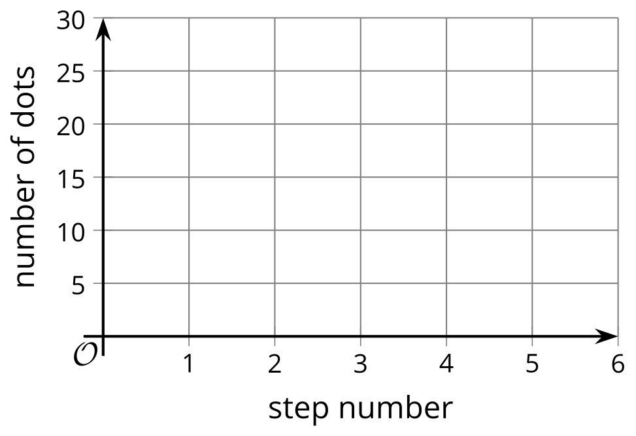

- Pattern 2
- Explain why the graphs of the 2 patterns look the way they do.

3 Expressing a Growth Pattern

Student Task Statement
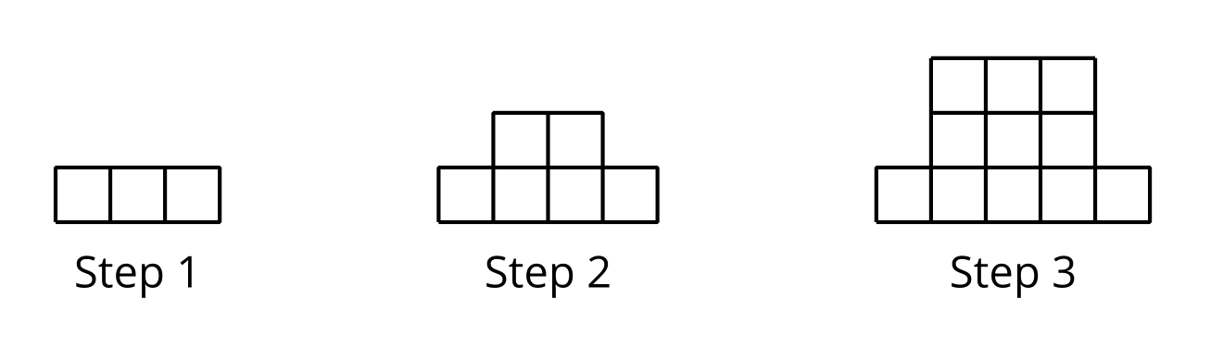
Here is a pattern of squares.
- Is the number of small squares growing linearly? Explain how you know.
- Complete the table.
- step | - number of small squares
- 1
- 2
- 3
- 4
- 5
- 10
- 12
- $n$
- Is the number of small squares growing exponentially? Explain how you know.
© CC BY 2019 by Illustrative Mathematics®

