Lesson 4 Practice Problems
- Angle $ABC$ is taken by a dilation with center $P$ and scale factor 3 to angle $A^{′}B^{′}C^{′}$. The measure of angle $ABC$ is ${21}^{∘}$. What is the measure of angle $A^{′}B^{′}C^{′}$?
- Select all lines that could be the image of line $m$ by a dilation.
- 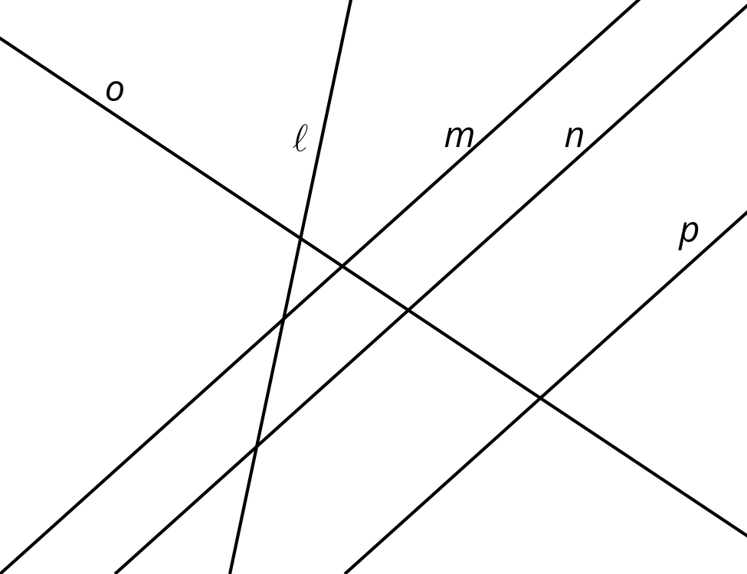
  - $ℓ$
  - $m$
  - $n$
  - $o$
  - $p$
- Dilate line $f$ with a scale factor of 2. The image is line $g$. Which labeled point could be the center of this dilation?
- 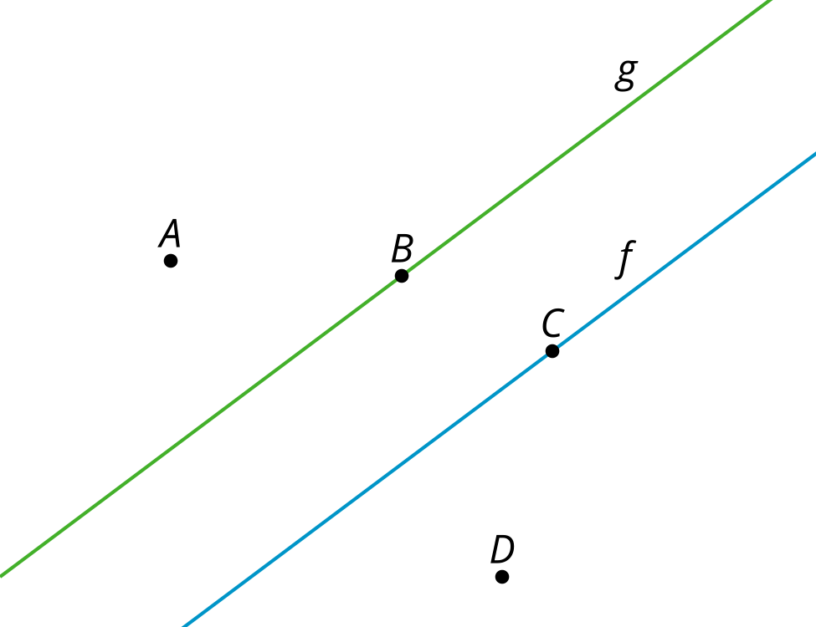
  - $A$
  - $B$
  - $C$
  - $D$
- Quadrilateral $A^{′}B^{′}C^{′}E^{′}$ is the image of quadrilateral $ABCE$ after a dilation centered at $F$. What is the scale factor of this dilation?
- 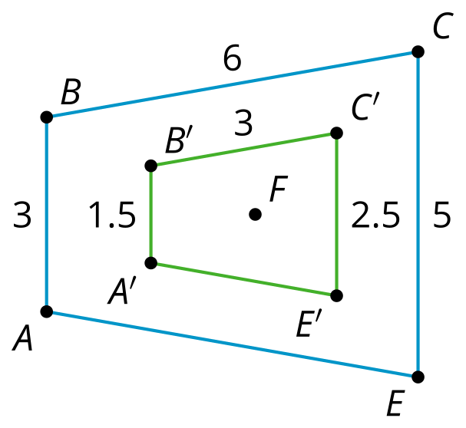
- (From Unit 3, Lesson 3.)
- A polygon has a perimeter of 18 units. It is dilated with a scale factor of $\frac{3}{2}$. What is the perimeter of its image?
  - 12 units
  - 24 units
  - 27 units
  - 30 units
- (From Unit 3, Lesson 3.)
- Solve the equation.
- $\frac{4}{7}=\frac{10}{x}$
- (From Unit 3, Lesson 1.)
- Here are some measurements for triangle $ABC$ and triangle $XYZ$:
  - Angle $CAB$ and angle $ZXY$ are both 30 degrees
  - $AC$ and $XZ$ both measure 3 units
  - $CB$ and $ZY$ both measure 2 units
- Andre thinks thinks these triangles must be congruent. Clare says she knows they might not be congruent. Construct 2 triangles with the given measurements that aren't congruent. Explain why triangles with 3 congruent parts aren't necessarily congruent.
- (From Unit 2, Lesson 11.)
© CC BY 2019 by Illustrative Mathematics®

