Lesson 4 Practice Problems
- The table shows the results from a survey that asked 100 adults if they had a high school diploma and if their annual income was more than $30,000.
 | - $30,000 or less | - more than $30,000
- high school diploma | - 21 | - 68
- no high school diploma | - 9 | - 2
- A person who took the survey is selected at random.
  - What is the probability that the person has a high school diploma and makes $30,000 or less?
  - What is the probability that the person has no high school diploma and earns more than $30,000?
- The table shows data from a science fair experiment that studied the number of eggs that hatched at three different temperatures.
 | - cool | - room temperature | - warm
- hatched | - 6 | - 14 | - 23
- not hatched | - 19 | - 11 | - 2
  - What percentage of the eggs hatched?
  - What percentage of the eggs that were at the cool temperature hatched?
  - What percentage of the eggs were not at room temperature?
  - What percentage of the eggs were at the warm temperature and did not hatch?
- The table shows information from a survey about the resting heart rate in beats per minute (bpm), for 50 people living at altitudes above and below 10,000 feet.
 | - below 80 bpm | - above 80 bpm | - total
- above 10,000 ft | - 3 | - 19 | - 22
- 10,000 ft or below | - 16 | - 12 | - 28
- total | - 19 | - 31 | - 50
  - Create a two-way table that shows the relative frequency for each of the values in the table relative to all 50 people in the survey.
  - What is the probability that a person surveyed, selected at random, has a heart rate above 80 bpm or lives above 10,000 ft?
  - What is the probability that a person surveyed, selected at random, has a heart rate above 80 bpm and lives above 10,000 ft?
- List all the possible outcomes for spinning the spinner and rolling a fair number cube.
- 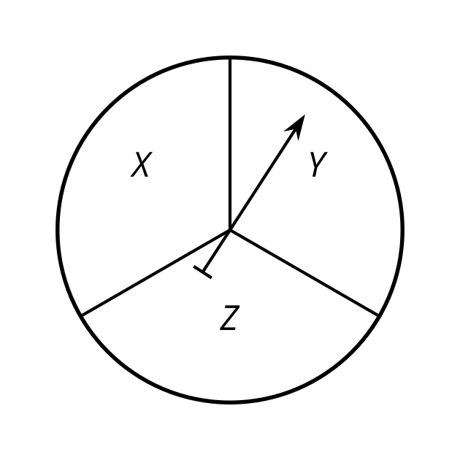
- (From Unit 8, Lesson 3.)
- A student flips a fair coin and then spins this spinner. How would you find the sample space?
- 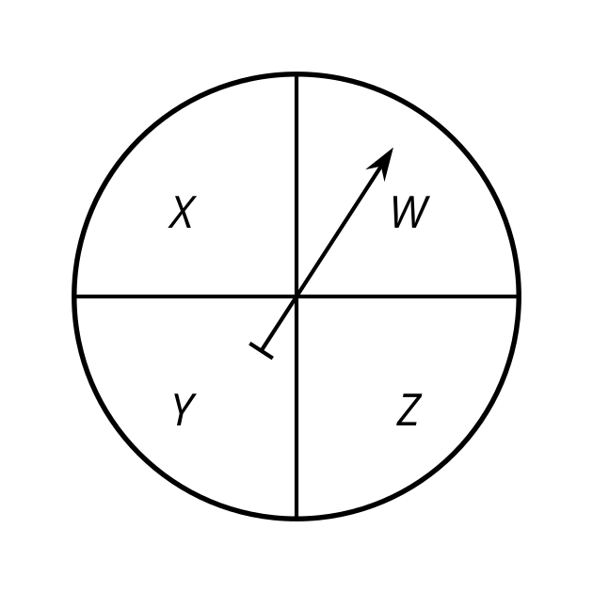
- (From Unit 8, Lesson 3.)
- Select all of the words for which the probability of selecting the letter A at random is $\frac{1}{4}$
  - AREA
  - ACID
  - ANGRY
  - APPEASED
  - AARDVARK
- (From Unit 8, Lesson 2.)
- On an assignment, there are two multiple choice questions with four answers choices each. You have no idea what the correct answer is to either one so you guess.
  - What is the probability that you get both of them right by guessing? Explain your answer.
  - What is the probability that you get exactly one of them right by guessing? Explain your answer.
- (From Unit 8, Lesson 1.)
- Here are 2 circles. The smaller circle has radius $r$, circumference $c$, and diameter $d$. The larger circle has radius $R$, circumference $C$, and diameter $D$. The larger circle is a dilation of the smaller circle by a factor of $k$.
- 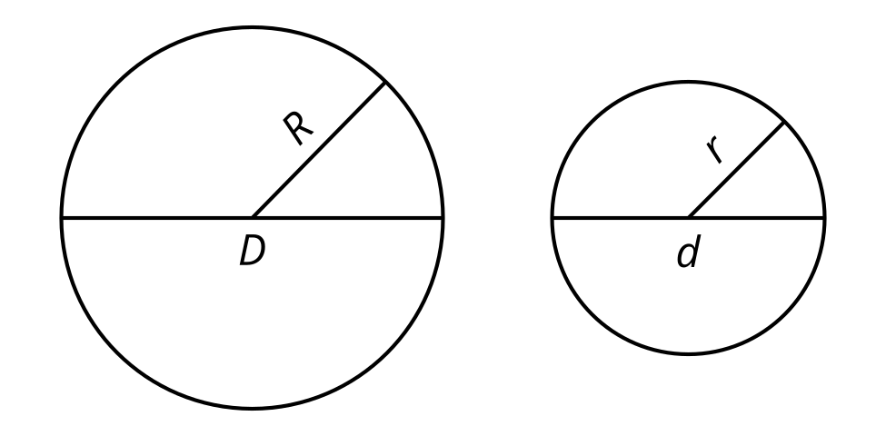
- Using the circles, match the pairs of ratios with their values.
  - The ratios $\frac{C}{c}$ and $\frac{R}{r}$ are both equal to $\underset{_}{}$.
  - The ratios $\frac{C}{D}$ and $\frac{c}{d}$ are both equal to $\underset{_}{}$.
  - The ratios $\frac{D}{R}$ and $\frac{d}{r}$ are both equal to $\underset{_}{}$.
  - 2
  - $k$
  - $π$
- (From Unit 7, Lesson 10.)
© CC BY 2019 by Illustrative Mathematics®

