## Unit 7 Lesson 3: Powers of Powers of 10

### 1 Big Cube (Warm up)

#### Student Task Statement

What is the volume of a giant cube that measures 10,000 km on each side?

### 2 Raising Powers of 10 to Another Power

#### Student Task Statement

* 1. Complete the table to explore patterns in the exponents when raising a power of 10 to a power. You may skip a single box in the table, but if you do, be prepared to explain why you skipped it.

|  |  |  |
| --- | --- | --- |
| * + expression | * + expanded | * + single power of 10 |
|  |  |  |
|  |  |  |
|  |  |  |
|  |  |  |
|  |  |  |

* 1. If you chose to skip one entry in the table, which entry did you skip? Why?

1. Use the patterns you found in the table to rewrite as an equivalent expression with a single exponent, like .
2. If you took the amount of oil consumed in 2 months in 2013 worldwide, you could make a cube of oil that measures meters on each side. How many cubic meters of oil is this? Do you think this would be enough to fill a pond, a lake, or an ocean?

#### Activity Synthesis

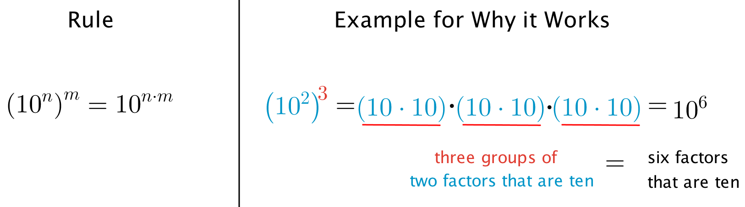

### 3 How Do the Rules Work?

#### Student Task Statement

Andre and Elena want to write with a single exponent.

* Andre says, “When you multiply powers with the same **base**, it just means you add the exponents, so .”
* Elena says, “ is multiplied by itself 3 times, so .”

Do you agree with either of them? Explain your reasoning.



© CC BY Open Up Resources. Adaptations CC BY IM.