Unit 8 Lesson 9: Finding Distances in the Coordinate Plane

1 Closest Distance (Warm up)

Student Task Statement
- Order the following pairs of coordinates from closest to farthest apart. Be prepared to explain your reasoning.
  - $(2,4)$ and $(2,10)$
  - $(\text{-}3,6)$ and $(5,6)$
  - $(\text{-}12,\text{-}12)$ and $(\text{-}12,\text{-}1)$
  - $(7,0)$ and $(7,\text{-}9)$
  - $(1,\text{-}10)$ and $(\text{-}4,\text{-}10)$
- Name another pair of coordinates that would be closer together than the first pair on your list.
- Name another pair of coordinates that would be farther apart than the last pair on your list.

2 How Far Apart?

Student Task Statement
Find the distances between the three points shown.
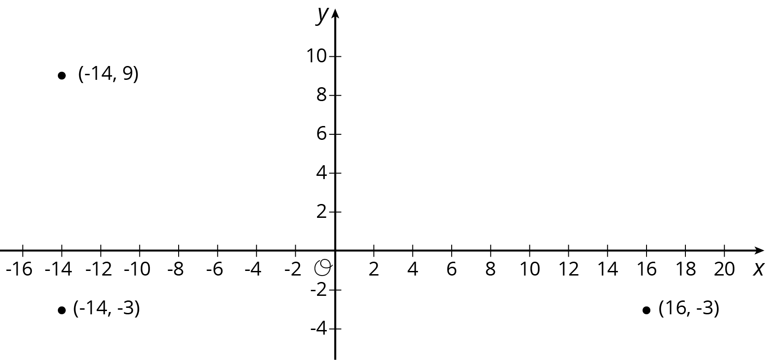

3 Perimeters with Pythagoras (Optional)

Student Task Statement
- Which figure do you think has the longer perimeter?
- Select one figure and calculate its perimeter. Your partner will calculate the perimeter of the other. Were you correct about which figure had the longer perimeter?
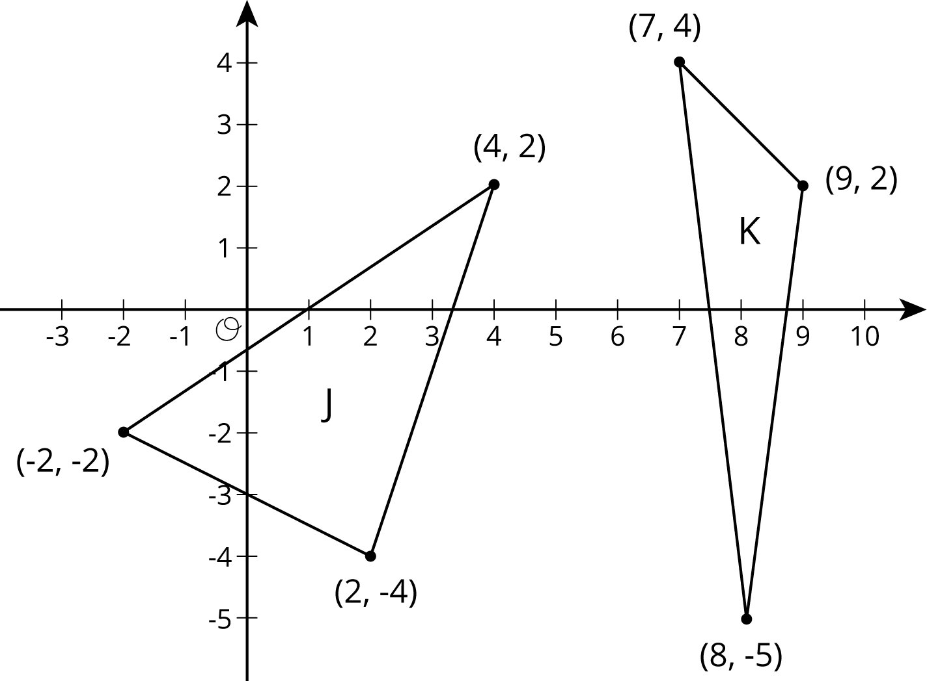

4 Finding the Right Distance

Student Task Statement
Have each person in your group select one of the sets of coordinate pairs shown here. Then calculate the length of the line segment between those two coordinates. Once the values are calculated, have each person in the group briefly share how they did their calculations.
- $(\text{-}3,1)$ and $(5,7)$
- $(\text{-}1,\text{-}6)$ and $(5,2)$
- $(\text{-}1,2)$ and $(5,\text{-}6)$
- $(\text{-}2,\text{-}5)$ and $(6,1)$
- How does the value you found compare to the rest of your group?
- In your own words, write an explanation to another student for how to find the distance between any two coordinate pairs.
© CC BY Open Up Resources. Adaptations CC BY IM.

