Lesson 20: Represent and Compare Numbers
- Let’s show numbers in different ways and make comparison statements.

Warm-up: Act It Out: Plates and Cups for Dinner
Lin and her brother are setting the table for dinner.
Lin put 8 cups on the table.
Her brother put 6 plates on the table.
Did Lin or her brother put more things on the table?
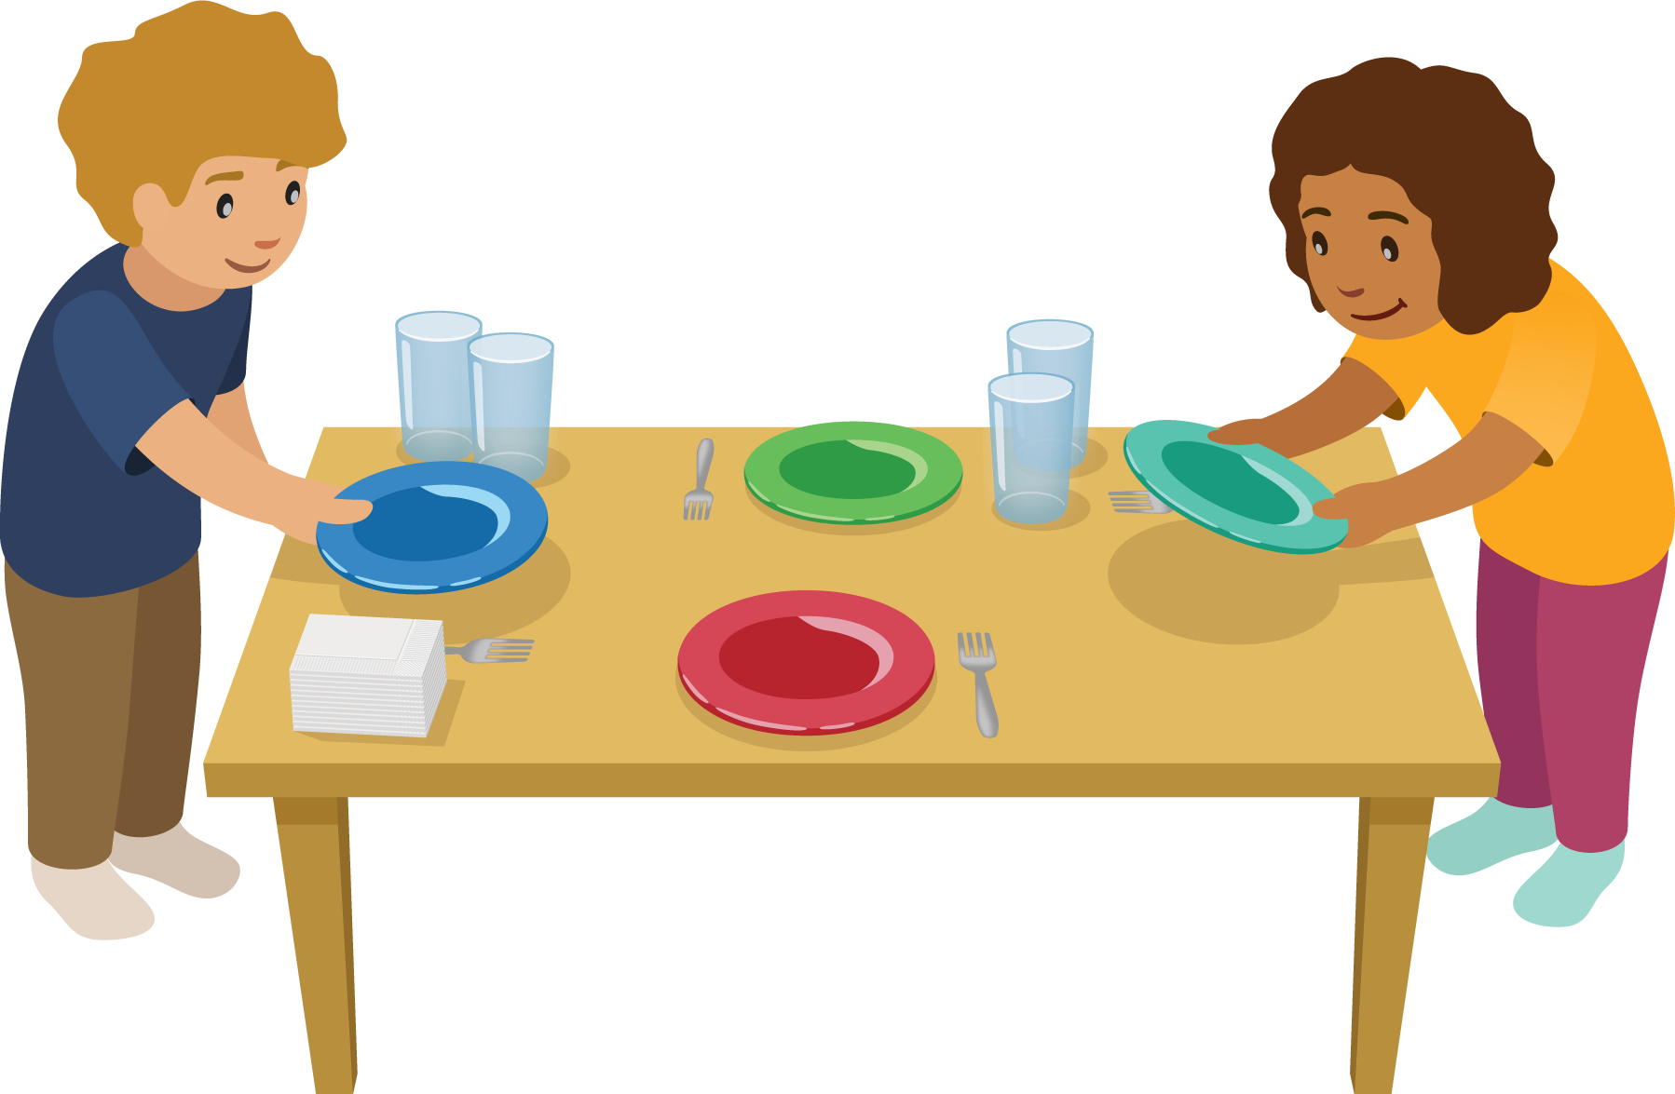

20.3: Centers: Choice Time
Choose a center.
Less, Same, More
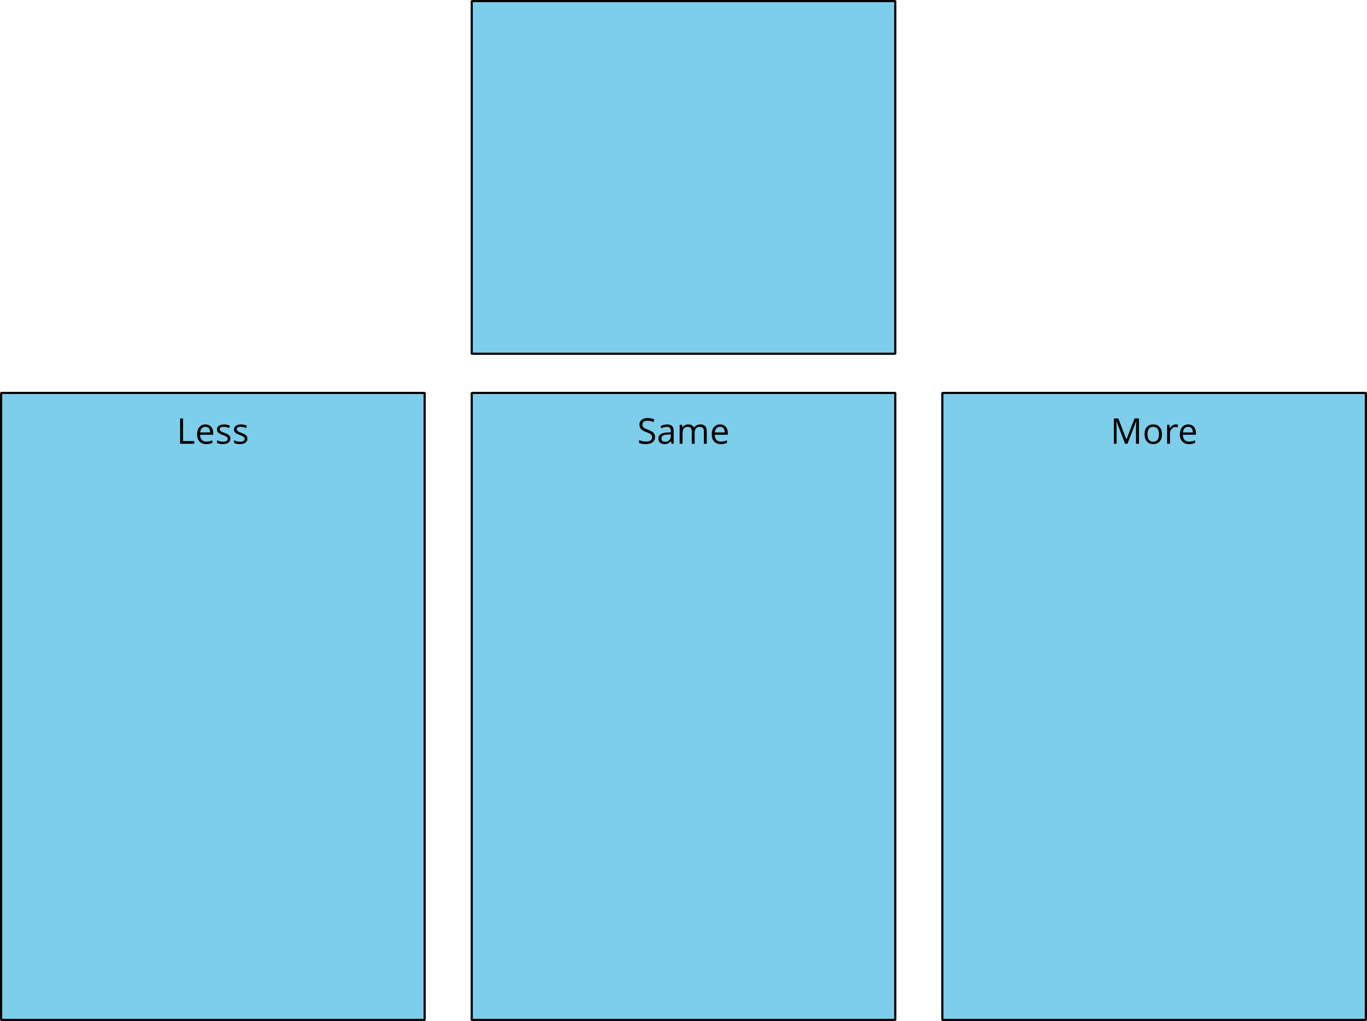
Math Libs
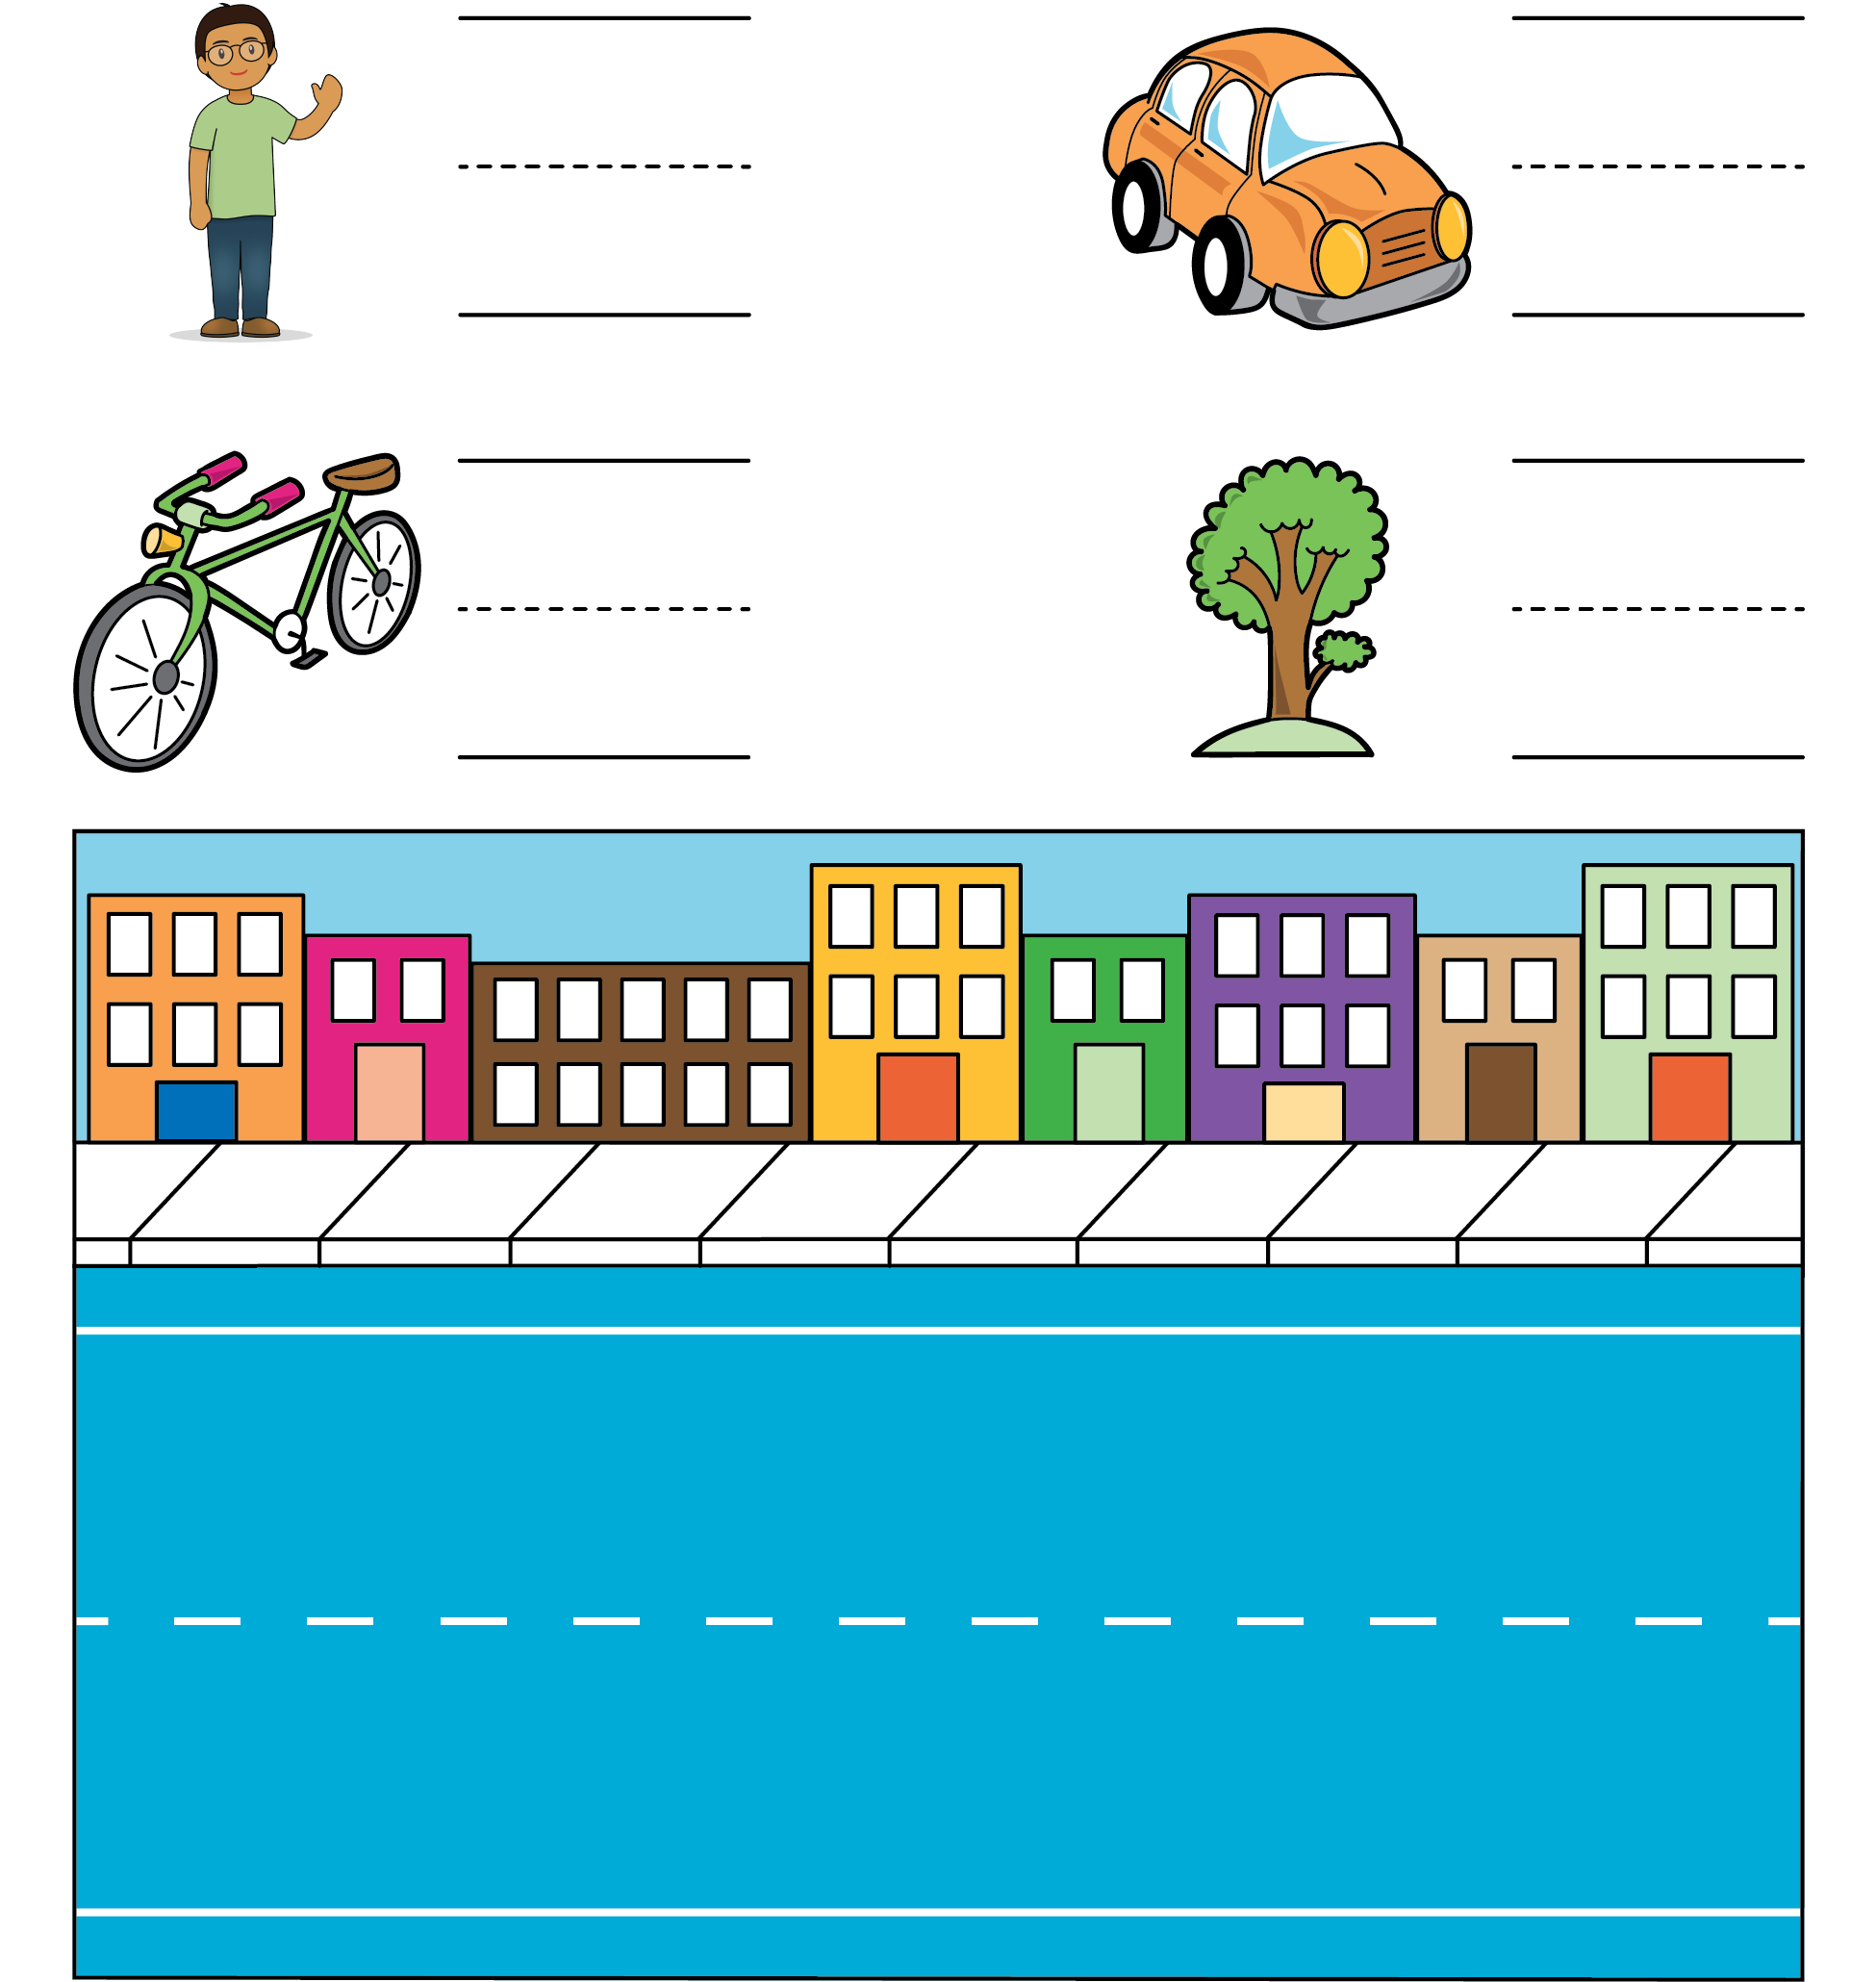
Number Race
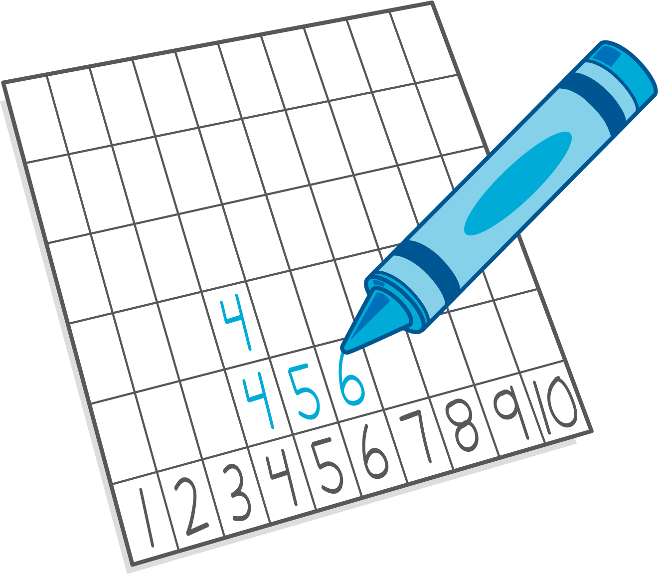
© CC BY 2021 Illustrative Mathematics®

