Lesson 13 Practice Problems
- Which expression is equivalent to $2i\left(5+3i\right)$?
  - $\text{-}6+10i$
  - $6+10i$
  - $\text{-}10+6i$
  - $10+6i$
- Lin says, “When you add or multiply two complex numbers, you will always get an answer you can write in $a+bi$ form.”
- Noah says, “I don’t think so. Here are some exceptions I found:”
- $\left(7+2i\right)+\left(3−2i\right)=10$
- $\left(2+2i\right)\left(2+2i\right)=8i$
  - Check Noah’s arithmetic. Is it correct?
  - Can Noah’s answers be written in the form $a+bi$, where $a$ and $b$ are real numbers? Explain or show your reasoning.
- Explain to someone who missed class how you would write $\left(3−5i\right)\left(\text{-}2+4i\right)$ in the form $a+bi$, where $a$ and $b$ are real numbers.
- Which expression is equal to ${729}^{\frac{2}{3}}$?
  - 243
  - 486
  - $9^{2}$
  - ${27}^{3}$
- (From Unit 3, Lesson 4.)
- Find the solution(s) to each equation, or explain why there is no solution.
  - $2x^{2}−\frac{2}{3}=5\frac{1}{3}$
  - ${\left(x+1\right)}^{2}=81$
  - $3x^{2}+14=12$
- (From Unit 3, Lesson 7.)
- Plot each number in the complex plane.
  - $5i$
  - $2+4i$
  - -3
  - $1−3i$
  - $\text{-}5−2i$
- 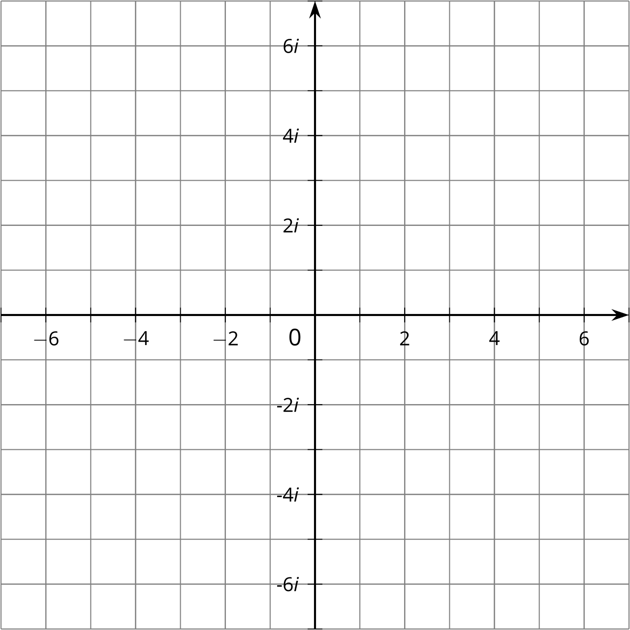
- (From Unit 3, Lesson 11.)
- Select all the expressions that are equivalent to $\left(3x+2\right)\left(x−4\right)$ for all real values of $x$.
  - $3x^{2}−12$
  - $3x^{2}−10x−8$
  - $3\left(x^{2}+2x−4\right)$
  - $3\left(x^{2}−3x\right)−\left(x+8\right)$
  - $3x\left(x−3\right)−2\left(5x+4\right)$
  - $3x\left(x−4\right)+2\left(x−4\right)$
- (From Unit 2, Lesson 23.)
© CC BY 2019 by Illustrative Mathematics®

