Unit 7 Lesson 13: Experimenting

1 Satisfaction Test (Warm up)

Student Task Statement
The dot plots represent the satisfaction ratings for two similar products resulting from a survey given to 5 randomly selected people who use product A and to 5 randomly selected people who use product B. The satisfaction rating is based on a scale of 1 to 5, where 1 is not satisfied, 2 is somewhat satisfied, 3 is satisfied, 4 is very satisfied, and 5 is extremely satisfied.
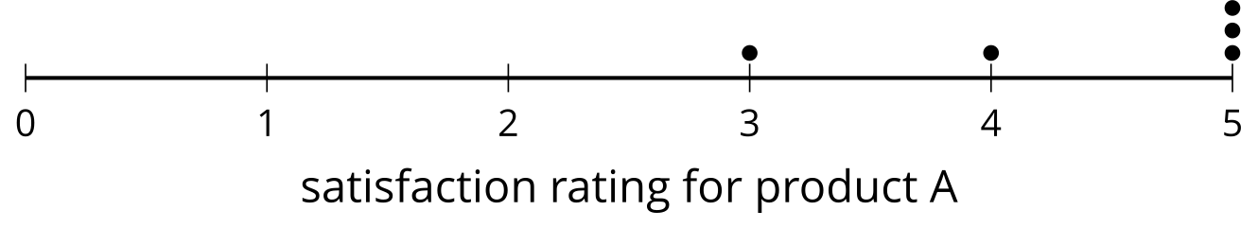
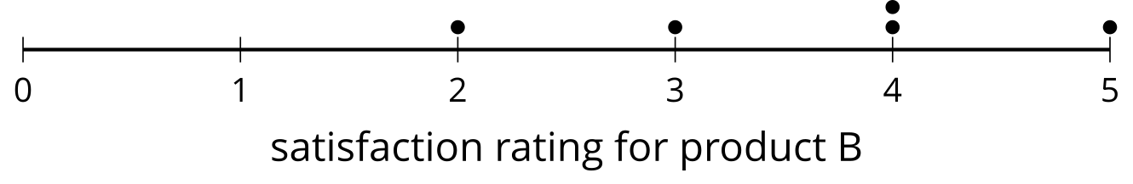
- Which product has a higher overall satisfaction rating? Explain your reasoning.
- Do you think that 2 different random samples of 5 people would lead you to the same conclusion?

2 Randomizing Satisfaction

Student Task Statement
Your teacher will select 10 of your classmates to create a randomization distribution using the data from the warm-up.
- Complete the table using the data from the activity.
- trial | - group 1's mean | - group 2's mean | - (group 1's mean) minus (group 2's mean)
- actual | - 4.4 | - 3.6 | - 0.8
- 1
- 2
- 3
- 4
- 5
- 6
- 7
- 8
- 9
- 10
- Complete the dot plot to display the distribution of the differences of the means.
- 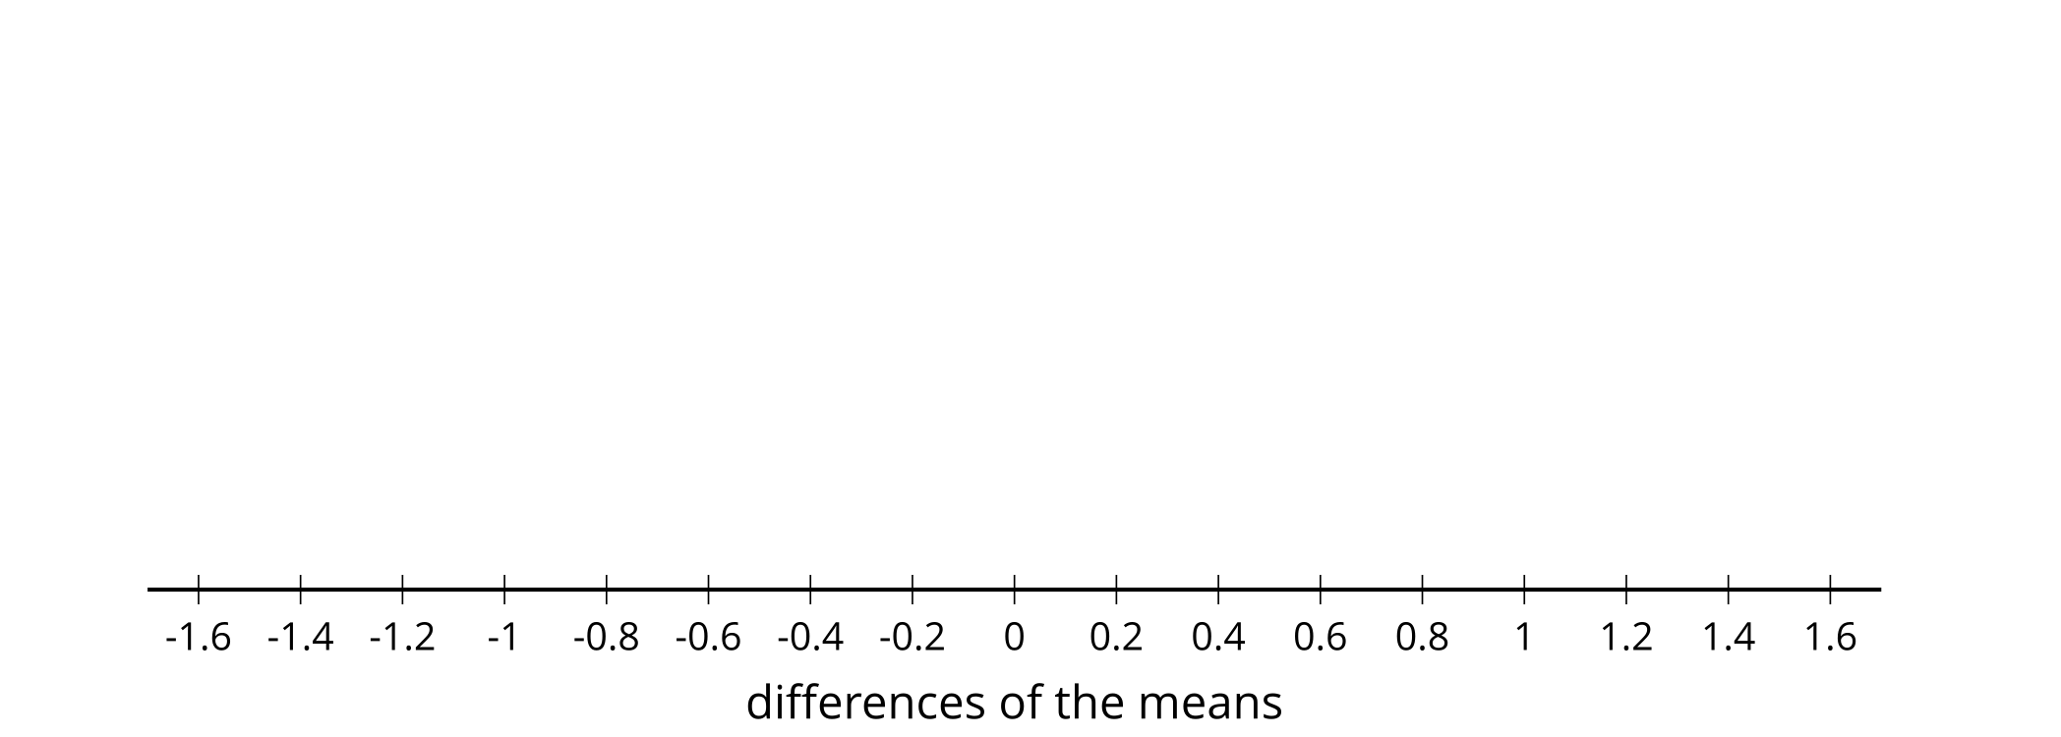
- What information is represented in the dot plot?
- In what percentage of the trials are the means from the two groups at least as far apart as the actual groupings from the warm-up?

Activity Synthesis
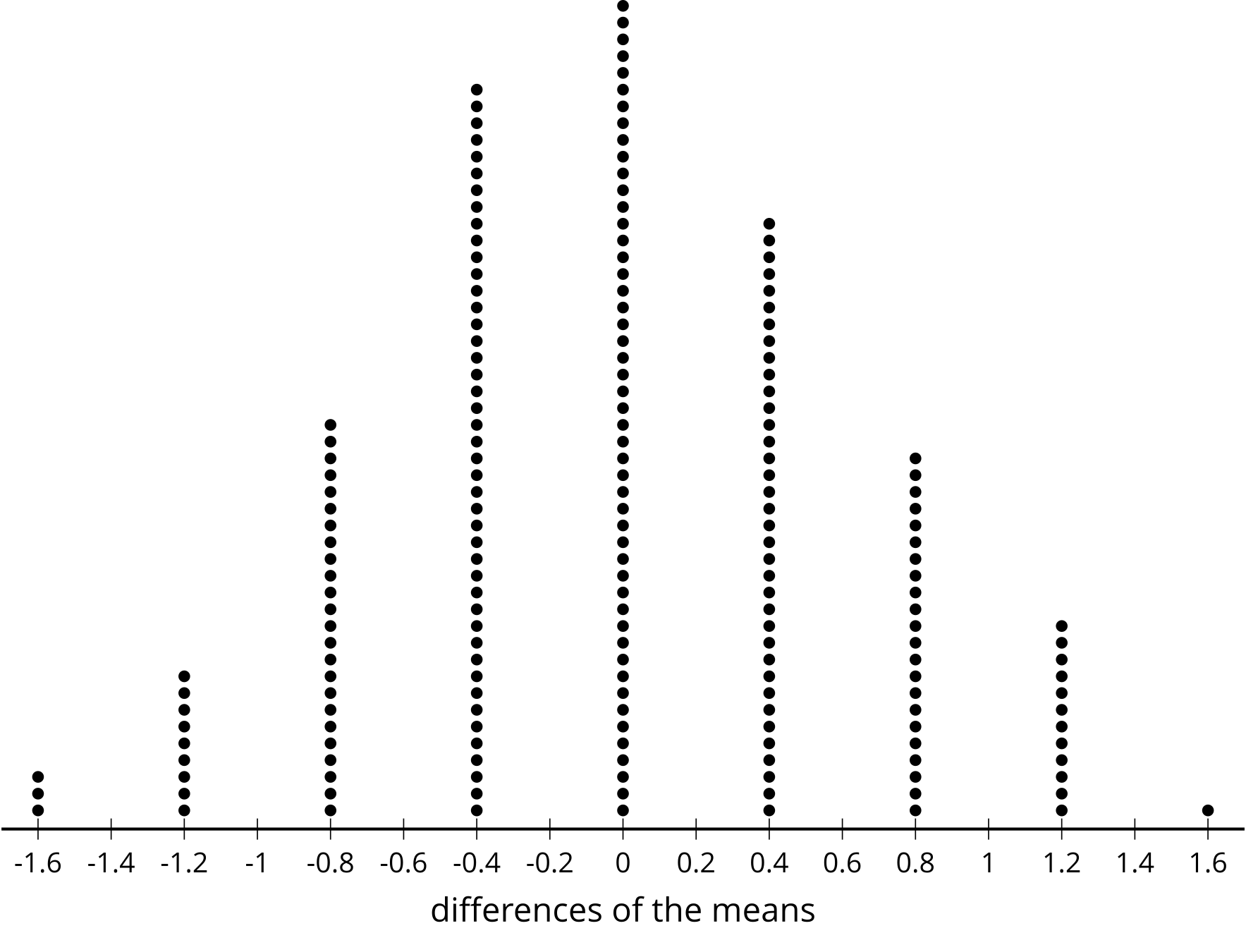

3 Get Ready to Experiment

Student Task Statement
Does counting while exercising affect your heart rate? Let’s think about how to design an experiment to find out.
- For another lesson, the class will be divided into 2 groups. One group will do an exercise silently. The other group will count out loud while they do the exercise. Which of these methods would be good for dividing the class so the results are based only on the counting and heart rate rather than other factors? Explain your reasoning for each method suggested.
  - The athletes in the class are assigned to the counting group and the non-athletes are assigned to the silent group.
  - The teacher puts everyone’s name in a bag and draws half of the names. The names that are drawn are in the group that counts, and the others remain silent for the exercise.
  - The tallest half of the students are put in the counting group and the shortest half of the students are assigned to the silent group.
- Do you think counting out loud will have an effect on heart rate? Explain your reasoning.
- A treatment is the value of the variable that is changed between the two groups in an experiment. What is the treatment in this experiment?
- How would you design an experiment to answer the question, “Does counting while exercising affect your heart rate?”
© CC BY 2019 by Illustrative Mathematics®

