Lesson 2 Practice Problems
- Figure $G^{′}$ is the image of figure $G$ by a dilation with scale factor 2. Where is the center of this dilation?
- 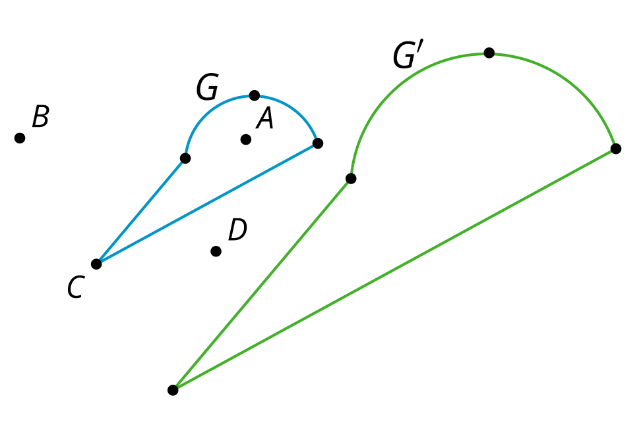
  - Point $A$
  - Point $B$
  - Point $C$
  - Point $D$
- Dilate quadrilateral $ABCD$ using center $A$ and scale factor $\frac{1}{2}$.
- 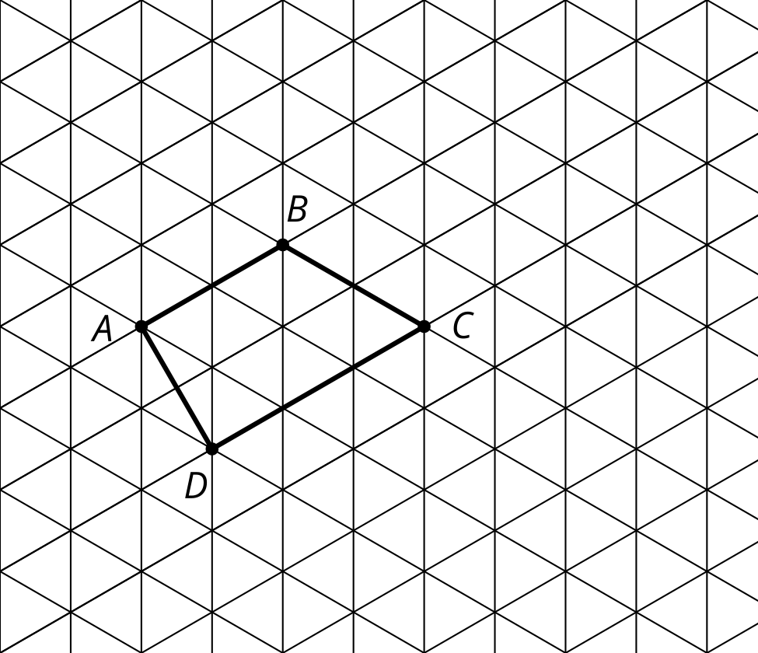
- Triangle $ABC$ is dilated. The image is $A^{′}B^{′}C^{′}$, find the value of $x$.
- 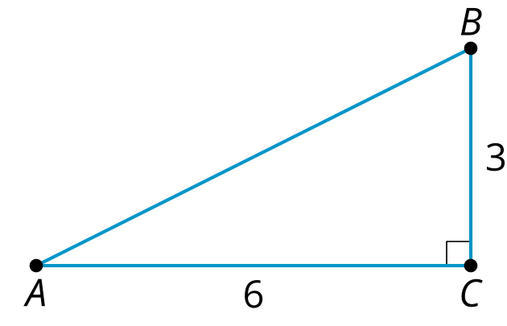
- 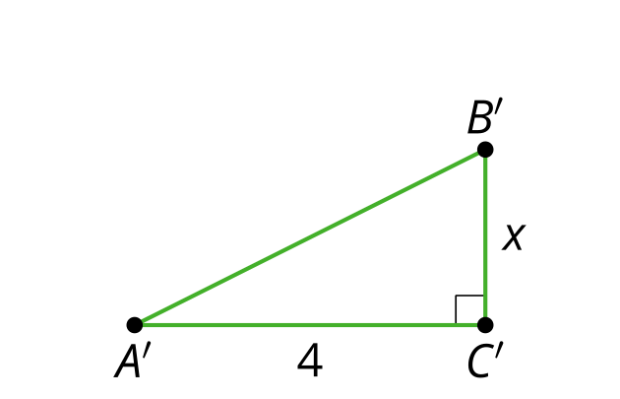
- Polygon $Q$ is a scaled copy of Polygon $P$.
- 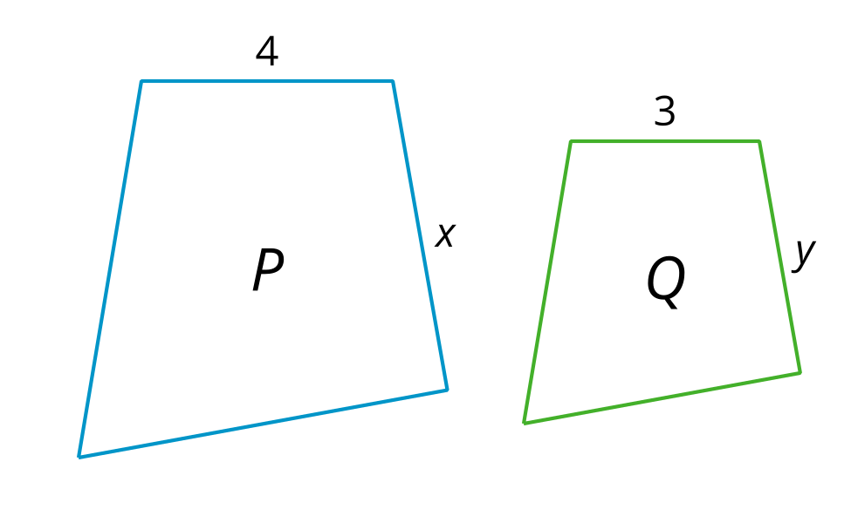
- The value of $x$ is 6, what is the value of $y$?
  - $\frac{7}{2}$
  - 4
  - $\frac{9}{2}$
  - 5
- (From Unit 3, Lesson 1.)
- Solve each equation.
  - $\frac{2}{5}=\frac{x}{20}$
  - $\frac{2}{3}=\frac{x}{10}$
- (From Unit 3, Lesson 1.)
- $WXYZ$ is a kite. Angle $WXY$ has a measure of 94 degrees and angle $ZYX$ has a measure of 60 degrees. Find the measure of angle $ZWY$.
- 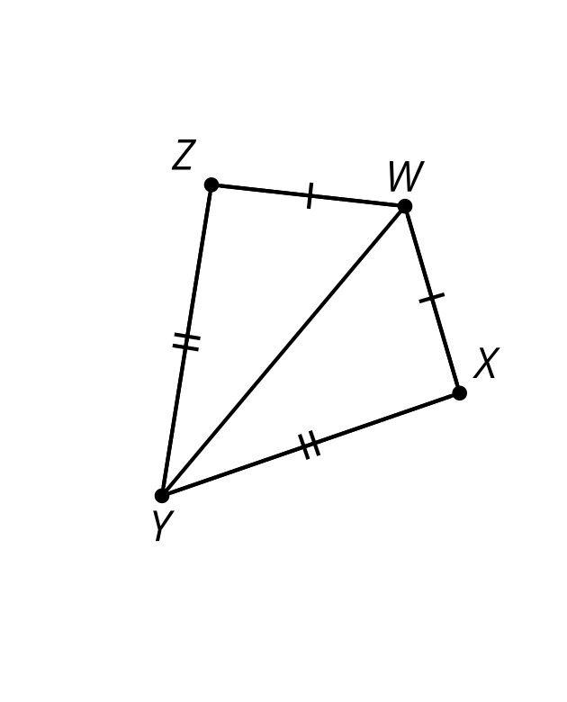
- (From Unit 2, Lesson 9.)
- The semaphore alphabet is a way to use flags to signal messages. Here's how to signal the letter U. Describe a transformation that would take the right hand flag to the left hand flag.

- U
- 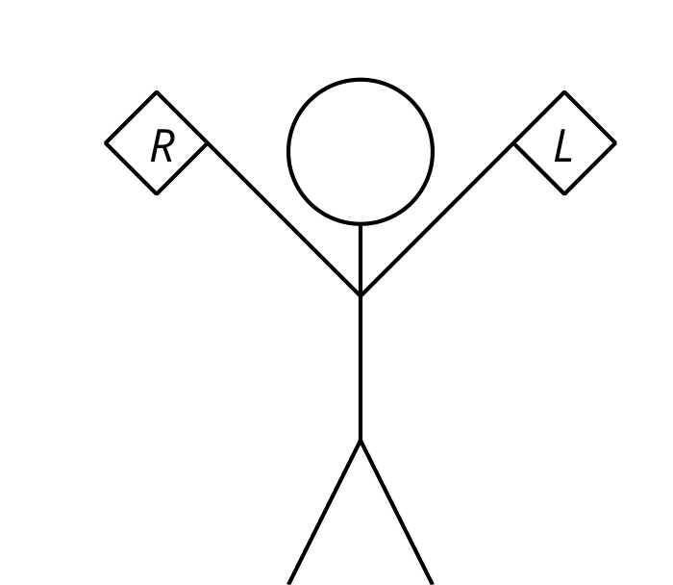
- (From Unit 1, Lesson 13.)
© CC BY 2019 by Illustrative Mathematics®

