Lesson 2 Practice Problems
- Six papers are placed in a bag with names written on them. The names are: Lin, Mai, Mai, Noah, Priya, and Priya. If one name is chosen at random, what is the probability that it is Priya?
  - $\frac{1}{4}$
  - $\frac{1}{6}$
  - $\frac{2}{4}$
  - $\frac{2}{6}$
- Select all of the words for which the probability of selecting the letter E at random is $\frac{1}{3}$.
  - THE
  - BEST
  - SNEEZE
  - FREES
  - SPEECH
- Design a situation where the probability of one event is $\frac{1}{5}$ and another event is $\frac{1}{10}$. Explain your reasoning.
- What is the probability of the spinner landing on the section labeled B?
- 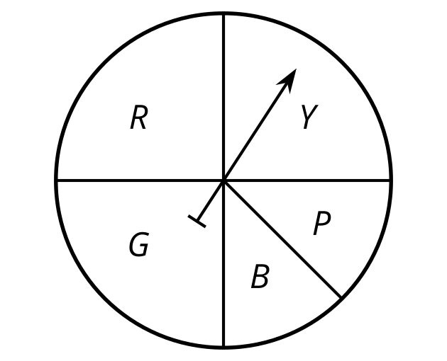
  - $\frac{1}{8}$
  - $\frac{1}{5}$
  - $\frac{1}{4}$
  - $\frac{1}{2}$
- (From Unit 8, Lesson 1.)
- This spinner is spun 300 times. Estimate the number of times it would be expected to land on the section labeled B.
- 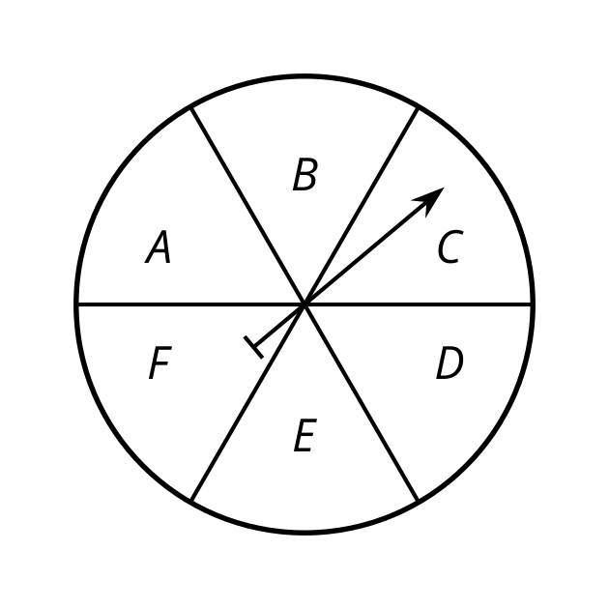
- (From Unit 8, Lesson 1.)
- A circle has radius 5 units. For each angle measure, find the area of a sector of this circle with that central angle.
  - $π$ radians
  - 3 radians
- (From Unit 7, Lesson 13.)
- Select all formulas that could be used to find the area of this sector. The angle $θ$ is measured in radians.
- 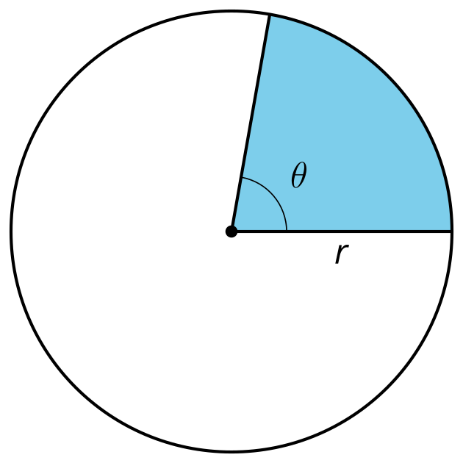
  - $\frac{1}{2}r^{2}θ$
  - $\frac{θ}{2π}⋅πr^{2}$
  - $\frac{θ}{360}⋅πr^{2}$
  - $\frac{π^{2}}{r}⋅θ$
  - $\frac{θ}{2π}⋅2πr$
- (From Unit 7, Lesson 13.)
- Triangle $ABC$ is shown with an inscribed circle of radius 4 units centered at point $D$. The inscribed circle is tangent to side $AB$ at point $G$. The length of $AG$ is 6 units and the length of $BG$ is 8 units. What is the measure of angle $B$?
- 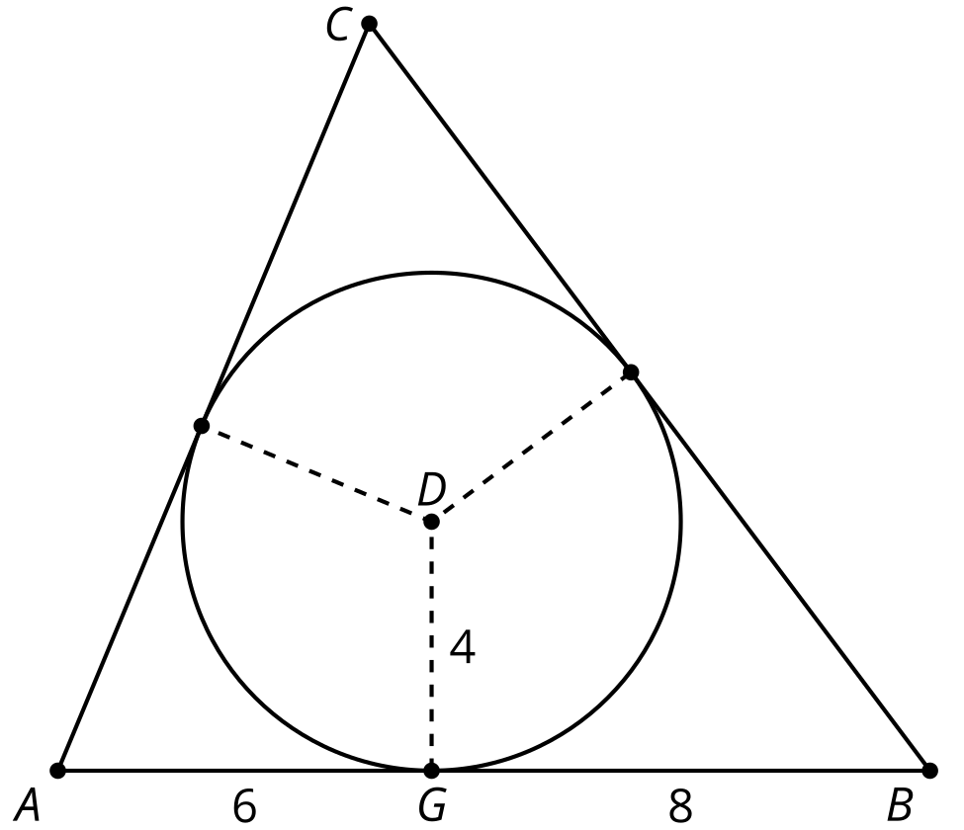
  - 60 degrees
  - 30 degrees
  - $2arctan\left(\frac{1}{2}\right)$
  - $arctan\left(\frac{1}{2}\right)$
- (From Unit 7, Lesson 7.)
- Select all the true statements.
- 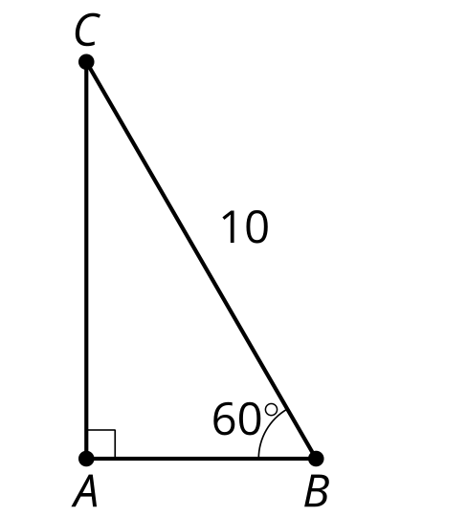
  - Angle $C$ is 30 degrees.
  - Side $AC$ is 5 units.
  - Side $AB$ is 5 units.
  - Side $AC$ is $5\sqrt{2}$ units.
  - Side $AC$ is $10\sqrt{3}$ units.
- (From Unit 4, Lesson 3.)
© CC BY 2019 by Illustrative Mathematics®

