Unit 4 Lesson 15: Find Missing Side Lengths

WU Estimation Exploration: The Garden (Warm up)

Student Task Statement
What is the area of one of the large rectangles in the garden?
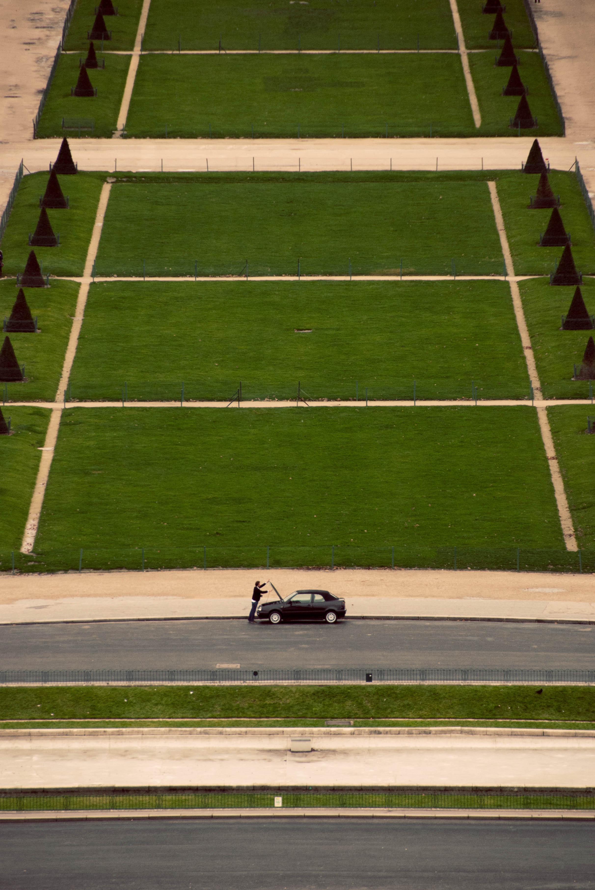
Record an estimate that is:
too low | about right | too high

1 Find the Missing Side Length, Part 1

Student Task Statement
Complete the table.
area  (square feet) | length  (feet) | width  (feet)
816 | 24
1,248 |  | 48
 | 23 | 253
5,796 |  | 36

2 Find the Missing Side Length, Part 2

Student Task Statement
- Complete the table.
- volume  (cubic feet) | - base  (square feet) | - height  (feet)
- 375 | - 15
- 1,176 |  | - 28
- Clare wants to find the height of a rectangular prism with the following measurements:
- volume  (cubic feet) | - length  (feet) | - width  (feet) | - height  (feet)
- 882 | - 6 | - 7
  - First, Clare finds the quotient $882÷6$. What could she do next to find the height?
  - Find the missing height to finish the problem for Clare.
- Complete the table.
- volume  (cubic feet) | - length  (feet) | - width  (feet) | - height  (feet)
- 936 | - 8 |  | - 9
- 1,536 |  | - 48 | - 2
- 1,008 | - 36
© CC BY 2021 Illustrative Mathematics®

