Lesson 13: Perimeter and Area of Rectangles
- Let’s explore the perimeter and area of rectangles on the coordinate grid.

Warm-up: Estimation Exploration: Window Washing
What is the area of one window?
Record an estimate that is:
too low | about right | too high

13.1: Rectangle Perimeters
length (cm) | width (cm)
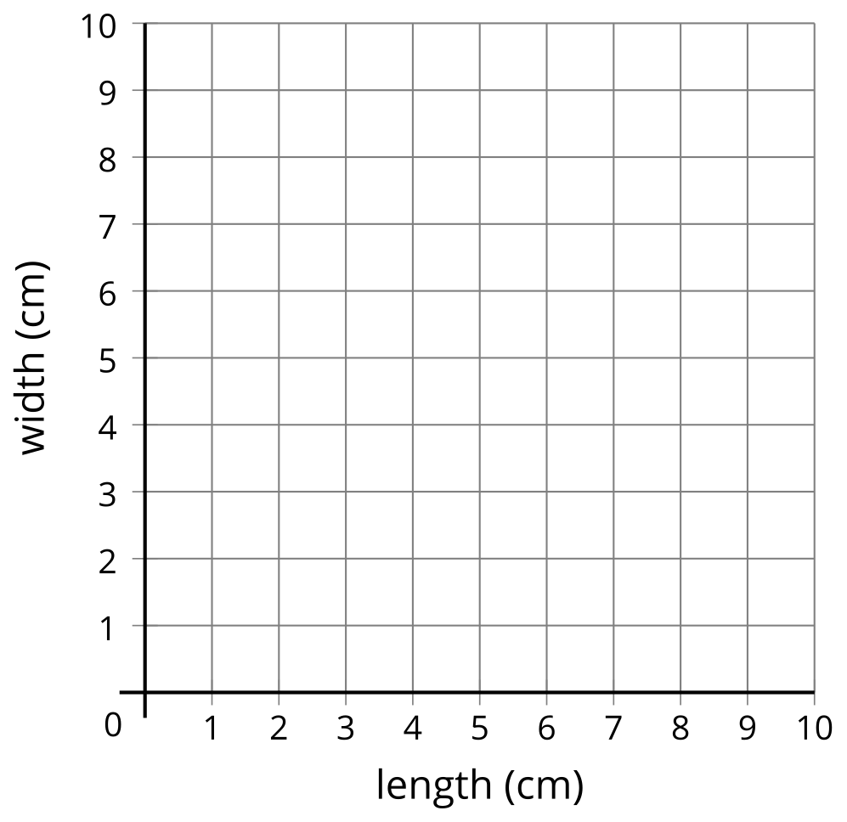
- Jada drew a rectangle with a perimeter of 12 centimeters. What could the length and width of Jada’s rectangle be? Use the table to record your answer.
- Plot the length and width of each rectangle on the coordinate grid.
- If Jada drew a square, how long and wide was it?
- If Jada’s rectangle was 2.5 cm long, how wide was it? Plot this point on the coordinate grid.
- If Jada’s rectangle was 3.25 cm long, how wide was it? Plot this point on the coordinate grid.

13.2: Rectangle Areas
length (cm) | width (cm)
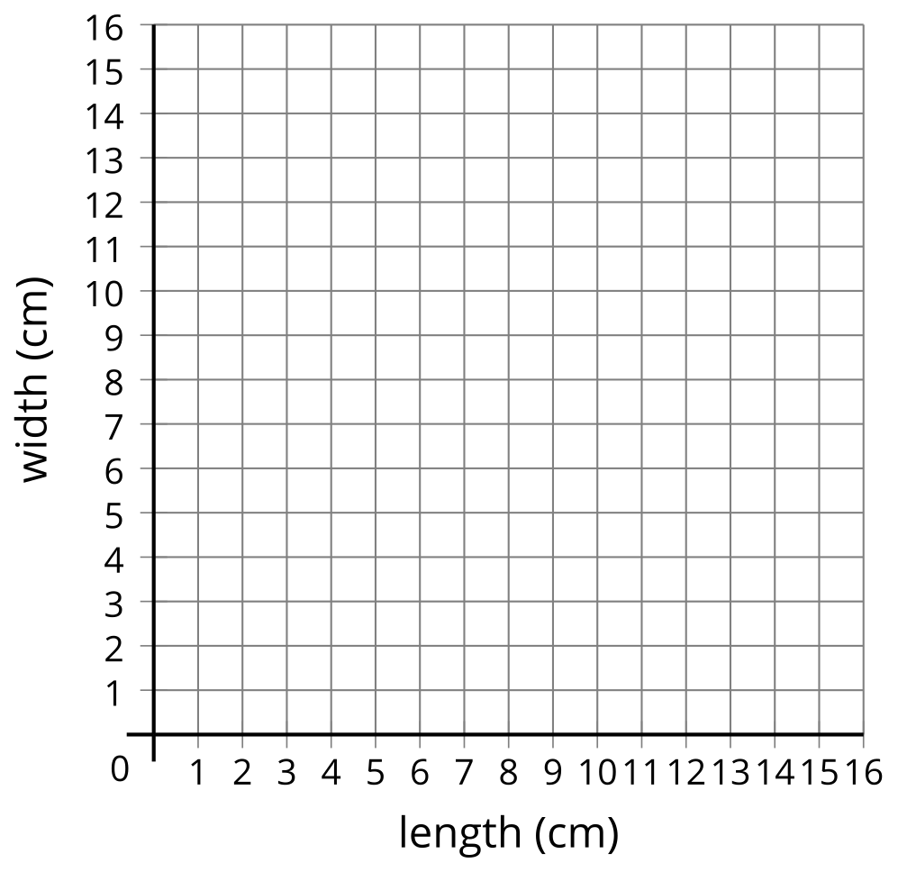
- Jada drew a rectangle with area 16 square centimeters. What could the length and width of Jada’s rectangle be? Use the table to record your answer.
- Plot the length and width of each rectangle on the coordinate grid.
- If Jada’s rectangle was 5 cm long, how wide was it? Plot this point on the coordinate grid.
- If Jada’s rectangle was 3 cm long, how wide was it? Plot this point on the coordinate grid.
- If Jada drew a square, how long and wide was it? Explain how you know.

Section Summary
Section Summary
In this section, we generated patterns and recognized relationships between two different patterns.
 | A | B | C | D | E | F
rule 1: Start at 0. Add 8. | 0 | 8 | 16 | 24 | 32 | 40
rule 2: Start at 0. Add 2. | 0 | 2 | 4 | 6 | 8 | 10
Each number in rule 1 is 4 times the value of the corresponding number in rule 2 and each number in rule 2 is $\frac{1}{4}$ times the value of the corresponding number in rule 1. We also plotted the rules together on a coordinate grid.
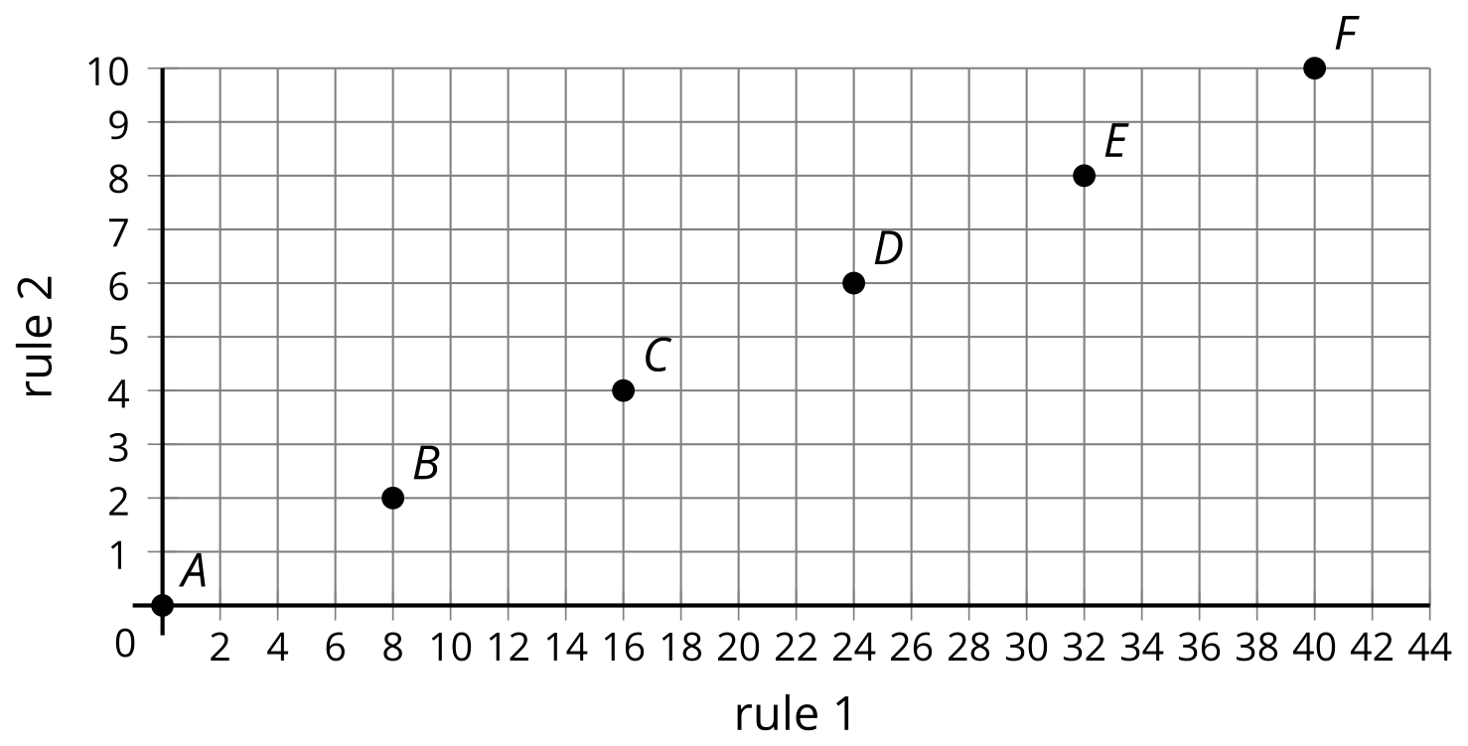
We also used the coordinate plane to represent other situations such as the length and width of rectangles with given area or perimeter.
© CC BY 2021 Illustrative Mathematics®

