Lesson 1: Times as Many
- Let’s represent situations that involve “times as many.”

Warm-up: Notice and Wonder: Compare Cubes
What do you notice? What do you wonder?
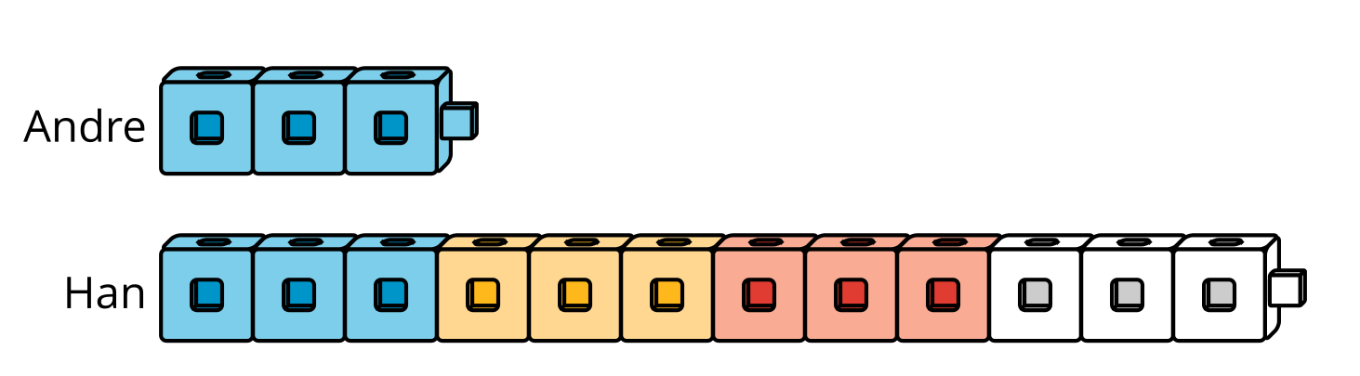
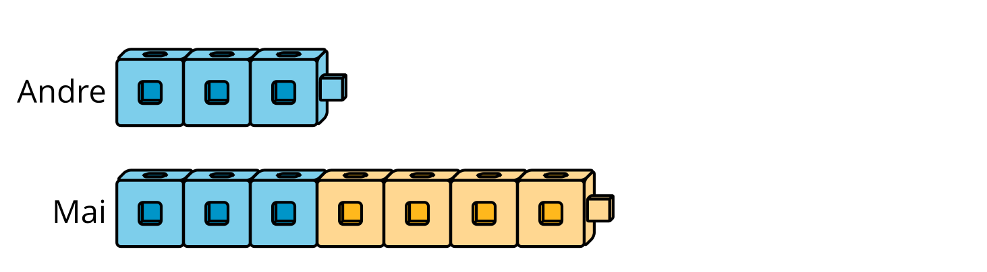

1.1: Twice as Many
Andre has some cubes. Han has twice as many cubes as Andre.
Use cubes, pictures, or other diagrams to show how many cubes Andre could have and how many cubes Han could have.
Be prepared to explain how your representation shows that Han has twice as many cubes.

1.2: Times as Many
Draw a picture to show the number of cubes the students have in each situation. Be prepared to explain your reasoning.
- Andre has the following cubes and Han has 4 times as many.
- 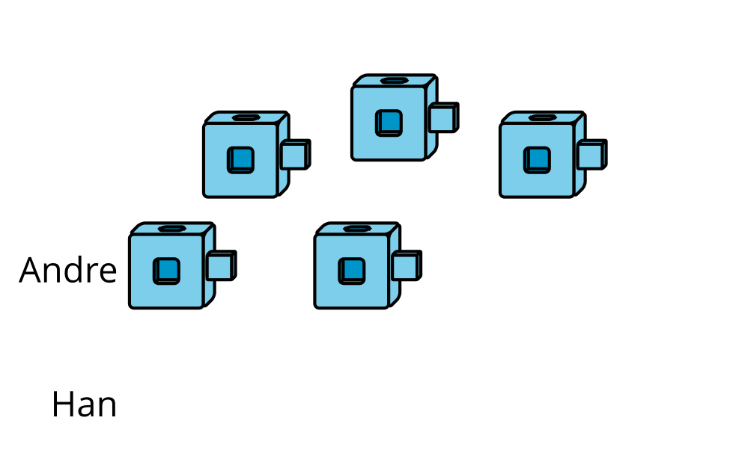
- Priya has the following cubes and Jada has 6 times as many.
- 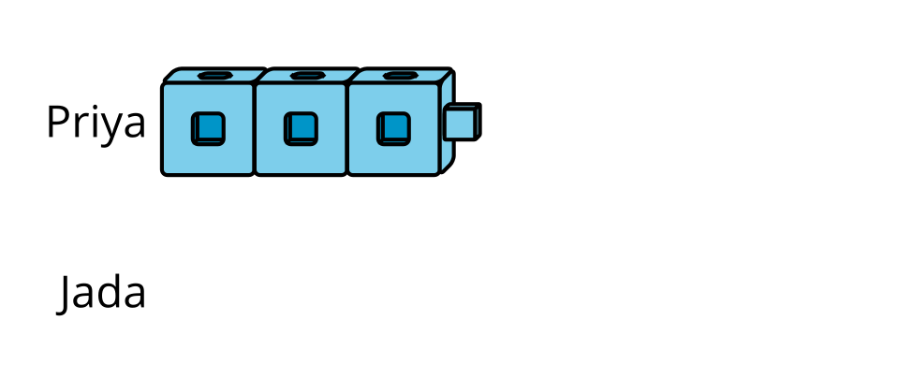
- Tyler has the following cubes and Mai has 8 times as many.
- 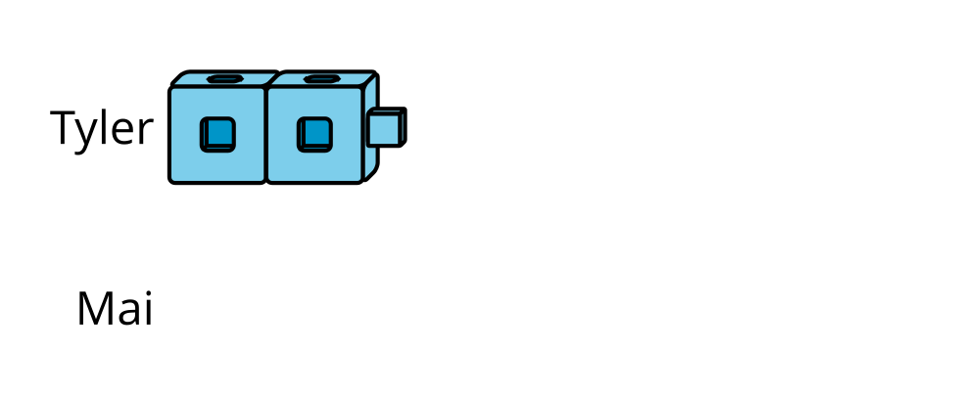
- What number represents “8 times as many as 2”? Show your reasoning.

1.3: Make $n$ Times as Many
Work with a partner on this activity.
- Partner A: Create a set of connecting cubes between 2–6 and show Partner B.
- Partner B: Roll a number cube. Let’s call the number rolled $n$.
- Partner A: Use the connecting cubes or a diagram to show $n$ times as many as the original set of cubes. Show your reasoning.
- Partner B: Check your partner’s work and discuss any disagreements.
- Switch roles and repeat.
© CC BY 2021 Illustrative Mathematics®

