Lesson 7 Practice Problems
- Literacy rate and population for the 12 countries with more than 100 million people are shown in the scatter plot. Circle any clusters in the data.
- 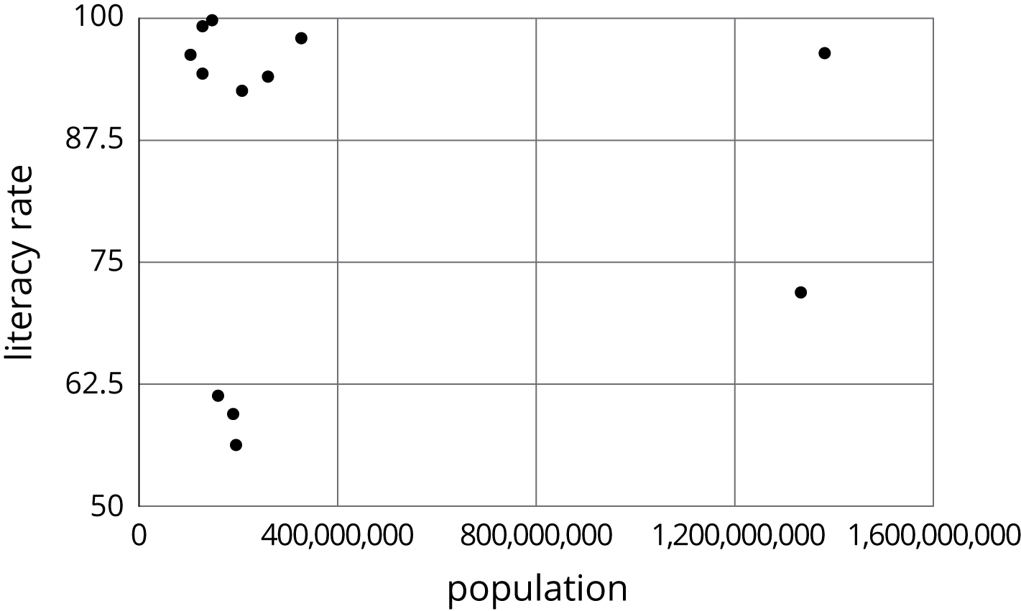
- Here is a scatter plot:
- 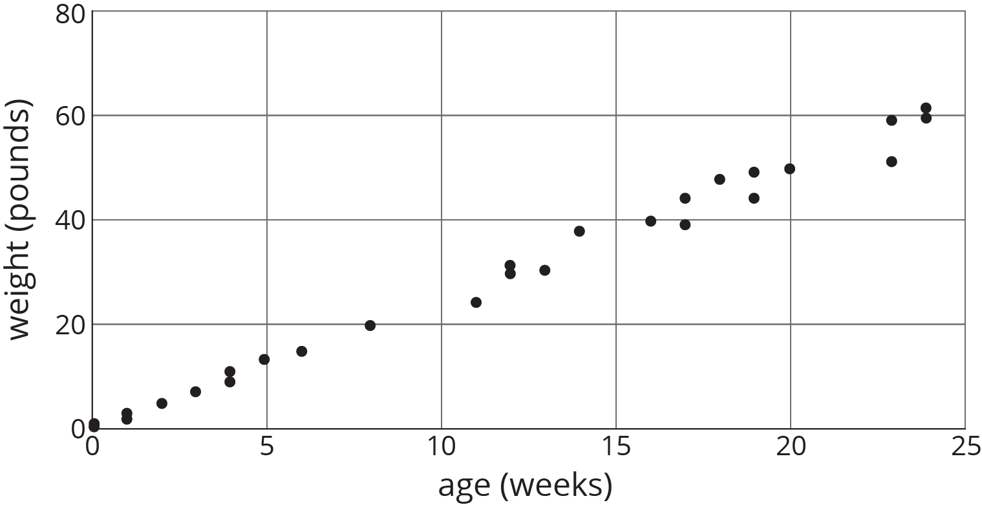
- Select all the following that describe the association in the scatter plot:
  - Linear association
  - Non-linear association
  - Positive association
  - Negative association
  - No association
- For the same data, two different models are graphed. Which model more closely matches the data? Explain your reasoning.
- 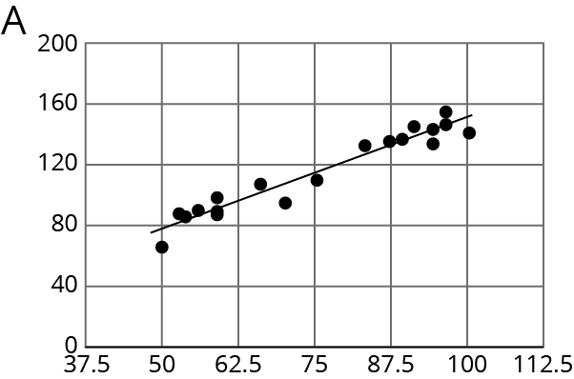
- 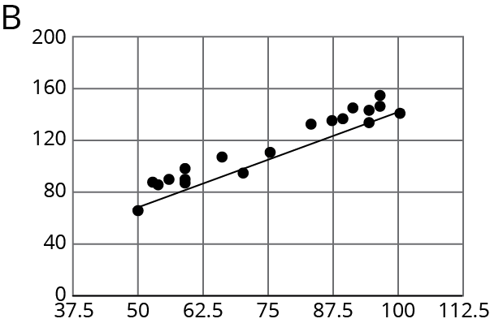
- (From Unit 6, Lesson 5.)
- Here is a scatter plot of data for some of the tallest mountains on Earth.
- The heights in meters and year of first recorded ascent is shown. Mount Everest is the tallest mountain in this set of data.
  - Estimate the height of Mount Everest.
  - Estimate the year of the first recorded ascent of Mount Everest.
- 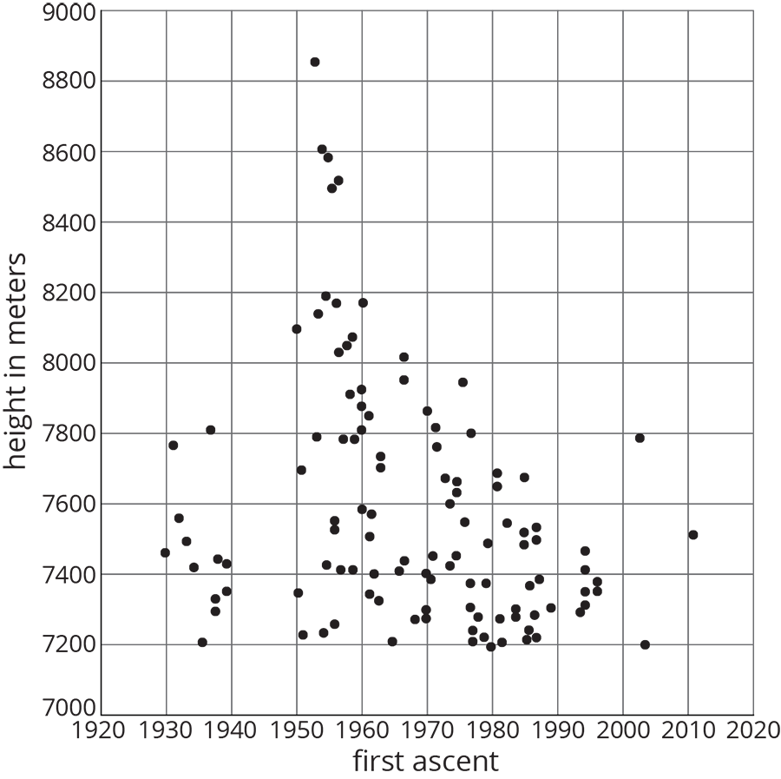
- (From Unit 6, Lesson 3.)
- A cone has a volume $V$, radius $r$, and a height of 12 cm.
  - A cone has the same height and $\frac{1}{3}$ of the radius of the original cone. Write an expression for its volume.
  - A cone has the same height and 3 times the radius of the original cone. Write an expression for its volume.
- (From Unit 5, Lesson 18.)
© CC BY Open Up Resources. Adaptations CC BY IM.

