Lesson 21: Compare Numbers
- Let’s figure out which number is more and which is less.

Warm-up: Act It Out: Hand Out Milk
Tyler is handing out the drinks to his class.
9 students chose milk.
5 students chose water.
Did fewer students choose milk or water?

21.1: Which Number is More?
Circle the number that is more.

- 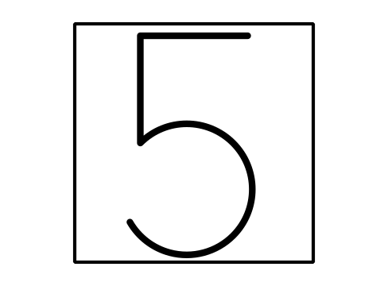
- 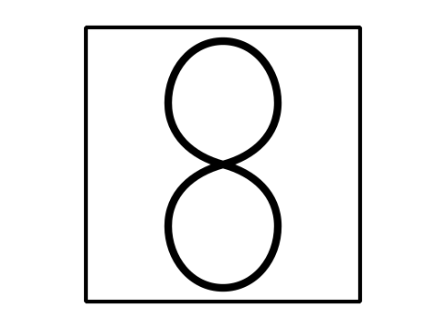

- 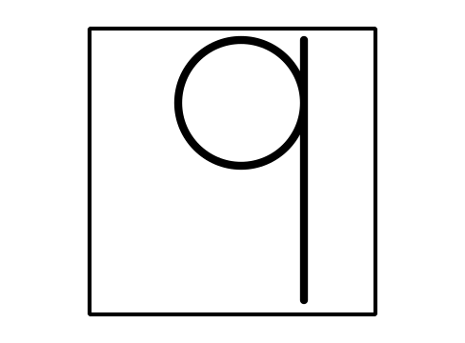
- 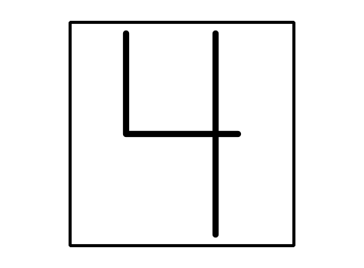

21.2: Which Number is Less?
Write the numbers you roll.
Circle the number that is less.
Write the numbers you roll.
Circle the number that is less.

21.3: Centers: Choice Time
Choose a center.
Less, Same, More
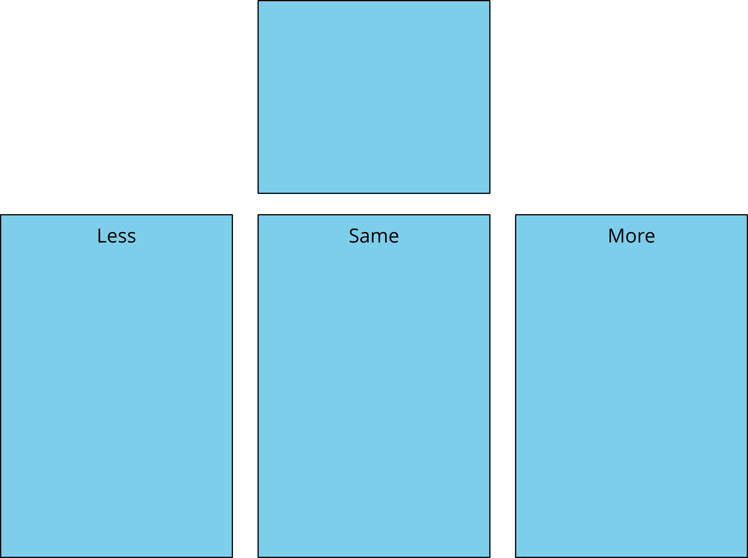
Math Libs
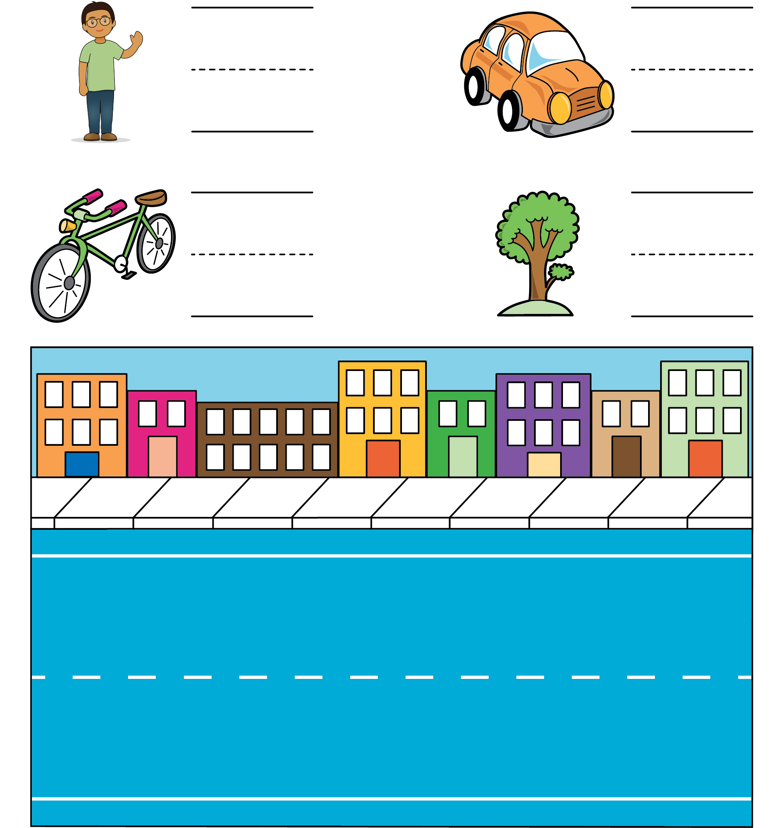
Number Race
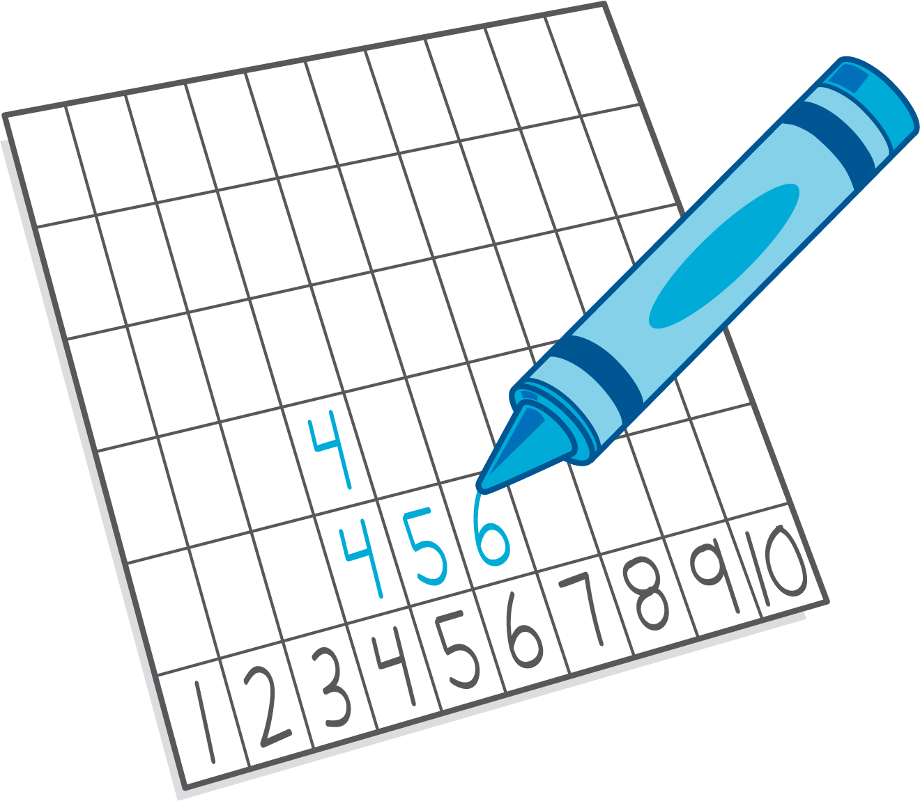

Section Summary
Section Summary
In this section we compared numbers. We used objects and drawings to help us figure out which number is more and which is less.
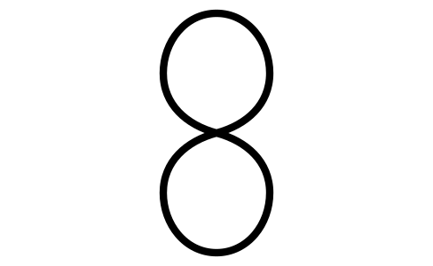
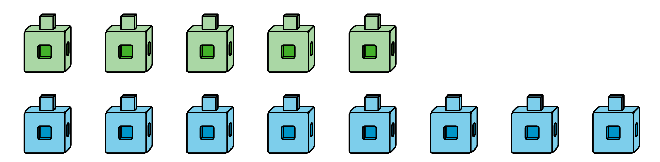
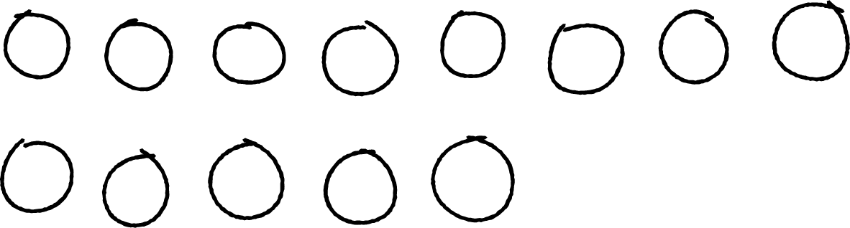
We also learned that we can use what we know about counting to compare the numbers.
1, 2, 3, 4, 5, 6, 7, 8, 9, 10
5 comes before 8 when we count.
5 is less than 8.
8 is more than 5.
© CC BY 2021 Illustrative Mathematics®

