Lesson 12 Practice Problems
- The shoe size for all the pairs of shoes in a person's closet are recorded.
- 7 | - 7 | - 7 | - 7 | - 7 | - 7 | - 7 | - 7
- 7 | - 7

  - What is the mean?
  - What is the standard deviation?
- Here is a data set:
- 1 | - 2 | - 3 | - 3 | - 4 | - 4 | - 4 | - 4
- 5 | - 5 | - 6 | - 7

  - What happens to the mean and standard deviation of the data set when the 7 is changed to a 70?
  - For the data set with the value of 70, why would the median be a better choice for the measure of center than the mean?
- Which of these best estimates the standard deviation of points in a card game?
- 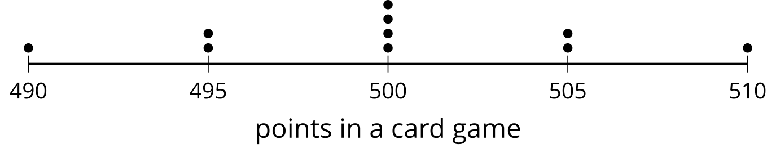
  - 5 points
  - 20 points
  - 50 points
  - 500 points
- The mean of data set A is 43.5 and the MAD is 3.7. The mean of data set B is 12.8 and the MAD is 4.1.
  - Which data set shows greater variability? Explain your reasoning.
  - What differences would you expect to see when comparing the dot plots of the two data sets?
- (From Unit 1, Lesson 11.)
- Select all the distribution shapes for which the mean and median must be about the same.
  - bell-shaped
  - bimodal
  - skewed
  - symmetric
  - uniform
- (From Unit 1, Lesson 10.)
- What is the IQR?
- 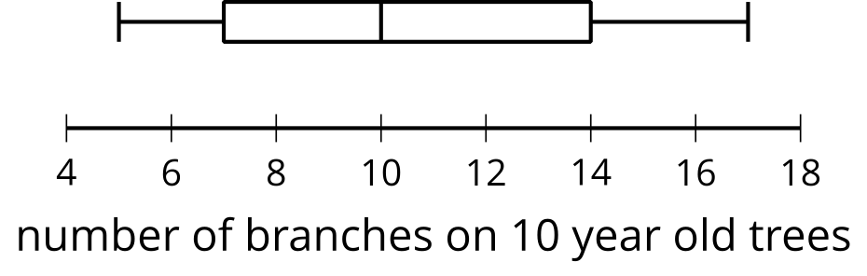
  - 5 branches
  - 7 branches
  - 10 branches
  - 12 branches
- (From Unit 1, Lesson 11.)
- The data represent the number of cans collected by different classes for a service project.
- 12 | - 14 | - 22 | - 14 | - 18 | - 23 | - 42 | - 13
- 9 | - 19 | - 22 | - 14

  - Find the mean.
  - Find the median.
  - Eliminate the greatest value, 42, from the data set. Explain how the measures of center change.
- (From Unit 1, Lesson 9.)
© CC BY 2019 by Illustrative Mathematics®

