Lesson 12: Prisms and Pyramids
- Let’s describe relationships between pyramids and prisms.

12.1: The Faces of Geometry
Three solids are shown.

A
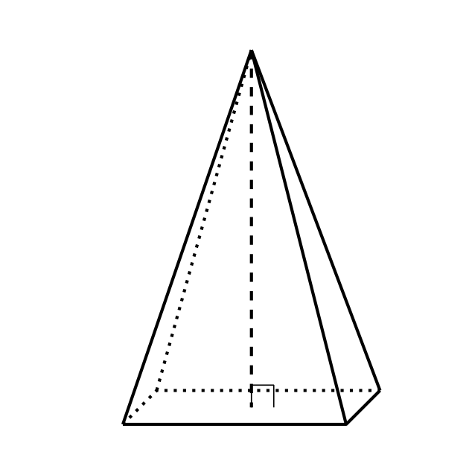

B
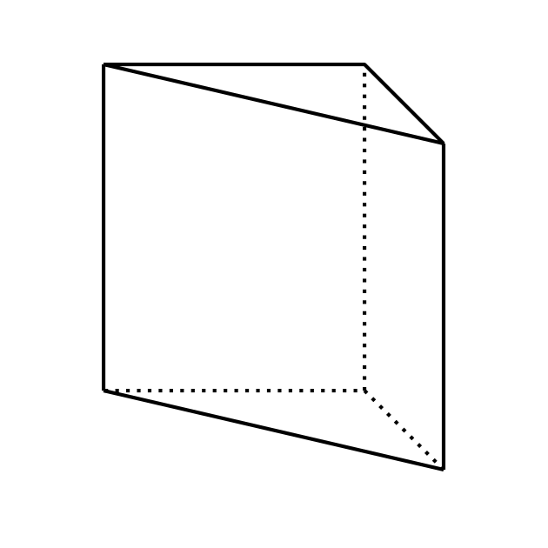

C
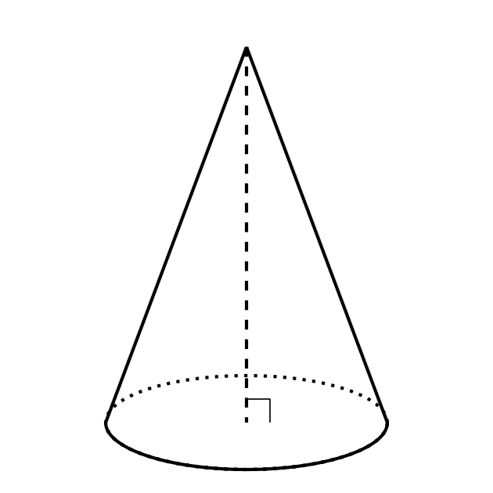
Draw all the surfaces of each solid.

12.2: Card Sort: Sorting Shapes
Your teacher will give you a set of cards that show geometric solids. Sort the cards into 2 categories of your choosing. Be prepared to explain the meaning of your categories. Then, sort the cards into 2 categories in a different way. Be prepared to explain the meaning of your new categories.

Are you ready for more?
The platonic solids are a special group of solids with some specific criteria:
- The faces are all congruent and are all the same regular polygon.
- They are convex, meaning that the faces only meet at their edges.
- The same number of faces meet at every vertex.
- Draw a platonic solid constructed with faces that are squares.
- Draw a platonic solid constructed with faces that are triangles.
- Draw a different platonic solid constructed with faces that are triangles.

12.3: Building a Prism from Pyramids
Your teacher will give your group 3 nets. Each student should select 1 of the 3 nets.
- Cut out your net and assemble a pyramid. The printed side of the net should face outward.
- Assemble your group’s 3 pyramids into a triangular prism. Each pair of triangles with a matching pattern will come together to form one of the rectangular faces of the prism. You will need to disassemble the prism in a later activity, so use only a small amount of tape (or no tape at all if possible).
- Make a conjecture about the relationship between the volume of the pyramid marked P1 and the volume of the prism.
- What information would you need to verify that your conjecture is true?
Don’t throw away your pyramids! You’ll use them again.

Lesson 12 Summary
Pyramids and cones are different from prisms and cylinders in that they have just one base and an apex, or a single point at which the other faces of the solid meet.
Cones are like cylinders and prisms in that they can be oblique or right. If a line dropped from the cone’s apex at right angles to the base goes through the center of the base, then the cone is right. Otherwise, the cone is oblique. Pyramids that have a clear center in their bases can also be considered right or oblique.
We can use relationships between pyramids and prisms to build a formula for the volume of a pyramid. The image shows 3 square pyramids assembled into a cube. We’ll use similar thinking, but with triangular pyramids and prisms, to create a pyramid volume formula in an upcoming lesson.
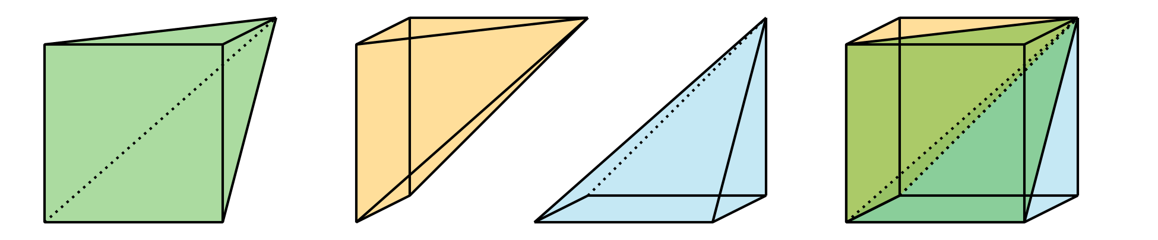
© CC BY 2019 by Illustrative Mathematics®

