Lesson 3 Practice Problems
- List all the possible outcomes for spinning the spinner and flipping a fair coin.
- 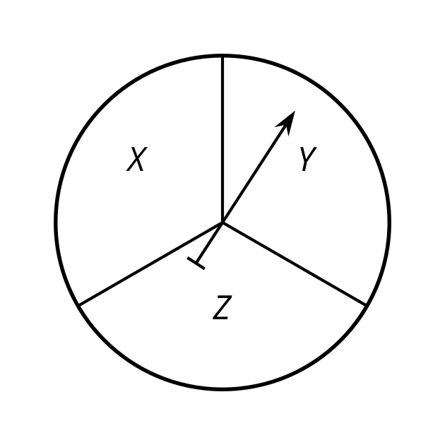
- A student picks a random letter from the word ”cat” and a random letter from the word ”meow.”
  - How many outcomes are in the sample space?
  - What is the probability that a “c” is chosen?
  - What is the probability that a “w” is chosen?
  - What is the probability that a “c” and a “w” are chosen?
- Tyler decides which type of pizza to order. The choices for crust are thin crust or regular crust. The choices for one topping are pepperoni, mushrooms, olives, sausage, or green peppers. Tyler has trouble deciding because there are so many possibilities. He selects the type of crust and one topping at random. How many outcomes are in the sample space?
  - 2
  - 5
  - 7
  - 10
- A spinner is divided into 5 equal sections. 2 of them are red, 1 of them is orange, 1 of them is yellow, and 1 of them is green.
  - What is the probability that it lands on red?
  - What is the probability that it lands on orange or yellow?
  - What is the probability that it lands on blue?
- (From Unit 8, Lesson 2.)
- Select all of the situations that have a 25% chance of occurring.
  - Rolling a standard number cube and getting a 4.
  - Flipping two fair coins and getting heads on the first flip and tails on the second flip.
  - Picking a letter at random from the word KALAMATA and getting an A.
  - Picking a letter at random from the word CALAMITY and getting an A.
  - Getting the correct answer when guessing randomly on a multiple choice question that has 4 choices.
- (From Unit 8, Lesson 1.)
- A circle has radius 12 inches, and a central angle is drawn in. The length of the arc defined by the central angle is $20π$ inches. Find the area of the sector outlined by this arc.
- (From Unit 7, Lesson 9.)
- Here is a straightedge and compass construction. Use a straightedge to draw a triangle that is not an equilateral triangle. Explain how you know.
- 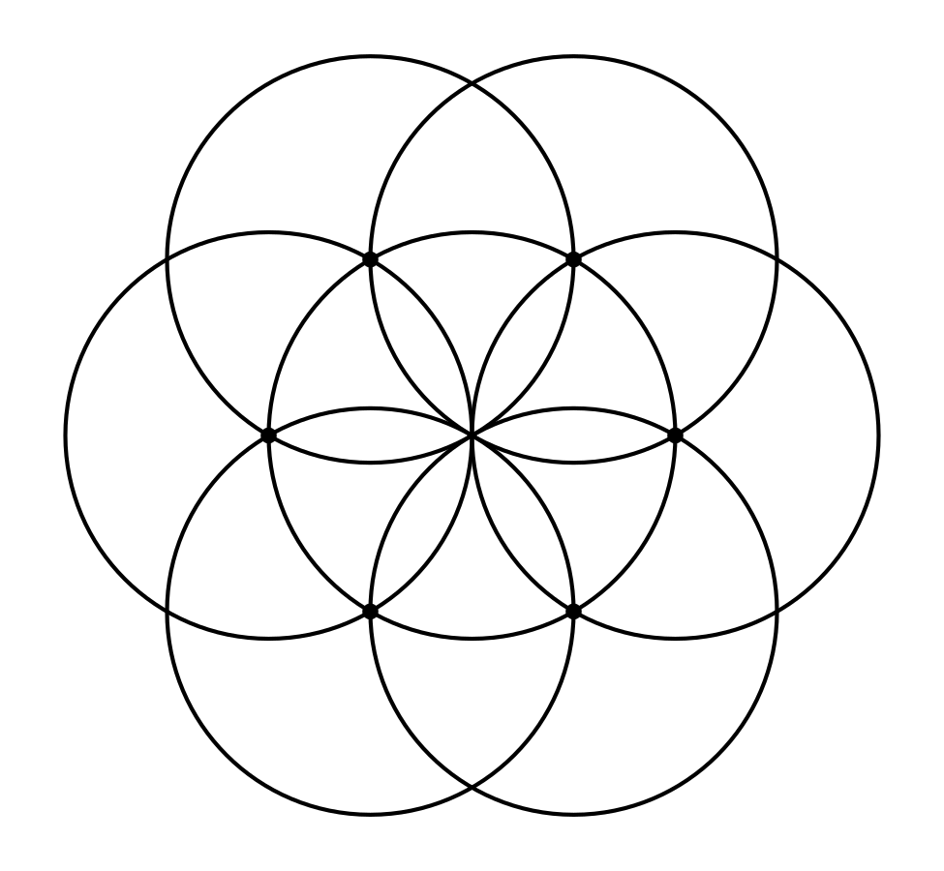
- (From Unit 1, Lesson 4.)
© CC BY 2019 by Illustrative Mathematics®

